St Thomas’ Church and Community Project
“A Place for You”
September Newsletter
ADENDUM (OR EXTRA BITS OF NEWS!)



This is proof that your newsletter is edited by a human person not AI! She forgot a couple of important pieces of news so for the first time ever! We have an extra newsletter this month!

Malawi container
A container will be going to Malawi in October and here is a list of items that are welcomed:
Books, both for children and adults. For future reference, if you hear of any primary schools that are updating their textbooks, we can always send the ones for disposal. Toys but not electric ones; second hand clothes especially children’s clothes; bed linen, light blankets; exercise books, A4 paper, black pens, colouring pencils; spectacles, first aid kits. Items need to arrive at St Thomas Church by the end of September, please, so they can be packed and dispatched to St Richard’s.
We also have to pay to send everything so donations towards the cost would be very welcome especially if you are donating things.
On Sundays, the money can be donated with the collection in an envelope marked ‘Malawi’. During the week you can put your donation in an envelope and hand it via the office.
If you’ve any questions, please don’t hesitate to ask. Contact Jan via the office.

Children's and youth activities at St Thomas' church.


Our regular groups have been closed over the summer, but the team haven't been lazing around in the sun. Adam, Lauren and Jess have been working hard delivering the holiday club and youth activities at Oasis Blakenhale Community Hub. They now have a couple of weeks to recover and start planning for our Monday evening activities in the church hall.
Children's club for children aged 6-10 every Monday from 4.00 till 5.30. Lots of games, crafts and activities
Youth Club for children aged 10 - 14 from 5.45 till 7.15 lots of exciting activities and challenges including some free time to chat with friends.
We re-open on Monday 14th September, cost £1.50 per week (cash or card). All our workers are experienced and are DBS cleared and trained in safeguarding procedures.
New members are welcome, pop in for more information or for a trial session and bring some friends.
Stay and Play
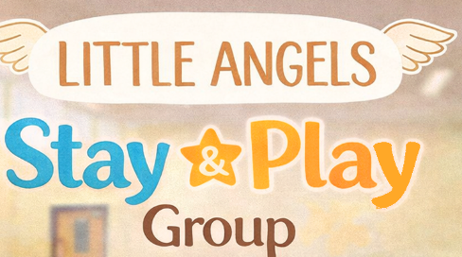
Are you left at home with an active toddler? Come and join us on Monday mornings from 9.00 till 11.00 to meet other parents and carers with pre-school children. Lots of toys and activities for you to enjoy with your children and to help them make friends, grow and confidence and learn social and communication skills in a friendly, relaxed atmosphere. We have free time where parents, carers and children can play together, be creative and grow together in preparation for nursery or school. After play time the children sit together for toast and then we finish with sing along and story time.
Many of our regular children are starting nursery or school in September so we have lots of spaces.
We re-open on Monday 14th September; cost is £2.00 per child (£1.00 for siblings), pay by cash or card, includes free refreshments. Come along for a free trial session and bring some friends and share your ideas for play with us.

