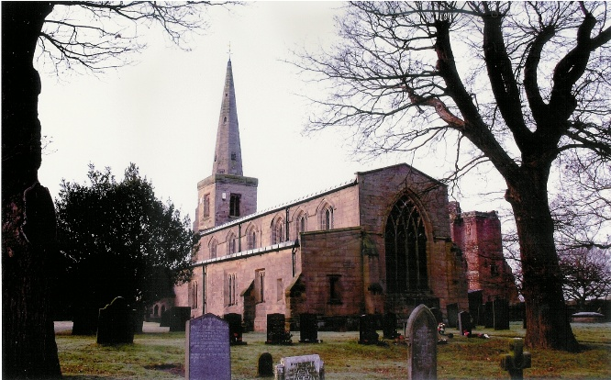
ST MICHAEL AND ALL ANGELS HAMSTALL RIDWARE
In the United Benefice of King’s Bromley,
the Ridwares and Yoxall

September 13th and 20th 2026

TRINITY 15 and 16

PARISH NOTICES

UNITED BENEFICE SERVICE ROTA
 | Hamstall Ridware  St Michael and All Angels | Yoxall  St Peter |  | King’s Bromley  All Saints | Mavesyn Ridware  St Nicholas
September 13th  Trinity 15 | 5.00 pm  Holy Communion |  | 10.30 am  Holy Communion | 10.30 am  Holy Communion
September 20th  Trinity 16 | 10.30 am  Harvest Festival |  | 5.00 pm  Holy Communion | 9.00 am  Holy Communion | 10.30 am  Holy Communion
September 27th  Trinity 17 | 10.30 am  Patronal Festival and United Benefice Service at Hamstall Ridware
October 4th  Trinity 18 | 9.00 am  Holy Communion |  | 10.30 am  Holy Communion |  | 4.00 pm  Harvest
October 11th  Trinity 19 |  |  | 10.30 am  Parish Communion | 10.30 am  Harvest  Holy Communion

Please note that services of Holy Communion at 9 am follow the Book of Common Prayer and are said. Services at 10.30 will include hymns and other singing.
There are services of Holy Communion at 10.00 every Wednesday at St Peter’s, Yoxall (except in September and November) and on the first Thursday of each month at All Saints, King’s Bromley.
**************
Rugeley Food Bank. Please do remember those who depend on Food Banks. They are needed now just as ever. If you wish to donate directly to Rugeley Foodbank at Rugeley Community Centre the Centre is open everyday to receive contributions. Alternatively, the Rugeley Food Bank welcomes financial contributions – see https://rugeley.foodbank.org.uk. Gifts can also be brought to St Michael’s and left in the box at the back of church near the font. If that is not convenient please contact Liz Carter on 07751 068181.
Contact details: If you wish to contact the Rector, Jeremy Brading you can do so on revd@kbhmy.co.uk and Glenis Turner, the PCC Secretary and Benefice Administrator is on admin@kbhmy.co.uk. Our churchwarden is John Ferguson (warden@hamstallchurch.co.uk). Information about events at church can be found at our webpages at https://www.achurchnearyou.com/church/4451/ and https://kbhmy.co.uk/hamstall/
**************
St Michael’s will continue to be open everyday (weather permitting) between 10.00 am until 6.00 pm. We will revert to shutting the church at 4.00 pm on October 25th 2026

Safeguarding of children and vulnerable adults. If you have any concerns please speak in complete confidence to the Parish Safeguarding Officer, Dr Paul Carter on 01889 504347 or the Diocesan Safeguarding Officer, Neil Spiring on 01543 306030.
PLEASE REMEMBER IN YOUR PRAYERS:
Those who are sick: Mary Mycock, Angela Perkin, Doug, David and Barbara Rudge, Pam Payne, Frank Finch, Chris Poole, Les Wood, Pat Lomax, Alison Barlow and any known personally to you.
Those who have died: Margaret Finch
Using the Archbishops’ prayer for Ukraine at this time let us remember the people of that war-torn land:
God of peace and justice, we pray for the people of Ukraine today. We pray for peace and the laying down of weapons. We pray for all those who fear for tomorrow, that your Spirit of comfort would draw near to them. We pray for those with power over war or peace, for wisdom, discernment and compassion to guide their decisions. Above all, we pray for all your precious children, at risk and in fear, that you would hold and protect them. We pray in the name of Jesus, the Prince of Peace. Amen
As the situation in the Middle East continues to see military action remember all those in all the countries affected by it – whether nationals or visitors, whether in those countries where and concerned for loved ones. Pray for wisdom on the part of the leaders of the nations involved and that hostilities and suffering may come to an end soon. Please pray also for seafarers and their families caught up in this conflict.
From the Diocesan Prayer Diary:
Sunday 13th September: (John Chrysostom, Bishop of Constantinople, Teacher of the Faith, 407)
A prayer of St John Chrysostom;
Remember, O Lord, this city where we dwell and every other city and country, and all the faithful who dwell in them. Remember, O Lord, all who travel by land or water, all who labour under sickness or slavery. Remember them, and give them health and safety. Remember, O Lord, all in your Holy Church who bring forth good fruit, are rich in good works and remember the poor. Grant your mercy and loving-kindness to us all, and grant that we may praise and glorify your great and glorious name with one mouth and one heart; Father, Son, and Holy Spirit, now and forever.
Monday 14th: (Holy Cross Day)
On Holy Cross Day we pray for the four churches in the diocese named 'Holy Cross', in Bilbrook, Bobbington, Ilam, and Tividale. We pray for your hand of blessing to rest on each of these churches and the communities they serve.
DATES FOR YOUR DIARIES!
Saturday September 19th
Special Community Café event for Harvest – the day before our Harvest Festival. This will be from 10.30 am to 2 pm. Offers to help will be welcomed by Jo Berriman berrijo@gmail.com and Liz Carter lizcarter3010@gmail.com
Wednesday September 30th
Evening Bat Walk and Talk at 6.15 – by popular request after last year’s successful event. After a fascinating talk, we'll head outside for a guided walk around the churchyard and surrounding area, where you'll have the chance to see bats in flight and listen to their echolocation calls using bat detectors – an unforgettable experience for adults and children alike! Ticket details from John Ferguson (warden@hamstallchurch.co.uk).
Friday October 16th
Musical evening in St Michael’s – local performers Tim, Mark & Issy and Jules will be performing. Ticket details to follow – but will include refreshments!
A prayer - during the time of seeking a successor to Bishop Michael
Eternal Father You have provided faithful pastors in every age to watch over your people and lead them in your ways: as you chose your servant Chad to be the first bishop of your church in Lichfield, so raise up for us, who follow Christ in your footsteps today, a shepherd to lead your people in the joy and steadfastness of the Holy Spirit, that all may know the abundant life which you give us in Jesus Christ your Son. Amen
St Michael’s encourages donations by means of this QR code and it will appear (all being well) on all our publications as an invitation to contribute to the important work of the church both
as a place of worship and a community asset where all can share in the wonderful place we have
inherited and wish to pass on to those who come after us.

