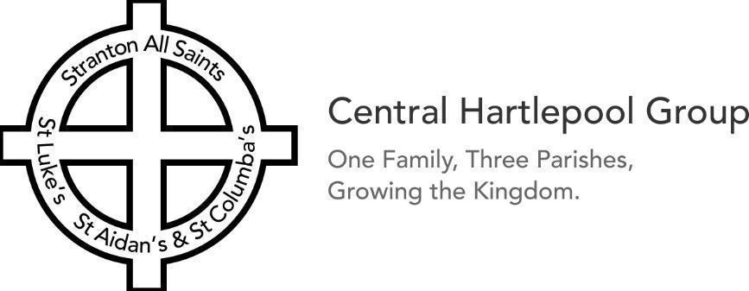


Welcome to Stranton All Saints
Sunday 27th September 2026
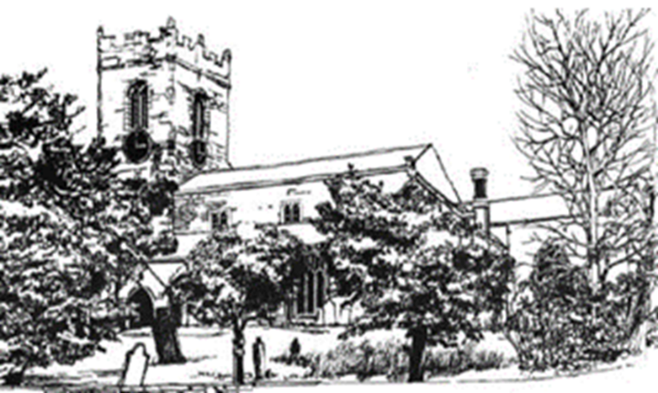

Rooted in God’s love, Growing together with Jesus,
Branching out in the Power of the Holy Spirit
Collect for 17th Sunday of Trinity-Harvest
Creator God,
you made the goodness of the land,
the riches of the sea
and the rhythm of the seasons;
as we thank you for the harvest,
may we cherish and respect
this planet and its peoples,
through Jesus Christ our Lord. Amen

Today’s services – 17th Sunday of Trinity Harvest (Green)
This week’s readings: Deuteronomy 8:7-18, 2 Corinthians9:6-end, Luke12:16-30
9:00am: Holy Communion (Revd John)
11:00 am: Harvest Morning Worship (Revd John)

Refreshments are served after all our services.
Do stay and join us if you can.

Services across the Central Hartlepool Group
Sunday 9:15am: Holy Communion, St Luke’s (Revd John / Kate)
Sunday 10:30am: Sung Mass, St Aidan’s

Tuesday 9:15am: Midweek Mass, St Columba’s
Wednesday 10:00am: Midweek BCP, St Luke’s
Wednesday 6:00pm: Bread for the Soul, St Aidan’s

For info: achurchnearyou.com or Facebook pages

The funeral of the late Eva Busby (longstanding member of Stranton Church) will be taking place in Stranton Church at 12noon on Monday 5th October. The family of Eva warmly invite those who knew Eva to come along to the funeral service to give thanks for her life.

Toddlers: at St Matthew’s, 9:00- 11:00am (Term time only)
The 4th Hartlepool Boys Brigade at St Matthew’s:
Juniors (ages 8-11) Monday 7th, 6:30 – 8:00pm
Anchors (ages 5½-8) Friday 11th, 6:00-7:00pm
Company Section (ages 11+) Friday 18th, 7:15-9:00pm
Subs £2. New Members Welcome

Rainbows, Brownies, Guides, and Rangers meet
Mondays at St Matthew’s:
Rainbows (ages 4-7) 5:30-6:30pm – Brownies (ages 7-10) 6:00-7:15pm
Guides (ages 10-14) 7:00-8:30pm – Rangers (ages 14-18) 7:00-8:30pm
New Members Welcome


Save the date! 900th Anniversary Events

Saturday 10th October: Family Quiz Night, 5pm to 6:30pm
@ Stranton Church, everyone welcome. Adults £4.00 &
Families £8.00 including food. Tickets available.

Coming Up
Saturday 26th September: Harvest Agape (Bring & Share) Meal 4pm at St Luke’s, with a time of fellowship and celebration of God’s love for us.

Sunday 27th September: Harvest Services (with collections and donations of nonperishable foods for Hartlepool Foodbank). The Boys Brigade will be offering Bacon Butties at St Matthew’s between 10am to 10:45am

New to Stranton Church? Please take a copy of ‘Signpost’ our church magazine. We’d love to keep in touch. Feel free to complete a Welcome contact card and then pass it onto clergy/churchwarden.
Please continue to pray for:

The ongoing work of our CMS Mission Partners, especially Andy, (with Kati, and Eva) serving out in Brazil.

Our schools & colleges, local businesses, aid agencies, and health & social care services across our town as they seek to work with, and support those in, our communities.

The ongoing conflict in the world around us, especially in Ukraine, and the Middle East. And for our brothers and sisters in Christ suffering persecution for their faith.

For our Prime Minister, Andy Burnham, his Cabinet, and all who serve in government at either a national or local level.

Renewed vision – in our churches, in our prayers, in our own discipleship and faith; for new people coming to know Jesus.

All who are struggling with health concerns or financial worries, or who are grieving the loss of loved ones.


If you’d like to give any foodbank donations,
please leave them in the box
at the back of church.
We support the Central Hartlepool Group Mission Project - activities/services through the week.
For info: check out the Facebook page or contact the Mission
Enabler: patrick@hartlepoolcoh.co.uk
Thank you: to everyone who currently gives financially to the church. If you would like to give too, there is a collection basket on your way in and out of church, as well as a contactless machine, or you can give online or through the Parish Giving Scheme – details at the back of church.
Key contacts:
If you have a Safeguarding concern, please contact:
Jacqui Rogers, Parish Safeguarding Officer
07749 163606, safeguarding@stranton-church.org.uk

Beth Miller, Diocesan Safeguarding Officer
07968 034075, Beth.miller@durham.anglican.org or Revd John

Church Office, St Matthew’s, Elwick Road, TS26 9JF
Weekdays 10am-12noon, 01429 894006 / 07305 550009
admin@stranton-church.org.uk

Revd John Bell, Priest-In-Charge:
01429 756309 / 07512 481115
revdjohnbell@stranton-church.org.uk (Day off – Friday)

Revd Claire Mead, Curate: 07598 070481
curate@stranton-church.org.uk (Day off- Friday)

Other clergy & churchwarden/activity contacts are in ‘Signpost’ or at: www.stranton-church.org.uk

