
SPIRE & LIGHT United Churches
United Benefice of St Keverne, St Ruan with St Grade & St.Wynwallow (The Lizard)

*If you do not wish to receive these notices, please let your Churchwarden know*

20th September 2026

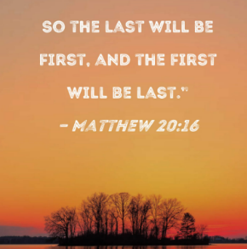
Readings
Jonah 3:10-4:11
Psalm 145:1-8
Philippians 1:21-30
Matthew 20:1-16

9.30am – Holy Communion - St.Peter’s, Coverack
9.30am – Holy Communion - St.Wynwallow, The Lizard
11am – Creation Sunday - St.Keverne
11.15am – Family Service – St.Ruan, Ruan Minor

Next week – Sept.27th
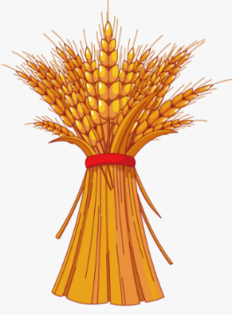
9.30am – Morning Prayer - St.Ruan, Ruan Minor
11am – Holy Communion HARVEST - St.Keverne (joint with St.Peter’s + Methodists)
11.15am – Café Church HARVEST– St.Wynwallow, The Lizard

St Keverne & St Peter's Coverack Harvest supper celebrations Friday 25th September
Service in Church 7pm followed by Harvest Supper in Church Hall 8pm.
Tickets £5.
Available in advance from Kathy Ough tel: 01326281079
As we begin to hold our Harvest services below is a list of foods the Foodbank is in particular in need of at the moment-


The Prayer Spot



We pray for the Deanery that we belong to and we thank you for the faithful people you have brought together here. Remind us that we have each been brought to faith by Our Saviour Jesus Christ.
Lord Jesus, we thank you for your presence in our lives and the love you give us to share with others. Keep us strong in our faith and close to you.
Help us to be always there for others in their time of need, you have given us each gifts to use to reach out to others and to give comfort to those around us.
Heavenly Father we live in a world slowly destroying itself, through greed, hatred, and with no concern for others. Remind us that we can bring love, care and understanding into the world, by reaching out into our communities and showing your love to all we meet. Loving God, be with us always. Remind us that we are brothers and sisters in Christ Jesus, that God is ever present in our lives, through his wonderful Holy Spirit that he has given to you as a free gift to us all.
Mighty God, everything you do reveals your Majesty. Open our eyes to see what you are doing in our lives. Let us marvel at your good gifts and your wise provision. Your acts are amazing Lord. We cannot comprehend the number of blessings you pour out to us from day to day. As we gather today around your name, we pray that you will fill our hearts, our minds and our souls. Transform us Lord and make us more like you. Through Jesus Christ our Lord. Amen
God bless you all. Samuel Buchanan

The Diocese of Truro’s Prayer Diary for this week

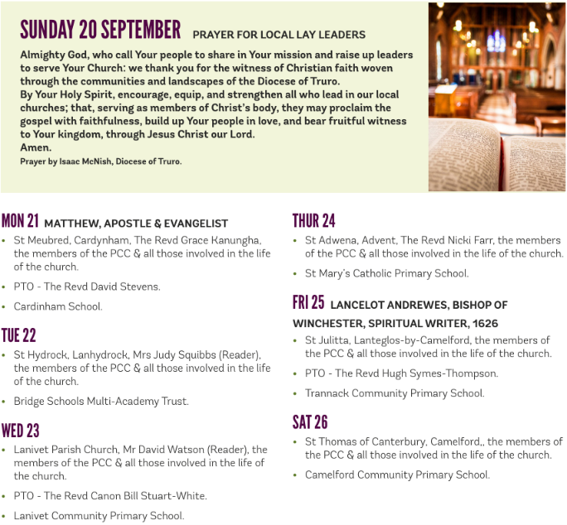

On the Way Prayers

Creator God today we come together in prayer to give you thanks for the gift of creativity. You created this world, but you put us here to tend and care for it and in doing so you passed on the creative gift to us, to make this world even more beautiful and meaningful.

We thank you for all musicians, for the joy that music brings, for the healing we now know it brings, particularly for people living with dementia and for the way it enhances our worship of you. We’re so lucky in Cornwall to have so much musical talent on show in our Cathedral, our churches, our pubs and halls and even on our streets and beaches. “Where words fail, music speaks”. Lord help us to listen.

We give thanks for the visual arts – for our galleries and wealth of local artists and craftsmen and women. Your beautiful world led to the creation of the St Ives School and the Newlyn School and that same light in our coasts, coves and skies continue to attract artists from all over the world. Many of our churches are great examples of architecture, of craftsmanship and of great majesty and awe. As custodians of these buildings help us not just to keep them as historical pieces. but as living, breathing and continually evolving examples of the natural history of creativity. We give thanks too for the written word – for poetry, novels and plays, for our theatres and cinemas, for our radios and screens.

Now we pray that in our own way we can all be creative – using those gifts that you have given us – whether it be making our homes into welcoming, attractive, cosy places or our gardens into landscapes of colour and shape, or even our baking, knitting, sewing, writing, preparing sermons or talks or whatever we are blessed with, or happy to be doing.

“Release in us the power of your Spirit that our souls may be free to roam your boundless stretches of space. May we soar high like the eagle, see horizons yet undreamed of, glow with fires of compassion, flow with streams of creativity. Breath of God, blow away all that is unclean. Breeze of God, refresh our tired frames. Wind of God, blow us where you will. Dew of God, refresh our tired routines. Rain of God, revive our withered lives, River of God, flow through us and heal our land.”

And now let us take some time to pray for anyone who needs our prayers or for anything that is bothering us.

We pray for your church here in Cornwall, for our Bishops David and James, for our Archdeacons, Clive and Helen and particularly for Stewart Shaw and his wife Heather who are moving into the vicarage in Constantine this week. Let us pray that other people are being called to come in minister to us in Cornwall. We pray for our Deanery, particularly for Heidi and Susie and all our PTOs. May this season of mellow fruitfulness enrich and bless us. May we harvest relationships of trust, forgiveness and generosity. And until we meet again, may we be kept in the hollow of God’s creative hand. Amen

