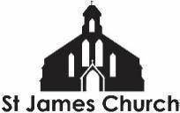
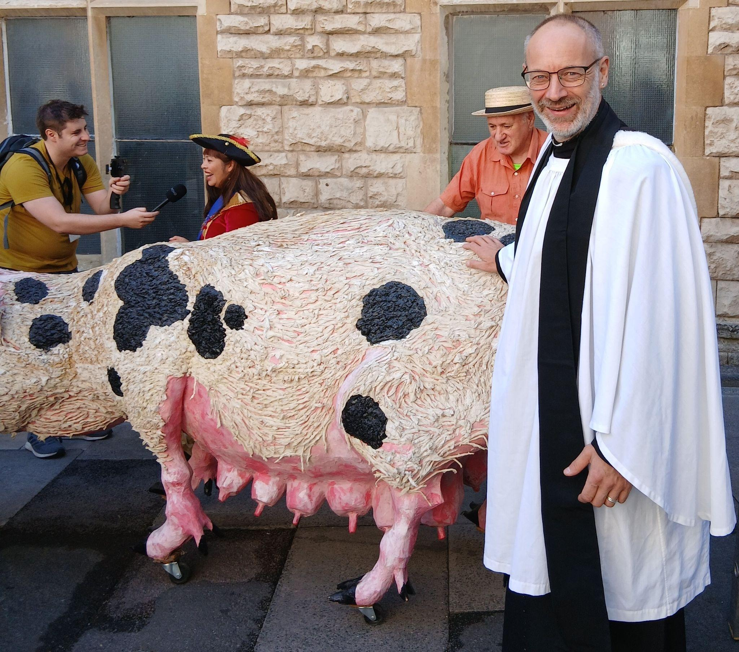
What’s On at St. James Church and in our local community from 11th September 2026 onwards

I hope you and your loved ones are doing well this week. Here is “What’s On” at St. James Church and some highlights from within our community this week.

Sunday 13th September
10.30am Coffee and conversation in the church. A chance to meet and spend time with one another before or after worship
11am Holy Communion Service - Jeremiah, Suki, and myself will all be helping lead our service this Sunday. There will be Godly Play for our Primary School age children with Alison and Tina. Ethan and Jeremiah (or Fola!) will be leading our worship along with the St James Singers.

Monday 14th September
Monday to Friday at 8.30am and 6pm: Morning and Evening Prayer on ZOOM
2pm Bible Study at Charter Court with Hazel and Trevor

Wednesday 16th September
9.15-10.45am English Corner - English language conversation class
1 - 2.30pm Art4Life group in church
6.30 - 7.30pm Youth Choir - Young people between 10 and 16 are invited to come and learn a range of new songs for Autumn, in a fun and friendly choir. Free.

More Community What’s On
The Fair Shares Allotments, Upton Street, are open on Monday, Wednesday and Thursday from 10am - 4pm - You can pick up some freshly picked vegetables, help to look after the crops, and find activities for children. As well as a cup of tea and a sit down! Everyone is welcome to go along.
St James City Farm - Do pop along and say hello to the animals on any day of the week.
Bartongate Children and Family Centre - 1.30 - 3pm Stay and Play session

In other news…
We are looking to employ a youth worker for our Friday evening youth group. If you know of anyone who might be interested in this then please ask them to contact me.
In addition, we are looking for someone to help with our pre-school children on a Sunday morning. If you know of anyone who might like to serve in this way then please let me or Fola know.
We are planning a Global garden - 4 raised beds growing food from Jamaica, Nigeria, Sri Lanka, and the UK. Would you be interested in being a part of this - helping to plan, plant, and nurture one of the beds? Speak to me or Chioma for more information.

Further ahead
Saturday 19th September
A celebration of lay ministry at the Cathedral.
1.15pm-2.45pm: Stalls set up in the Cathedral Cloisters highlighting some of the lay ministries exercised across the Diocese.
3pm Service celebrating all those who exercise a lay ministry in our church.
All may attend and support and there are some specific invitations in church as well.

As always, if you would like me to pray for, or have a conversation about anything then do get in touch. I am available to listen and share in whatever might be arising for you at this time.

God Bless, Rev Steve 07503164309

