GRATWICH NEWSLETTER  AUGUST 2026  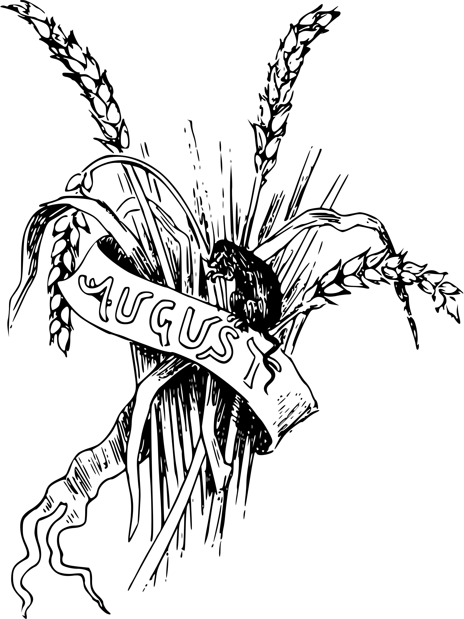  For further information about anything in the newsletter, please contact:  Jenny Talbot: 01889 502471 email:jenny477@btinternet.com  Facebook: St. Mary’s Church Gratwich  DATES FOR YOUR DIARY  22nd August 7.00pm onwards Wheelbarrow Racing on the church croft – see flieer  27th September 7.00pm Harvest Festival in church  3rd October 7.00pm Harvest Supper in church  Join us for our annual Harvest meal and a chance to get together and chat.  Contact Carolyn (01889 502680) to book a place by 27th September.  CLEANING ROTA  Carol Woolley & Jenny Talbot  USED STAMPS & INK CARTRIDGES  If you have any used stamps there is a box in church for them – Collecting for the RNIB.  Also St. Mary’s in Uttoxeter are collecting glasses for the Lions and Printer Ink Cartridges (used and unused) to raise money for MS research.  They are open on a Wednesday, as is their café serving lunches, tea/coffee and cake.  Useful Contact Numbers  To Book a Baptism, Wedding or Funeral contact Nicola at Uttoxeter Area Parish Office: Tel: 07365 608186  Email:uttoxeterareaparish@outlook.com  Uttoxeter Area Stipendiary Clergy  Rev. Joe Cant 07592 206706  Area letter - Living in unity and love  Dear Friends,  As Checkley’s July magazine combines with that of August, I am writing this August Area letter somewhat early!  At this point of time, we are being inundated with rainy weather but the odd ray of sunshine is appearing and, in spite of many troubling world events, I have just enjoyed  watching the first event of the 2026 World Cup! Although I am not an avid football supporter, I do enjoy these world events, which show how countries can work together in mutual respect and tolerance, even while obviously sending their teams out there in the hope that they will outperform others!  Continued/…………………………………………………… | GRATWICH SERVICES AUGUST  AUGUST  SUNDAY 9th 11.15am Holy Communion  SUNDAY 30th 2.00pm Baptism  SEPTEMBER  SUNDAY 13th 11.15am Morning Prayer  SUNDAY 27th 7.00pm Harvest Festival  Sunday 23rd August Our usual week for evening prayer is a special event  At St. John’s, Marchington Woodlands  for Rev. Jules Walker who leaves at the end of August  If anyone would like a lift please let Jenny (01889 502471) know  Still dry, sunny weather – lovely to sit in and sunbathe and for drying washing but the fields are now looking very brown and dry! The excitement of earlier when we all had a good crop of silage has now turned into worry that it may have to be used to feed stock now and not kept for winter. Let’s hope and pray that we have some rain soon, the grass recovers and there will be at least one more crop to silage.  The bingo evening at the beginning of July went well with almost everyone winning a bar of chocolate and enjoying the delicious cakes kindly provided by Julie.  Then on the 18th we had our Fun on the Field afternoon with everyone enjoying a cream tea after winning lots of prizes on the tombola.  Now looking forward to WHEELBARROW RACING on 22nd August on The Croft  Contact Jenny to book a team or just come along and watch. See flier.  There will be refreshments to buy, a raffle and some games in church afterwards.  100 CLUB – JUNE/JULY  1st Sally-Anne Lander /Sophia Capewell  2nd Lynn Hulin/Stewart Talbot  3rd Nicola Talbot/Rory Owen  August prizes will be drawn after the morning service on the 9th August  Mega-events like the World Cup generate significant goodness by boosting local economies, fostering international unity, and driving transformative urban development. Other positive impacts of the tournament manifest in several key areas: Host nations experience substantial financial boosts through tourism, hospitality, and upgraded infrastructure. The event also creates thousands of temporary and permanent jobs. The tournament unites billions of fans worldwide, fostering a spirit of global harmony and providing a stage for diverse cultures to celebrate together. Such tournaments often leave a lasting legacy through grassroots programs. Initiatives like the FIFA Foundation use football to promote education, health awareness, and gender equality in disadvantaged communities.  While mega-events require massive upfront investment, their long-term benefits can deeply enrich the host societies. It must surely rejoice the heart of God to witness the cooperation fostered by such events, no matter which nation comes out top at the end of it all! They become a focal point for social interaction, as people gather to watch matches together, celebrate victories, and mourn defeats. Such communal experiences strengthen social bonds and create a sense of unity.  Before the crucifixion, Jesus famously prayed "that they may all be one" (John 17:21), as he prayed for his followers to be united, just as he and the Father are one.  As death was looming before him, the unity of his believers was foremost on his heart and he wanted that unity to be visible so that the world would know that he had come from the Father. And that desire for unity extends to us too as we deal with one another in all of our varied relationships- in our families, our workplaces, our social time, our differing Christian denominations, our relationships with those from other cultures and backgrounds.  I am sure, too, that we are all wishing The Revd Jules Walker all the very best as she leaves the Uttoxeter Area for her new post as Vocations Officer for lay and ordained callings. We thank her for her time here and wish her many fulfilling relationships as she seeks to encourage others to pursue their vocations across the diocese. Jules has said: “I am excited to be combining my commitment to both lay and ordained vocations, drawing on my experience of working in industry, leading lifelong learning and in fourteen years’ parish ministry. I deeply value exploring the varied ways God calls his people to ministry, have a love for encouraging theological learning, and I look forward to this new post with real joy and anticipation as these different experiences come together in one role.”  God be with you, Jules.  Peace and prayers,  Irene Smith

