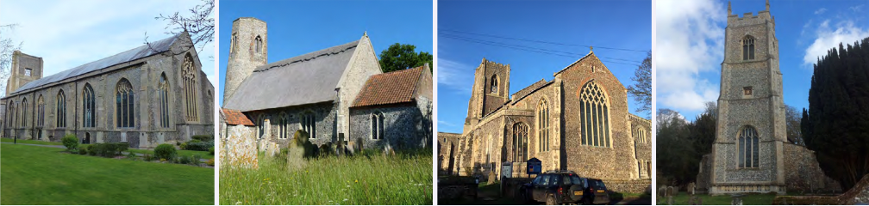

N.E.W.
North Walsham
Edingthorpe
Worstead and Westwick
NEWS
The Magazine for the North Walsham Benefice October 2026 40p
Transformed by Christ: Prayerful, Pastoral, Prophetic

Editor’s Bit

Contents in this issue:
- Vicar’s Page
- From the assistant curate
- Dates from the Diary
- September service Dates
- Upcoming Events
We hope to see you at our services, you are all welcome.

Please note the date for items to go in the November edition of NEWS needs to be at the Parish office by October 18th latest.

Financial Information

Please may we remind you, that if you are giving us a cheque for any of the Churches, they need to be made payable to the following:
St Nicholas’ Church – North Walsham PCC
All Saints’ – Edingthorpe PCC
St Mary’s – Worstead PCC
St Botolph’s – Diocesan Churches Trust

Please may we ask if you are sending any payments to us via an online service that you put a meaningful reference on the payment to ensure we know where the payment should go to.

Live-streamed services are available on YouTube - please search St Nicholas North Walsham. Do you participate in our live-streamed services - we would love to hear your feedback: contact David on 07506 723946 or davidnorthwalsham@gmail.com

If you are considering a change to your Committed Giving for St. Nicholas, please inform Chris Sherman (Committed Giving Officer)
Please support St. Nicholas Church, North Walsham on #easyfundraising, you can raise FREE donations when you shop online with over 5,000 retailers. It is simple and only takes 2 minutes to sign up! Plus, once you have raised your first £15, easy fundraising will match it!
Sign up now: https://www.easyfundraising.org.uk/causes/stnicholaschurchnw/

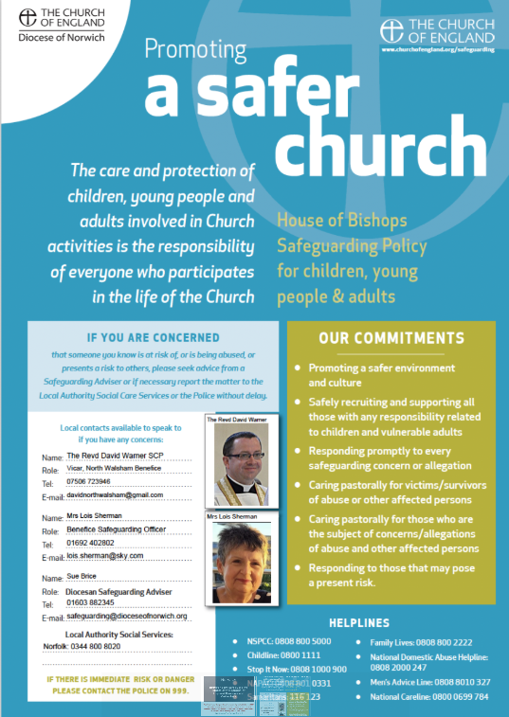

You may have noticed at St Nicholas in recent weeks, particularly since Dan was ordained priest, that the clergy share some parts of the service: usually share together in the Eucharistic prayer: you may have noticed they extend their hands towards the bread and wine together and also share some of the words between themselves.
This is known as concelebration: the person leading the service is sometimes called the celebrant or the president. The priests who assist them are known as concelebrants because they celebrate with that person. Of course, we all come to the Eucharist, to Holy Communion and to its celebration together: priests do what priests do and the wider people of God do what they do: together we pray.
As a benefice we welcome all priests to preside and concelebrate, be they male or female (and assuming all relevant safeguarding requirements are in place): all are welcome here just as all our welcome in our congregations.
This concelebration is a model of what we should be together: the people of God celebrating his sacraments as one.
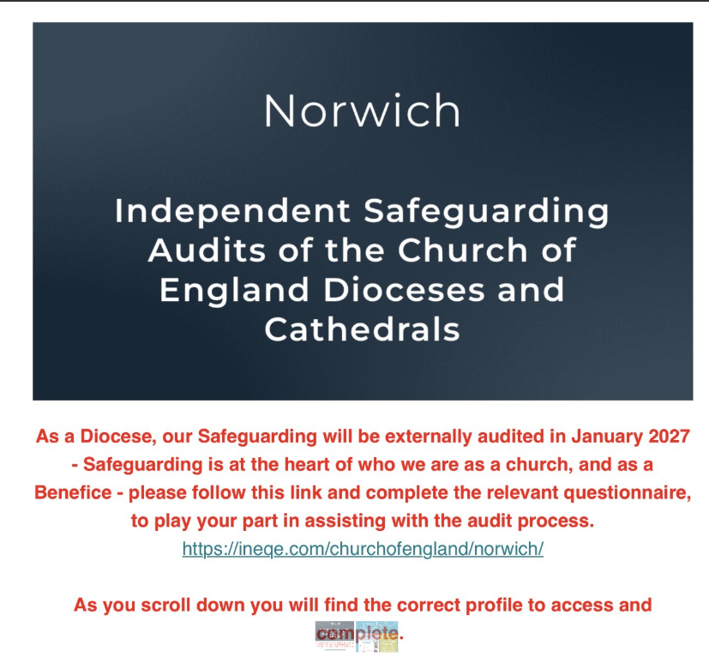
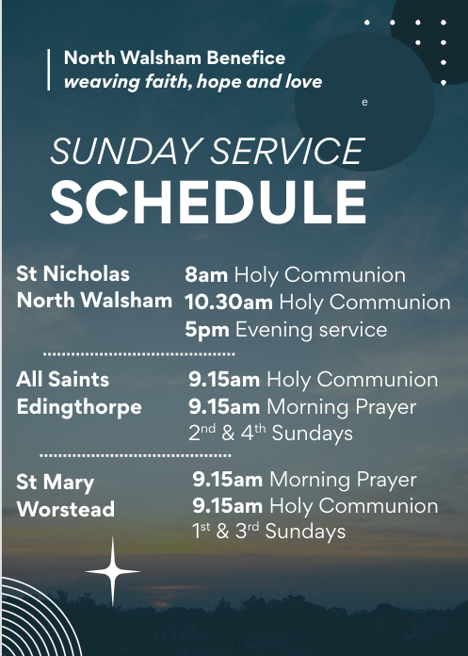

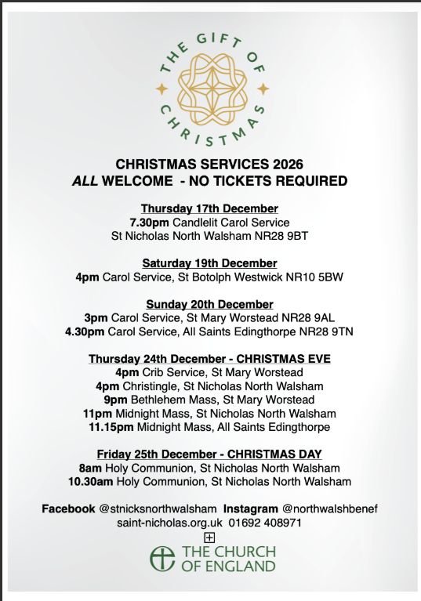
The Vicar’s page:
From David:
October heralds busy weeks leading to the celebration of Christmas and the end of the year. October has become a month of celebration for us as a family, marking as we do our James' birthday. It will be good to celebrate his 1st birthday with you, grateful as we are for the kindness that has been shown to him, and to us, since his birth.

It may surprise you to know that I would describe myself as a rather pessimistic optimist. I hope for the best of course - in Christ the best has already been accomplished and is promised to us all, but the other half of my mind always plans for the worst, even though so often those plans are (thankfully) not needed. In all our churches there are signs for great optimism, and causes for great rejoicing:

At St Nicholas we continue behind the scenes to discuss our plans for the future with our architect, the Major Churches Team and others - be assured there is much going on at this very vital planning stage. We give thanks too, for an increasingly real and tangible prayer ministry both in church, in our schools and care homes, and with our growing virtual prayer chain. We have also spent much of the past few months renovating and renewing our busy church halls, thanks to the generosity of all who support the fundraising for the buildings.

At St Mary's, a busy Festival means our finances are secure for another year (we pray), and we are pushing ahead with plans to renovate the south porch roof (hopefully with the help of the Worstead Festival). The small and committed congregation continue to do wonders of fundraising, worship and fellowship.

At Edingthorpe we continue to discover new ways to use the churchyard and we hope that in the near future all this work may be even further recognised. Our churchyard team recently spoke to the Deanery Synod to encourage others to explore what can be done.

As we enter the seasons ahead, when we welcome so many amongst us, let us be optimistic: always hopeful, while planning to support the hopeless and the lost, and ALWAYS grateful for the blessings we have received, in order that they may ALWAYS be shared.

David

The Curate’s Page
It’s officially Autumn, which is my favourite time of year.
The beauty of Creation around us changes: leaves falling from the trees, bugs disappearing from our gardens, weather getting colder and days shorter.
For many it may seem bleak; but the life of the Church seems to be in rebirth after the quieter time of Summer.
This time of year is, in many ways, the busiest time of the year! Michelmass, Harvest, All Saints’, Remembrance, Bereavement Services, Carols and finally Christmas; Church spoils us this time of year.

What remains constant is the love of God, available and given to us daily!
As we approach this busy Church period, let us remember the love of God in thanksgiving for the beauty of Creation and Harvest plenty, let us remind ourselves of the love of God, present in lives of those, who departed this earth before us, let us contemplate the love for God and country, and finally let us prepare our hearts and minds for the welcoming of the Love of the World at Christmas.

Busy time in Church means need for volunteers, for people of good will and time to help one another with things to come.
And so while remembering the love of God towards us in life and worship, let us give that love to one another, let us share it with our neighbour, and if one feels so, let us give it back in the life and ministry of the Church, especially here in our amazing Benefice.
If you feel called to help with countless cups of coffee or tea, with numerous church rotas and many other roles so essential to the mission of our Church communities: be BRAVE and COURAGEOUS, come and speak to us!

Dan

Edingthorpe Village news for October

All Saints Church, Edingthorpe
Services
11th October. Holy Communion 9.15am
25th October. Morning Prayer 9.15am

On a lovely sunny Sunday afternoon Edingthorpe Church held a pet service. There were many happy dogs and photographs of cats with their owners and all very well behaved. Each pet was blessed by David and Dan. Afterwards tea and cakes were served.
The weather forecast was not good for our event in August when we had a stall at the Church entrance in North Walsham but we raised nearly £400, in aid of Edingthorpe Church. All cakes and preserves were sold by 11.45am. Bric a Brac and books were in high demand. Many thanks to all who helped to make it such a successful morning.
Our thanks go to Chris and Karen and their helpers who run a Coffee Morning on the 2nd Thursday of each month in St. Benet’s Hall. Do go along for a cup of coffee to support them.
Sunday 1st November at 4pm there is a Patronal Evensong. A quiet prayerful service sung by the choir followed by refreshments.
On Thursday 10th December we will have our Christmas Coffee morning at St Benet’s Hall, North Walsham from 9am to 12 noon. There will be various stalls including cakes, bric a brac, tombola, crafts together with a Hamper Raffle. Further details will be in the next issue of the Village News but if anybody would like to help in any way the contact 01692 402337.
"Do you play the piano or pipe organ? If so, would you like an opportunity to accompany Sunday services at All Saints? Our usual 9.15am services would hugely benefit from your talents! If you're interested, please contact the Revd David Warner, Vicar, on 07506723946."
All events about the Church are on https://www.achurchnearyou.com/church/10076/ or the village website www.edingthorpe.village.org.uk
June Hannant 01692 402337

ST MARY’S - WORSTEAD
With another, successful and enjoyable, Harvest Supper over for another year, we approach the coming season with renewed enthusiasm. The raffle proved entertaining and many, generous, donations were received for the North Walsham Food Bank.
The Diocesan Architect has made a start on assessing, and planning, the necessary work to renew the main Porch roof. We are awaiting the Contractor’s quotation with bated breath!
We are looking forward to welcoming back the Cawston Band on Saturday, October 24th at 7.00 pm for “A Night at The Proms.” Tickets are £12.00, to include light refreshments, and Union Flags will be provided! See you there.
Looking forward to next month (already), don’t forget our traditional ‘Service of Remembrance’ when we come together as a community to remember those who gave their lives in time of war. Sunday, November 8th at 10.45 am.
In its long, and no doubt distinguished, 800 – year history, there will have been many ‘firsts’ for St Mary’s. Well, here’s another one:
On Sunday, May 9th, 2027, the Norwich Cathedral Choir will be coming to Worstead. They will be singing Evensong at 3.30 pm. More details will follow, nearer the time, so, do put the date in your diaries. A rare opportunity to witness, and participate in, something unique in the life of our Church.
Diary Dates:
Sunday, 4th October – Morning Prayer – 9.15 am
Sunday, 18th October – Holy Communion – 9.15 am
Sunday, 8th November – Service of Remembrance – 10.45 am

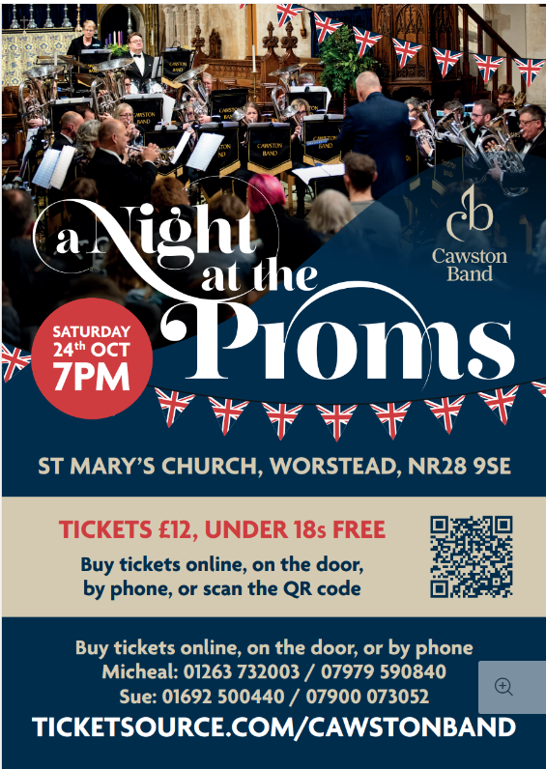

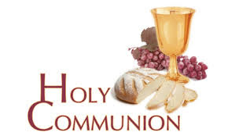
You may have read items in the press relating to the use of 'gluten free' wafers at Holy Communion - for those who require them, we use wafers which are approved and recommended for use by Coeliac UK - more information here. If you need a gluten free wafer, please advise the churchwardens/welcomers when you arrive for the service, and please indicate to the clergy distributing Holy Communion.
The Church teaches that receiving Holy Communion in both kinds (wafer and wine), or in one kind (the wafer or the wine) are acceptable and contain the fulness of the Sacrament. There are many reasons why this will be the case at different times in our lives, and there will be times when we cannot physically receive but join in an Act of Spiritual Communion (as those who watch online do - see below).

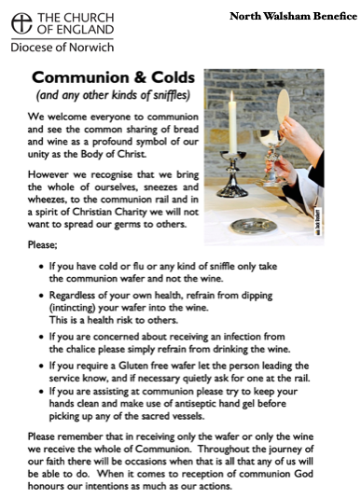
​Intinction (that is, dipping your wafer into the wine) is not permitted, both for hygiene reasons and because it might introduce gluten to the wine, which could be consumed by someone who is allergic to it.
If you wish to discuss any of this, please speak to David.

An Act of Spiritual Communion
In union, O Lord, with the faithful at every altar of your Church, where the Holy Eucharist is celebrated, I desire to offer you praise and thanksgiving. I present to you my soul and body with the earnest wish that I may always be united to you. And since I cannot now receive you sacramentally, I ask you to come spiritually into my heart.
I unite myself to you and embrace you with all the affections of my soul. Let nothing ever separate you from me. May I live and die in your love. Amen.



Why not come along to Sunday Kids and find out how to learn about what we do? We meet on the 1st and 3rd Sunday of the month at St Nicholas Church during the 10.30am service. You are most welcome.

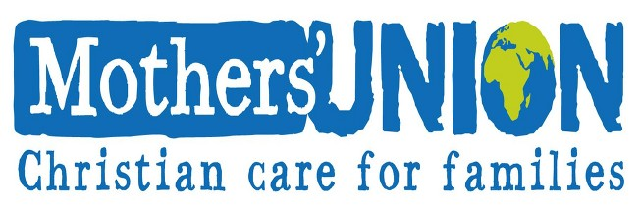

North Walsham Mothers’ Union. We meet in St Nicholas Room on the second Tuesday of the month at 2.00 p.m. Following a short act of worship and a few notices our speaker then takes the floor, after which, over tea and biscuits, there is an opportunity to ask questions and socialise. We usually finish about 3.30 pm.

North Walsham Churches Together Christmas Day Lunch

This has been an event in town for over thirty years. Its aim is to ensure that no resident of our town has a lonely Christmas Day but can join with others in a welcoming space for a traditional meal.
Since the friendly welcome is as important as the food volunteers for all sorts of roles are needed. Collect and drive guests, welcome and chat, help lay tables and arrange the big room, prepare, cook the food and serve the food and drink and finally clear up. The guests arrive from 12:15pm. The meal is at 1pm. Tea/coffee is served in time for His Majesty The King’s broadcast at 3pm before the party ends. Hopefully everyone (including the clearing up team) is safely home before dark. The event is free and the organisers are very grateful for many individual, shop and group donations, and a wonderful grant from The NW Community Shop not to mention the Community Centre who give us free use of the building.
The guests who booked to come in previous years will be contacted in good time to be invited again. If you, or someone you know living in town has not been before and this year will be alone without any company on Christmas Day and would like an invitation please request an invitation by posting a note with their name, address and a contact email or phone number to
CTNW Christmas Meal
32 Youngmans Close
North Walsham
NR28 9JQ
Email address: ctnw.christmas@gmail.com

All volunteers from previous years will be asked if they are able ( but not pressured) to help again. New people offering to help please make contact with a note to:
The Parish Church of St Nicholas,
Market Place,
North Walsham NR28 9BT
The church letter box is in the door at the base of the remaining tower.
Or volunteers email: nwchristmaslunch@gmail.com

Coordinating this event is no small task and this year the organisers aim to have the guest lists completed by 1st December and all the Volunteers allocated roles by 1st November. It’s such a busy time of year and forward planning can make the festivities so much more enjoyable for all volunteers and guests can look forward to their day out with confidence when they all know their arrangements are complete.
So please, any questions do contact us now before the summer is ended.
Benefice Prayer Cycle

Every day we pray for our community - today we’re especially praying for…

1. Bishops of Norwich, Thetford and Lynn and their families and PAs
2. Archdeacons of Norwich, Norfolk and Lynn and their families and PAs
3. Cathedral, the Dean and Canons, staff and community
4. Parish Support Team
5. Deanery
6. Vicar & Assistant Curate: David and Dan and their families
7. Assistant clergy: Nigel, Maggie, Penny and their families
8. Authorised Pastoral Assistants: Felicity, Lois, Chris, Elizabeth, Sue
9. North Walsham Churchwardens, PCC & congregations
10. Worstead Churchwardens (Michael & Susan), PCC & congregations
11. Edingthorpe Churchwardens (Chris), PCC & congregations
12. Westwick
13. Diocesan Safeguarding Team (Sue & Peter) and Benefice Safeguarding Officer (Lois)
14. PCC Treasurers (Sam, Erica, Michael)
15. Musicians (Tim, Matthew) and choirs
16. Servers, welcomers and coffee teams
17. Flower arrangers, cleaners, polishers
18. Funeral directors, crematorium and cemetery staff
19. Baptism, wedding and funeral families
20. Churches Together in North Walsham
21. Veterans Organisations: RBL, RAFA
22. Schools: Paston, NW High, Millfield, North Walsham, Worstead
23. Nurseries, Cuddles and Catch-up, Sunday Kids
24. Hospitals, Hospices and Dr’s Surgeries, Hospital Chaplains
25. Emergency services: Police, Ambulance, Fire, Coastguard, RNLI, Air Ambulance
26. Care homes, home communicants, all we visit
27. Online worshippers
28. Church hall users, Foodbank and Community resources
29. Town, Parish, District and County Councils and MP, public services
30. Businesses
31. Charities

If the month doesn’t have enough days, all the remaining petitions are made on the last day of the month

Services for October
Thursday 1st October
9am Morning Prayer at North Walsham
9.30am Market Day coffee morning in the St Nicholas Room
9.30am Quiet Prayer at North Walsham
10.30am Holy Communion at North Walsham
Friday 2nd October
9am Morning Prayer at North Walsham
9.30am Cuddles and catch-up at North Walsham

Sunday 4th October 18th Sunday after Trinity
8am Holy Communion (1662) at North Walsham
9.15am Morning Prayer at Worstead
10.30am Holy Communion at North Walsham
5pm Choral Evensong at North Walsham
Monday 5th October
9am Morning Prayer at North Walsham
Tuesday 6th October
9am Morning Prayer at North Walsham

Wednesday 7th October
9am Morning Prayer at North Walsham
10am Worstead Wednesday coffee morning at the Village Hall
Thursday 8th October
9am Morning Prayer at North Walsham
9.30am Market Day coffee morning in the St Nicholas Room
9.30am Quiet Prayer at North Walsham
10.30am Holy Communion at North Walsham
Friday 9nd October
9am Morning Prayer at North Walsham
9.30am Cuddles and catch-up at North Walsham

Sunday 11th October 19th Sunday after Trinity
8am Holy Communion (1662) at North Walsham
9.15am Holy Communion at Edingthorpe
10.30am Holy Communion at North Walsham
5pm Choral Evensong at North Walsham

Tuesday 13th October
2pm Mothers’ Union in St. Nicholas’ Rooms

Wednesday 14th October
10am Worstead Wednesday coffee morning at the Village Hall

Thursday 15th October
9.30am Market Day coffee morning in the St Nicholas Room
9.30am Quiet Prayer at North Walsham
10.30am Holy Communion at North Walsham
6.45pm Wave of Light service at North Walsham

Friday 16th October
9am Morning Prayer at North Walsham
9.30am Cuddles and catch-up at North Walsham

Sunday 18th October – St Luke
8am Holy Communion (1662) at North Walsham
9.15am Morning Prayer at Worstead
10.30am Holy Communion at North Walsham

Monday 19th October
9am Morning Prayer at North Walsham
10am Knitting Group in North Walsham Church Hall

Tuesday 20th October
9am Morning Prayer at North Walsham

Wednesday 21st October
9am Morning Prayer at North Walsham
10am Worstead Wednesday coffee morning at the Village Hall

Thursday 22nd October
9am Morning Prayer at North Walsham
9.30am Market Day coffee morning in the St Nicholas Room
9.30am Quiet Prayer at North Walsham
10.30am Holy Communion at North Walsham
Friday 23rd October
9am Morning Prayer at North Walsham
9.30am Cuddles and catch-up at North Walsham

Sunday 25th October - Last after Trinity
8am Holy Communion (1662) at North Walsham
9.15am Holy Communion at Edingthorpe
10.30am Holy Communion at North Walsham
4pm Bereavement Service at North Walsham
Monday 26th October
9am Morning Prayer at North Walsham
Tuesday 27th October
9am Morning Prayer at North Walsham
Wednesday 28th October - Simon & Jude
9am Holy Communion at North Walsham
10am Worstead Wednesday coffee morning at the Village Hall
Thursday 29th October
9am Morning Prayer at North Walsham
9.30am Market Day coffee morning in the St Nicholas Room
9.30am Quiet Prayer at North Walsham
10.30am Holy Communion at North Walsham
Friday 30th October
9am Morning Prayer at North Walsham
9.30am Cuddles and catch-up at North Walsham

Sunday 1st November – All Saints
8am Holy Communion (1662) at North Walsham
9.15am Holy Communion at Worstead
10.30am Holy Communion at North Walsham
4pm Choral Evensong at Edingthorpe
Monday 2nd November – All Souls
9am Holy Communion at North Walsham
10am Knitting Group in North Walsham Church Hall

Tuesday 3rd November
9am Morning Prayer at North Walsham

Wednesday 4th November
9am Morning Prayer at North Walsham
10am Worstead Wednesday coffee morning at the Village Hall

Thursday 5th November
9am Morning Prayer at North Walsham
9.30am Market Day coffee morning in the St Nicholas Room
9.30am Quiet Prayer at North Walsham
10.30am Holy Communion at North Walsham
Friday 6th November
9am Morning Prayer at North Walsham
9.30am Cuddles and catch-up at North Walsham
Sunday 8th November - Remembrance Sunday
8am Holy Communion (1662) at North Walsham
10.45am Morning Prayer at Worstead
10.55am Holy Communion at Edingthorpe
10.55am Holy Communion at North Walsham
3pm Civic Service at North Walsham

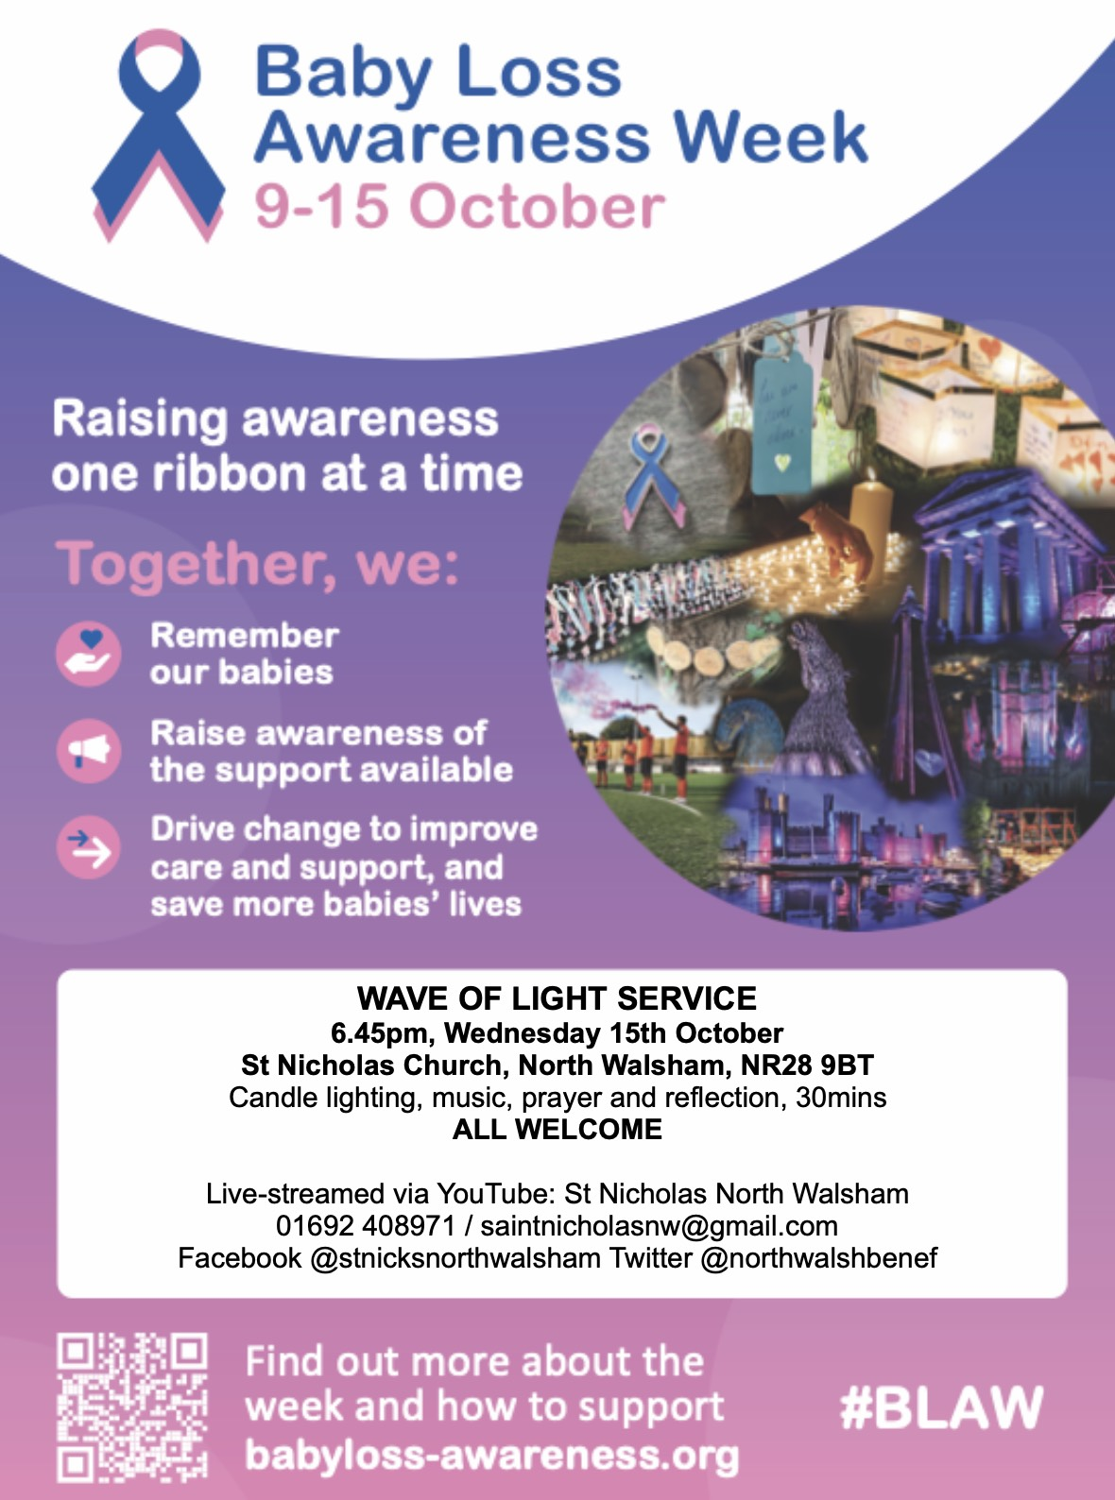
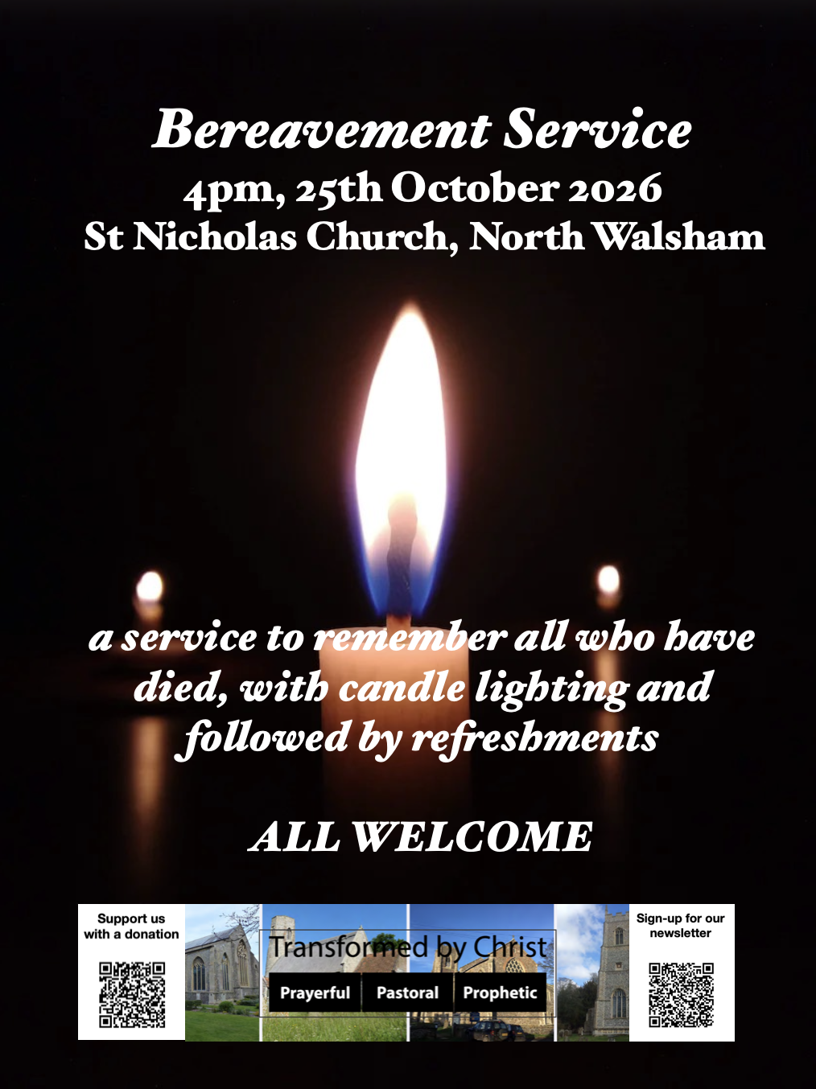
************************************************************************************

We are privileged to hold special
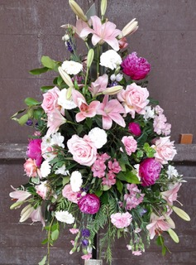
services at any of our churches
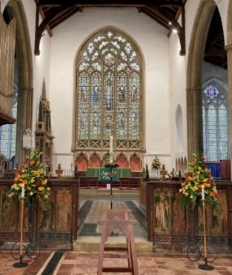
All who live in the benefice are entitled to a baptism, wedding or funeral service in church, and our clergy can officiate at the crematorium and cemeteries too. The church is here for you, through every moment of life.

From the Diary

Baptism
Theo Brown
Willow Hastie
Rosie Hubbard
Jack Hubbard

Burial of Ashes
Daphne Anderson

Funeral
Anna Croucher
Evelyn Havis

Please hold those above and their families in your prayers.

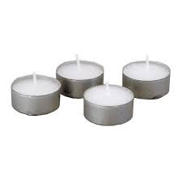
*************************************************************************************TThanks to all who’ve provided tealights for prayer stations at St Nicholas!
All donations of white, unscented tealights gratefully received!





We're pleased that our weekly coffee mornings at North Walsham and Worstead are now registered with Warm Welcome Spaces
North Walsham Market Day Coffee Morning
Thursdays 9.30 – 12.00noon
The space is open to all (and their well-behaved dogs on leads), every Thursday! A warm welcome and refreshments available

Thank you to everyone for raising donations for St. Nicholas Church, North Walsham with #easyfundraising! If you have not signed up yet, it is easy and completely FREE. 8,100 brands will donate to us when you use easy fundraising to do your everyday online shopping - at no extra cost to you! Every donation you raise makes a difference to us so please sign up & share today. https://join.easyfundraising.org.uk/stnicholaschurchnw/XT7MPH/at/TSX8RX7z/RTND2/facebook/
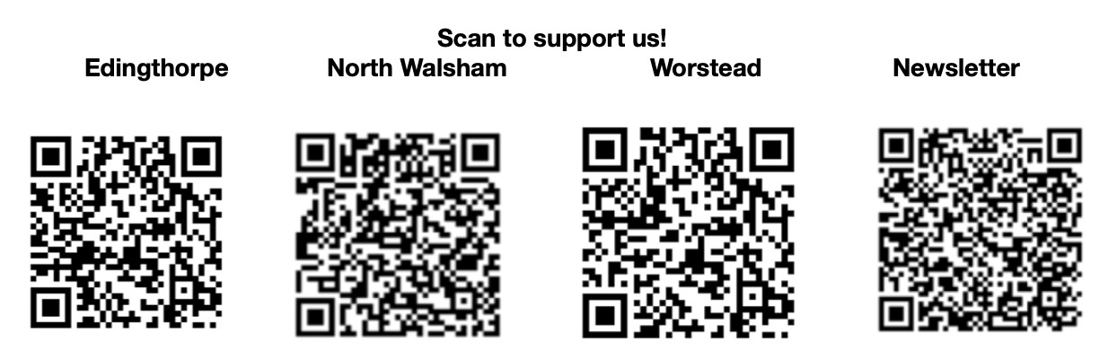


Please support the work of our Churches, by using the contactless giving point at St Nicholas or St Mary’s, leaving your gift on the offering plates or in the wall safes, or through these QR codes. Thank you.

Do you have a Business you would like to advertise in this magazine?
Whole, half or quarter page space is available.
Full Page £ 150.00
Half Page £ 75.00
Quarter Page £ 50.00
Please contact the Benefice office on 01692 408971
or email saintnicholasnw@gmail.com
for details and prices

Church Postcodes
Edingthorpe NR28 9TN, North Walsham NR28 9BT, Worstead NR28 9AL, Westwick NR10 5BW

Benefice dates

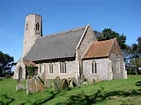
All Saints’ Edingthorpe
11th October. Holy Communion 9.15am
25th October. Morning Prayer 9.15am

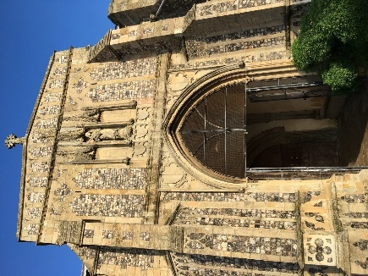
St. Mary’s, Worstead
Sunday, 4th October – Morning Prayer – 9.15 am
Sunday, 18th October – Holy Communion – 9.15 am
Sunday, 8th November – Service of Remembrance –
10.45 am

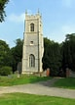
St Botolph’s Westwick

No service in October

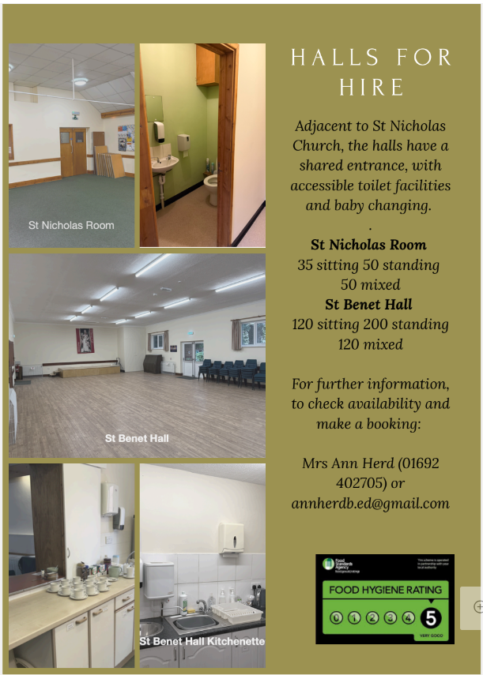

Ready to tick off your list – Will Made?
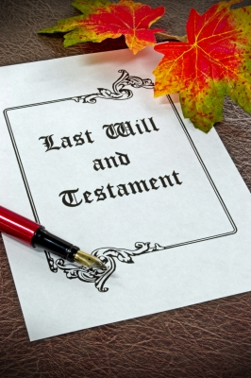
"The Church of England have teamed up with Farewills to provide a free will writing service: Online Will Writing Service | Legal Will In 15 Minutes . Anyone can use this service and it is not compulsory to leave something to your church, but it would be nice if you did. It is important for each one of us to leave our earthly matters in good order so why not take advantage of this opportunity now? It is good to remember a gift in your will to a charity is tax free. If you already have a will, you could consider leaving a legacy to the church by adding a codicil. https://farewill.com/norwich-diocese

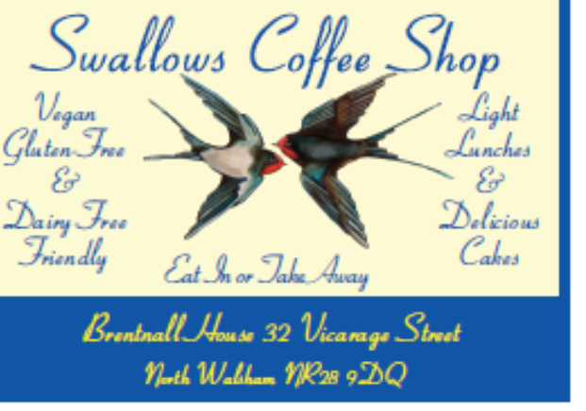

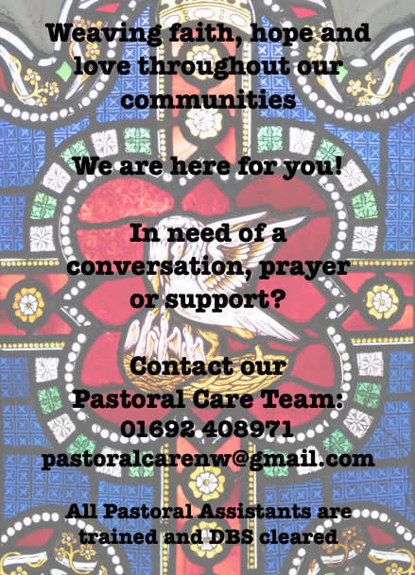

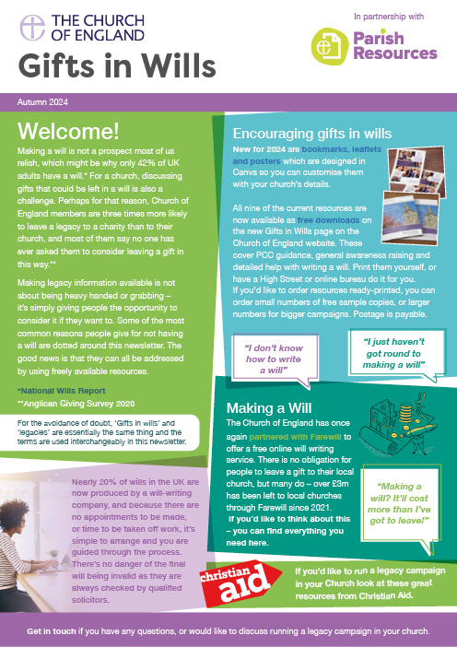
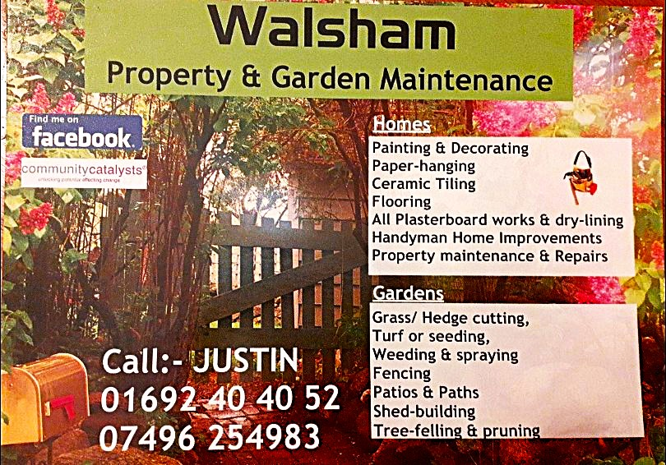

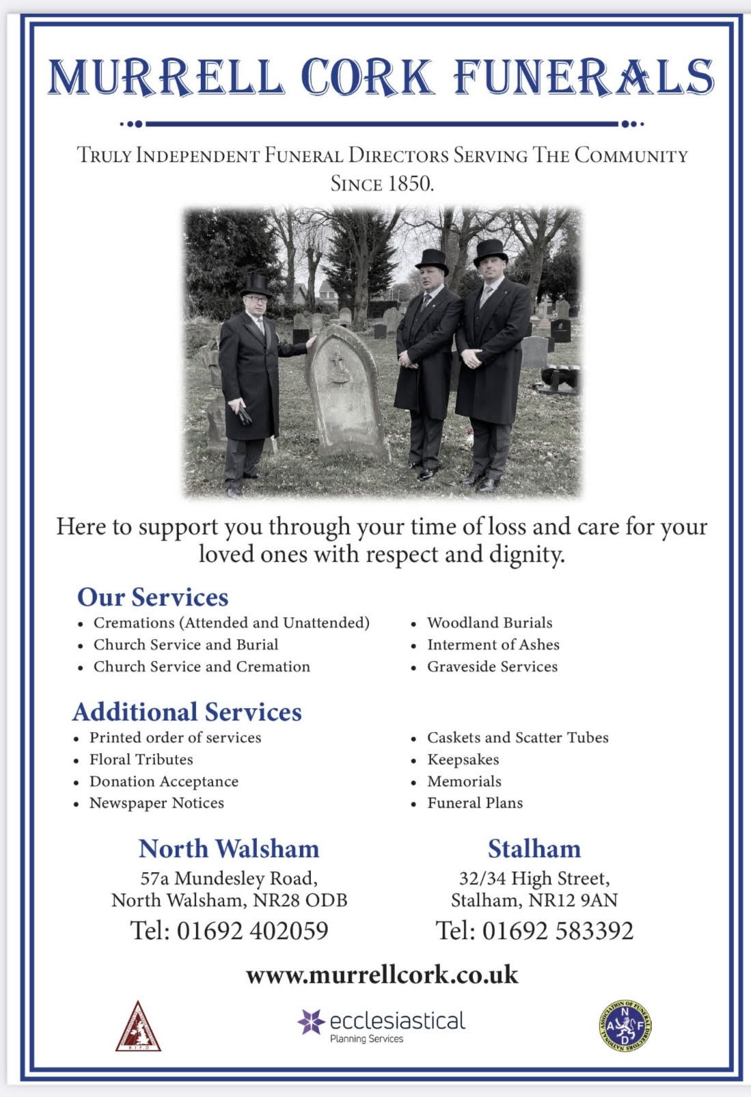
r Sale and Wants Page




Money Matters …
A regular report for our readers written by James Reginald Drake at ClearView Financial Consultants
Burgh Road, Aylsham - 01263 734859, Station Road, Hoveton - 01603 273590 and North Walsham 07773 626662

Lasting Powers of Attorney – Why are they so Important?
Lasting Powers of Attorney (LPA’s) are documents that give an individual you trust (your attorney) the legal authority to make decisions on your behalf should you either lose the mental capacity to make them, or you no longer wish to make these decisions yourself. Lasting Powers of Attorney come in 2 forms, these coming under the heading of ‘Property & Financial Affairs’ and ‘Health & Welfare’
So, how can they help?
The Property & Financial Affairs LPA covers things such as running your bank and savings accounts, making or selling investments, paying bills, buying or selling property and applying for benefits.
The Health & Welfare LPA covers things such as the type of health care and medical treatment you receive (including decisions on life sustaining treatment), where you live, as well as the type of care that you receive in areas such as diet and daily routine.
Given the wide range of areas that these documents cover, it becomes quite obvious as to why they are so important. However, according to ‘The Office of the Public Guardian’ via an article produced in 2022, less than 1% of the UK population have a Lasting Powers of Attorney in place.
So, why do so few people have them in place? One of the most commonly mentioned reasons is that people assume that their spouse will automatically have the right to make decisions for them should they ever reach the stage where they are unable to. This however is a common misconception and it is very often discovered far too late that they actually have no legal authority at all. Cost is another reason people put it off, I can assure you are costs for this type of work are minimal, in the hope this is not a reason to delay.
What should you do?
Well, the answer to this one is quite simple……. get on and set up both types of LPA as soon as you can. It is never too soon to set one up, but it certainly can be too late. By law, once your mental capacity has gone, so has your opportunity to appoint attorneys to act on your behalf. At this point your loved ones will be required to go down a different route and apply to the Court of Protection for a Deputyship order. This requires more forms, more cost and more time, which can all be easily avoided with a bit of forward planning.
So, if setting up Lasting Powers of Attorney(s) is something that you think would benefit you and your loved ones, please feel free to contact me and we can discuss how they can be put in place in a way that is best suited to your own personal requirements.
This short article in no way should be taken by readers as advice.
James can be contacted on either of the above landline numbers or via email at support@smithifa.co.uk
ClearView Financial Consultants is a trading name of Martin Smith Independent Financial Adviser Ltd, a company registered in England
under number 11439150 and authorised and regulated by the Financial Conduct Authority under number 944677.





