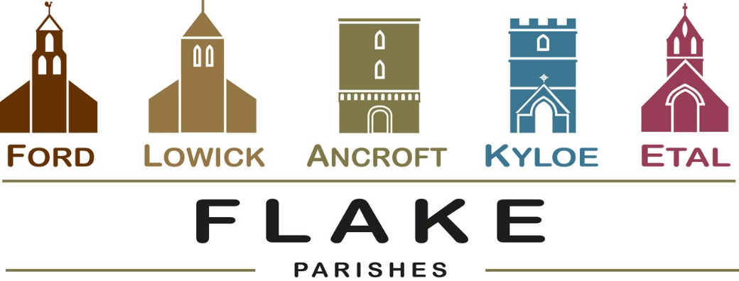
A very warm welcome to you, especially if you are visiting. Please take this sheet home with you and use it as a basis for prayer.

Sunday 13th September 2026
Lowick 9.15 Holy Communion
Ford 11am Holy Communion
Lowick Vicarage Garden 4pm Pet Blessing and tea

Sunday 20th September 2026
Lowick 9.15 Holy Communion
Ford 11am Holy Communion

Sunday 27th September 2026
Lowick 9.15 Harvest Thanksgiving
Ford 11am Harvest Thanksgiving

Sunday 4th October 2026
Lowick 9.15 Holy Communion
Ford 11am Holy Communion

Sunday 11th October 2026
Lowick 9.15 Holy Communion
Ford 11am Holy Communion



- Sunday 13th September Lowick Vicarage Garden
Pet Blessing 4pm with refreshments
(weather permitting)
Contact Alex for details 07935 732811

- Thursday 17th September Lowick PCC meeting, 7.30 at the Vicarage

- Friday 18th September Lowick Church Annie Robinson helps us to ‘Look through Lowick’s windows’
6pm -7.30pm Drinks, nibbles, donations

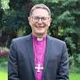
- Saturday 19th September 9am -1pm
Etal Village Hall Vision Morning 2 with Rt Revd Mark Wroe. Still come even if you haven’t signed up….

- Sunday 20th September
6pm Evensong Berwick Parish Church for installation of New Area Dean (4pm if you would like to sing in the choir)

- Tuesday 22nd September 1.30pm Ancroft PCC meeting


- Friday 25th September LVH Macmillan Coffee Morning 10-12

- Saturday 26thSeptember Harvest Supper with live music Lowick Village Hall 7pm. Free tickets from Lowick Shop


Tonight: Week 2 - Who is Jesus?
Lowick Village Hall
5pm for refreshments, 5.15 start

Bring your friends – and let’s explore together. A short video, open conversation, light refreshments. No pressure, no judgement. Come and see.

- Holy Island Arts Festival:
Saturday 26th September – Sunday 4th October.
Brochures available in Lowick shop.

October and November Events

- Wednesday 21st October 6.30pm A Musical Soiree at the Etal organ. Our organists Martin, Liz and Alison entertain. Drinks and nibbles. Donations in aid of Ford church loo.
- Thursday November 12th Quiz and Supper, Etal Village Hall, also in aid of the loo.
- Sunday 15th November 6pm Lowick Church
Come and sing Evensong

In our prayers

All who suffer in body, mind or spirit, especially Heather Piper, George Hall, Gail Calder, Don and Sam Quilty, Sue Pattinson, Brenda Cossar. We pray for those who mourn, and for all who mark anniversaries of death at this time of year: Leo Osborn, Mick Bennett and Bob Gallon.
Charlotte would value your prayers as she leads the Chelmsford Diocese ordination retreat, and for the 15 deacons who will be ordained in two services in Chelmsford Cathedral today.

Flake Parishes Contacts

Revd Charlotte Osborn (Vicar) 01289 388591 ceosborn@mail.com 07957 367457
Revd Alex Firman (Assistant Curate) 07935 732811 alex_firman@hotmail.co.uk

Our other licensed clergy
Revd Margaret Sentamu 077871 204745
Canon Nick Sagovsky
Revd Marion Penfold 01289 305664

Church Contacts
Ancroft Leigh Yorke 07716 116739
Etal Andrew Joicey 01890 820540
Ford Kathleen Holmes 07951 099668
Lowick John Dickson 07967 343211

Parish Administrator
Sheena Atkinson
admin@flakeparishes.org

Safeguarding Officer
Philip Greene
safeguarding@flakeparishes.org
07555 412284

