The Parishes of St Anne’s Greenland’s  and St Paul’s North Shore  Week Commencing: 27th September 2026 | 
Sunday 27th September 2026  St Anne's Eucharist Service at 9-30am Harvest Festival  St Paul's Eucharist Service 11.15am  Tuesday at St Paul's Ecumenical Prayer  meeting at 9-30am in the chapel  If you would like a peaceful start to your day please come along to  Morning Prayer at St Anne's  8.00am Sunday  followed by crumpets and time to talk  8.00am Tuesday — Friday for 20 minutes  If you would like a calming end to your day please come along to  Evening Prayer at St Paul's  4.00pm Tuesday — Friday for 20 minutes  and Sunday at 3.00pm  Mass at 6.00pm with Laying on of Hands Tuesday 29th September at St Anne’s  St Michael and All Angels  Followed by angel cake!  St Anne's Thursday Evening Eucharist Service at 6.00pm  St Anne’s Lunchtime Eucharist Service at 12noon every Friday  Sunday 4th October 2026  St Anne's Eucharist Service at 9-30am  St Paul's Eucharist Service 11.15am  Harvest Festival    Sunday and Wednesday at 6-30pm At St Paul’s church Phone Jim on 07955597771 jim@libertychurchblackpool.org.uk Liberty Church is a safe inclusive church that welcomes everyone who celebrates the diversity of LGBT+ |   Please pray for:  Avril and David; Terry Williams; Fr Michael Fish; Paul Heelam; Anne Russell; Louise Jones; David Lee Fletcher; Amanda Smith; Wendy Booth; Sue Heelam; lain Thompson Snr; Michael Eaton; Sue Simpson; Darren Marchant; Denise Murphy; Chris Waller; Marion Farrar; Margaret Crook; Stephen; Joanne; Glenn; Christine Elias; Richard Grimstead; Christine Wright; Michael; Samantha; Julie Haynes; Revd Linda Tomkinson; Baby Levi.  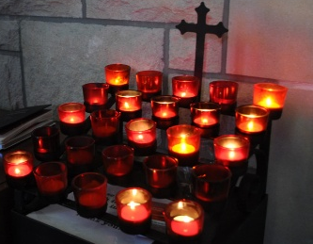  In Memorium:  Joe Bamforth; Edna Hardcastle;  Arthur Blundell; John Henry Shaw;  Kenneth Suthrun; Gloria Thompson;  Ada Alice Ridgway; Baby Paige Keeley Simpson.  In your prayers this week remember our parishes and the families in; In your prayers this week remember our parishes and the families in:  Collins Avenue, Corrib Road,  Devonshire Road East, Edmonton Place,  Derby Road, Moorhouse Street, Wilton Parade, Imperial Street, Dickson Road, Eaves Street, Richmond Road.

  Low Moor Community Centre  Coffee Morning every Monday from  10am–12noon  Everyone welcome    Come along and join in Pilates at St Anne’s Church  Monday, Tuesday & Thursday mornings.  For more information: Please phone Claire on 07599659154  St Paul’s Allsorts  Every first and third Wednesday after  Mid-week Communion.  Thursday at St Paul’s Drop In Café    9-30am to 12-00noon.  Bring a friend along for a warm welcome.  Thursday at St Paul’s  The uniformed groups are now meeting again after the summer break.  Uniformed organisations, from 6-00pm – 9-00pm. Please invite any young people who may want to join these groups to come along and meet our leaders |   Flowers  Money is required for the church flowers.  If you are able to donate for flowers please see Angela at St Paul’s or Ena at St Anne’s.  Sunday lunches at St Paul’s  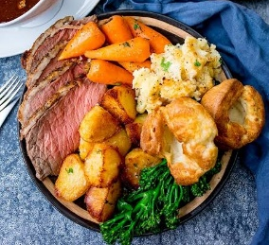  Join us after you have been to our morning service. (or before our evening service) There is no charge for this but donations are welcome.  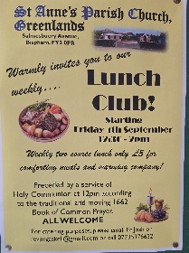  Lunch Club – every Friday at 12.30pm at St Anne’s following a short Eucharist service at 12.00noon. Cost £3 for 2 course lunch.  Harvest Festival at St Anne’s on  27th September  All donations will go to StreetLife again this year. Donations of tinned and dried food, toiletries, underwear, socks, gloves etc will be gratefully received. Thank you.  Coffee Morning at St Anne’s  Friday 2nd October  10.30am – 12noon. All welcome.  All proceeds in Aid of Trinity Hospice.

