Who to contact at St Helen’s Church:  - To sponsor floodlighting of the church at £5 per night please see the John Sparkhall. (PCC Treasurer)  - If you wish to have an inscription in the Memorial Book and your loved ones name to be read out in church, it is £25. Please see John Sparkhall. (PCC Treasurer)  - If you wish to donate to the Heritage of Sefton Church, details are as follows: Sefton Church.  RBS Account Number 10047948. Sort Code. 16-24-06  - For wedding and graveyard information contact Jane Cave  jane_k_cave@yahoo.co.uk  - For Choir: Andy Freeman – 0151 292 1763  - For website enquiries/events = Angela Rushton  07977344169 rushtonangela@hotmail.com  For information regarding opening times, events and services etc please see our www.achurchnearyou.com website. |  |  | 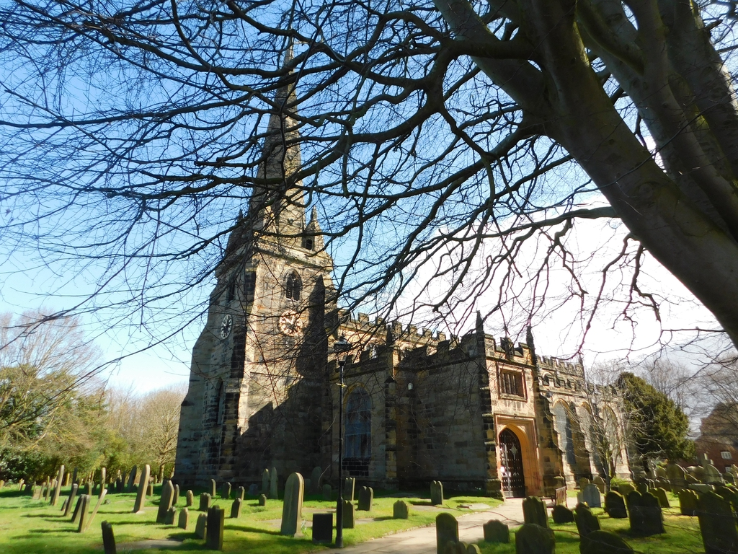  Sefton Parish Church Newsletter  JUNE 2026  Church Services at 11am unless noted:  7th Confirmation Service with Holy Communion at 10.30am  with Bishop Ruth. Refreshments after the service.  13th Café Church at 10.45am.  14^{th.} Blessing of the Animals Service  21st Holy Communion  21st Archdeacon Visitation at the Cathedral at 3pm (see pg 2)  28th Baptism. Refreshments after the service.  Church Floodlighting in June:  2nd Emily’s Birthday  8th In memory of my friend Nita  13th Ruth’s Birthday  17th Keith’s Birthday  From our Church Register:  Burial of Ashes:  21/5/26 Eileen Edington  Weddings:  2/5/26 Oliver Knight and Adrienne Molyneux
Clergy Contact Details
Associate Vicar:
Rev Jackie Parry: 07803468870 rev.jackie@nschurches.uk
Ministry Team:
Rev Penny Leeman (Retired Priest)
Mr Ray Glenn and Mrs Polly Glenn (Readers)
Churchwardens Contact Details
Mrs Jane Cave: 07426 880690 jane_k_cave@yahoo.co.uk
Mr Darren Charnock: 07518 738364 darren.seftonchurch@gmail.com

Events and News from Sefton
Sunday 7th June at 10.30am.  We are delighted that Bishop Ruth will be presiding at our Confirmation and Holy Communion service. We have 2 candidates being presented Elin and Andrea.    “A Cuppa and a Chat”  Please come and join us at Sefton Meadows Coffee Shop “Rosies” on the 10th June from 10.15 – 12pm. All are welcome.    Sunday.14th June at 11am - Blessing of the Animals Service. A special focus for this service is a public expression of the bond we have with all animals. Each animal will be blessed, by name, and we hope you take this opportunity to bring your animal companions to church for this special blessing. We do ask that all animals are secure, either on a lead or in a cage/carrier!! Please encourage friends to attend.  Archdeacons Visitation on Sunday 21st June at 3pm.  Every year, the Archdeacons hold Visitation services across the diocese in order to formally admit all elected churchwardens as office holders of the diocesan bishop. At the Visitation services the archdeacons welcome, encourage and prepare the churchwardens for the coming year. This year the primary occasion for admission takes place at Liverpool Cathedral presided by Bishop Ruth. We warmly encourage sidespeople, friends and family to come along to support our two new churchwardens, Jane and Darren. |  |  | MADUkes Concert on Friday 26th June at 7.30pm.  Please see the fliers and A4 posters at the back of church and please distribute any that you can. Tickets are now on sale from Ange until 19th June. They are selling fast but please encourage friends and family to attend. The price £8 includes a beefburger form the BBQ during the interval. Please bring your own drinks. There will be a raffle on the night.  Advance Notice for Saturday 7th August 2027!!  I am currently organising a Parish Trip to the National Memorial Arboretum in Staffordshire. This will be open to friends and family. We will need a minimum of 35 people to make it a viable trip. A brief outline for the day (tbc):  07.30 Leave church by coach! Comfort stop on the way.  09.45 Arrive at NMA  10:45 Daily Act of Remembrance  11:00 Talk on The Arboretum, Past, Present and Future  11:30 Land Train Trip – 50min recorded commentary  13:00 Two Course Hot Lunch with Tea and Coffee in the Founders’ Room. Choice of meat, fish or vegetarian dish of the day followed by a hot pudding or cake, tea or coffee. Table service is included.  15:00 Free time to explore the Arboretum, the exhibitions and gift shop.  16.00 Depart for Home.  Total package cost will be confirmed shortly and due to the coach cost I will take deposits in February and then if you wish extra instalments throughout the year until June.

