
SPIRE & LIGHT United Churches
United Benefice of St Keverne, St Ruan with St Grade & St.Wynwallow (The Lizard)

*If you do not wish to receive these notices, please let your Churchwarden know*

6th September 2026

Readings

Ezekiel 33:7-11
Psalm 119:33-40
Romans 13:8-end
Matthew 18:15-20

9.30am – Holy Communion - St.Peter’s, Coverack
9.30am – Holy Communion (BCP) - St.Wynwallow, The Lizard
11am – Morning Prayer (BCP) - St.Keverne
11.15am – Morning Prayer – St.Ruan, Ruan Minor

Next week – Sept.13th
9.30am – Morning Prayer - St.Peter’s, Coverack
9.30am – Holy Communion - St.Ruan, Ruan Minor
11am – Holy Communion - St.Keverne
11.15am – Café Church – St.Wynwallow, The Lizard
6pm – Evensong – St.Grade


St Keverne & St Peter's Coverack Harvest supper celebrations Friday 25th September
Service in Church 7pm followed by Harvest Supper in Hall 8pm.
Tickets £5.
Available in advance from Kathy Ough tel: 01326281079


The Prayer Spot

The Diocese of Truro’s Prayer Diary for this week

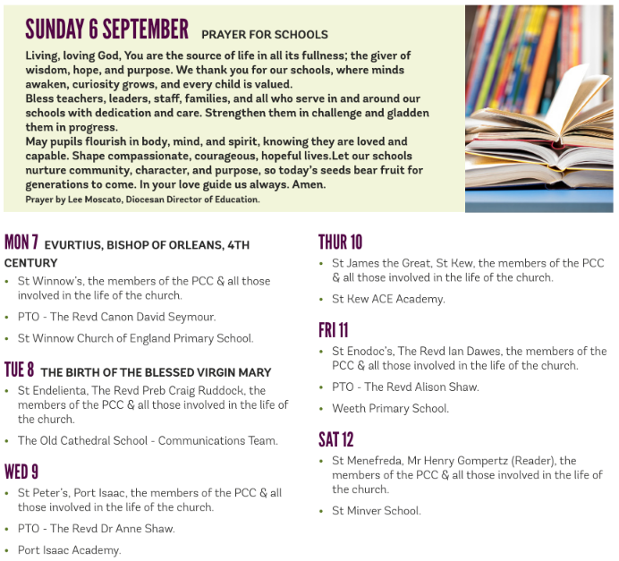

We pray for the Deanery that we belong to and we thank you for the faithful people you have brought together here. Remind us that we have each been brought to faith by Our Saviour Jesus Christ.
Lord Jesus, we thank you for your presence in our lives and the love you give us to share with others. Keep us strong in our faith and close to you.
Help us to be always there for others in their time of need, you have given us each gifts to use to reach out to others and to give comfort to those around us.
Heavenly Father we live in a world slowly destroying itself, through greed, hatred, and with no concern for others. Remind us that we can bring love, care and understanding into the world, by reaching out into our communities and showing your love to all we meet. Loving God, be with us always. Remind us that we are brothers and sisters in Christ Jesus, that God is ever present in our lives, through his wonderful Holy Spirit that he has given to you as a free gift to us all.
Mighty God, everything you do reveals your Majesty. Open our eyes to see what you are doing in our lives. Let us marvel at your good gifts and your wise provision. Your acts are amazing Lord. We cannot comprehend the number of blessings you pour out to us from day to day. As we gather today around your name, we pray that you will fill our hearts, our minds and our souls. Transform us Lord and make us more like you. Through Jesus Christ our Lord. Amen
God bless you all. Samuel Buchanan

On the Way Prayers

As Summer gives way to Autumn, we give thanks for the changing seasons, the rhythm of life and the richness of experience that it brings. As we enter Creation Season in our churches let us give thanks for all that this very hot summer has taught us about how we must care for this world. We give thanks for the rain that is already turning our brown, crispy lawns and fields to a lovely fresh green. And suddenly the cliffs have burst into flower, displaying the mystery and wonder of your creation. We give thanks for the things that have happening in our churches over the summer, the visitors we have and still welcome and the things that we still have coming up.

Let us pray for our farmers who have had such a tricky time. As we turn our thoughts to things like harvest festivals let us find new ways of reaching out to those who provide our food, particularly our local farmers and fisher folk. Farming can be such a lonely vocation; so let us particularly pray now for those farming families that we know in our local communities.

As our children go back to school, we pray that all our schools are places of hospitality, where all feel welcome and cared for. We particularly pray for all those starting school for the first time, those starting new schools or colleges and those young people moving away for university. As Susie seeks to strengthen our relationship with schools we pray for her work, that more people will come forward to help her from across the Deanery. We give thanks for the Out of the Box training that a few of us recently did, so that we can help her with schools and Wild Church work. We pray too for Heidi as she begins a couple of weeks holiday – may she and Phil find peace, fun and real rest.

As our government gets back to business let us pray for Andy Burnham and for his message, which should also be our message, of hope. We pray for all in authority, that they may be constantly guided by Christian principles, whatever their belief. As our county councillors return to business let us also pray for them, that they too will be focussed on looking after the most vulnerable in Cornwall and caring for our county. And again, may we do all we can to help them in this task.

As Stewart Shaw and his wife Heather prepare to move to our Deanery, let us pray for them, for their life they are leaving behind, for their new life here in our midst, and for us, that we may be welcoming, warm and helpful as they settle in. We pray for our DIT which meets regularly and for the Deanery Synod Standing Committee which meets ahead of Deanery Synod meetings. Lord be with us all as we seek to grow your kingdom in this place

And now let’s pray for anything that we want to bring before you Lord.

The Lord bless us and keep us; the Lord make his face shine upon us and be gracious to us; the Lord turn his face toward us and give us peace. Amen

