St James the Great  Wrightington with Heskin  www.stjamesthegreat.net  Facebook https://www.facebook.com/share/1P2dybXWY/ |  | 92 Church Lane  Wrightington  WN6 9SP  Phone 07976179206  maree@nwss.co.uk
13th September The Fifteenth Sunday after Trinity
Mission Weekend
09.00am Holy Communion - David Gaskell
10.30am Holy Communion - Alex Baker
5.00pm No 30@5

MISSION WEEKEND – Sunday 13th is the final day of our Mission Weekend and following the 10.30am service there will be a Jacobs Join lunch in the hall, all welcome. During the afternoon there will be lots of activities for all ages, both in the hall, on the field (weather permitting) and in Church. A really Fun Afternoon for everyone. The Stained Glass Window Competition will be judged and winners announced. Cathy has worked really hard to make this weekend a success, please give her your support.

Harvest Sunday is approaching, if you provide items to decorate the windows in Church, please bring them either on Friday 2nd October or Saturday 3rd – thank you. Help will be needed to set up the hall for Harvest Lunch on Sunday 4th October – see Anne or Sue Wild and please sign up for a food item for the Harvest Lunch.
*+*+*+*+*+*+*+*+*

Wed 16th Sept 10.30am Play & Praise Toddler Group

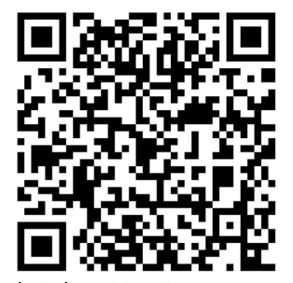
20th September The Sixteenth Sunday after Trinity
09.00am Holy Communion - Pat Belshaw
10.30am Holy Communion - Mike Hatton
12.00 36 Club Draw
5.00pm 30@5 Returns

