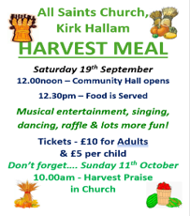
Psalm 114
Please stand, if able, and join in with the verses in bold italics

When Israel came out of Egypt,
Jacob from a people of foreign tongue,
Judah became God’s sanctuary,
Israel his dominion.

The sea looked and fled,
the Jordan turned back;
the mountains leaped like rams,
the hills like lambs.

Why was it, sea, that you fled?
Why, Jordan, did you turn back?
Why, mountains, did you leap like rams,
you hills, like lambs?

Tremble, earth, at the presence of the Lord,
at the presence of the God of Jacob,
who turned the rock into a pool,
the hard rock into springs of water.

Glory be to the Father and to the Son and to the Holy Spirit,
as it was in the beginning, is now and ever shall be,
world without end. Amen
Harvest Meal
Donations for the raffle are welcomed, please leave on the table at the back of church.

In our weekly prayers for our parish
This week we pray for God’s blessing on Keswick Close, Ladywood Road and Limetree Rise.

All Saints Church
Distribution of Communion –currently the Priest will dip the communion wafer in the wine while we discern a safe way to bring the common cup back into worship, as we want everyone to feel included and safe. We also have gluten free wafers available.

Do you want this to carry on, or would you rather have the chalice? We will be asking everyone what they would like and take it to the PCC meeting in September.
Refreshments After the Morning Service
Please stay seated after the service and a hot drink will be brought to you in the pews. Do not get up and head to the back of church, it is becoming a hazard, and a risk as trays of hot drinks could be knocked over.
Church contact information
Contact: Rev’d Christine - revchristine@outlook.com
The Rectory, The Village, West Hallam, DE7 6GR
Landline 0115 646 1497
Rev’d Ailsa -revailsahunt@gmail.com
Tel - 07356064856

Churchwardens – Mrs Janet Wheeldon, -Tel: 0115 8771593
Mrs Linda Gregory – linda.gregory3@icloud.com
https://www.achurchnearyou.com/church/13402/
https://www.facebook.com/allsaintskirkhallam
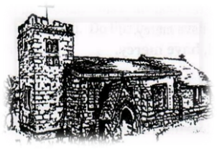
Kirk Hallam
Disabled Toilet in Friendship House.
Disabled Toilet in Friendship House.

Working with God to transform lives & communities.
Please can you ensure your mobile is on silence, or off during the service, it is affecting people with hearing aids and the loop system.

13th September – Fifteenth Sunday After Trinity
10.00am Iona Communion Service with Rev’d Christine
6.00pm Iona Evening Prayer with Eileen and Julie

Forthcoming Events
Tues 15th 6.30pm Home Group in Friendship House
Weds 16th 9.30am Morning Prayer at UCAS
Fri 18th 6.00pm Choir in Friendship House
Fri 18th 7.00pm Volunteers to help set up at Hall
Sat 18th 10.00am Prayer Meeting in Friendship House
Sat 18th 12noon Harvest Meal at Hall
Sat 18th 2.00pm Baptism of Gillie Sampler

20th September – Sixteenth Sunday After Trinity
10.00am CW Communion Service with Rev’d Christine
2.00pm Baptism of Henry Robinson by Rev’d Christine
6.00pm BCP Holy Communion with Rev’d Christine
It’s Good to Talk! If you spot that someone is missing, please pop a news sheet through their door, & if you’ve time, call for a chat - just to check they’re OK & to let them know that they are not forgotten!

‘Every word of God proves true; he is a shield to those who take refuge in him’ Proverbs 30:5

