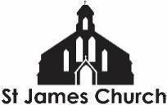
What’s On at St. James Church and in our local community from 24th September 2026 onwards

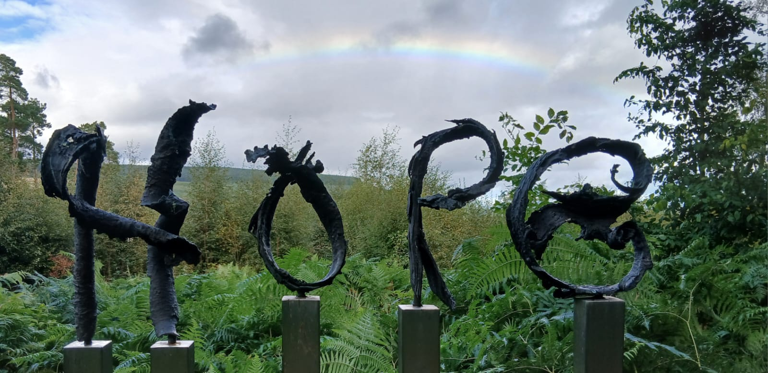
I hope you and your loved ones are doing well this week. Here is “What’s On” at St. James Church and some highlights from within our community this week.
The picture of HOPE and the Rainbow was taken whilst visiting the Corbenic Camphill Community poetry and sculpture trail in Scotland.

Thursday 24th September
6 - 7.30pm Youth Group

Friday 25th September
YOU are invited to come and sing at St. James and Gloucester Cathedral! On Friday 25th September and Friday 2nd October from 7.15 -8.45pm we will be learning a new pieces of music to be sung at the Cathedral, alongside professional singers, on Wednesday 7th October at 7pm. You do NOT NEED TO BE A 'SINGER' to attend... the more voices the better. It will be lovely to sing with you.

Saturday 26th September
10 - 11.30am St James Family and Friends working morning - come and help keep the church and grounds look beautiful. Whatever your skills, we can find a job for you! Making tea, pulling up weeds, fixing IT systems, polishing brass etc.
12noon Baptisms - Come along to welcome Michaela, Sidonia, Amaris, and Amias as they get baptised and join the church family.

Sunday 27th September
9am Taize Holy Communion Service - We have developed our 9am Holy Communion so it now includes several well known chants from the Taize community in France. This service is on EVERY Sunday of the month. All are welcome before…
10am Coffee and conversation in the church. A chance to meet and spend time with one another before or after worship
11am Holy Communion Service - This week we celebrate Nigerian independence and all things Nigerian! Come and sing songs, listen to testimonies, and worship God in a way that will transport you to the “Giant of Africa”! There is Godly Play for our Primary School children and soft play areas for pre-schoolers. All are welcome.

Monday 28th September
Monday to Friday at 8.30am and 6pm: Morning and Evening Prayer on ZOOM

Tuesday 29th September
10.30-11.30am Coffee and Chat - At the Friendship Cafe

Wednesday 30th September
9.15-10.45am English Corner - English language conversation class
6.30 - 7.30pm Youth Choir - Young people between 10 and 16 are invited to come and learn a range of new songs for Autumn, in a fun and friendly choir. Free.

Thursday 1st October
6 - 7.30pm Youth Group

More Community What’s On
The Fair Shares Allotments, Upton Street, are open on Monday, Wednesday and Thursday from 10am - 4pm - You can pick up some freshly picked vegetables, help to look after the crops, and find activities for children. As well as a cup of tea and a sit down! Everyone is welcome to go along.
St James City Farm - Do pop along and say hello to the animals on any day of the week, especially “Nature Craft and Play” on Thursdays 10.30am - 12noon.
Bartongate Children and Family Centre - 1.30 - 3pm Stay and Play session every Wednesday

In other news…
We are looking to employ a youth worker for our Friday evening youth group. If you know of anyone who might be interested in this then please ask them to contact me.
In addition, we are looking for someone to help with our pre-school children on a Sunday morning. If you know of anyone who might like to serve in this way then please let me or Fola know.
We are planning a Global garden - 4 raised beds growing food from Jamaica, Nigeria, Sri Lanka, and the UK. Would you be interested in being a part of this - helping to plan, plant, and nurture one of the beds? Speak to me or Chioma for more information.

Further ahead
Wednesday 7th October 7.30pm
Come and hear the wonderful “Everything Slips” by Verity Standen at Glocuster Cathedral AND the new pieces of music that will be performed by all the singers that have come along on Friday 25th And 2nd October. Click here for tickets (pay what you can)

Saturday 10th October 7pm
St James, with St Pauls and St Stephens, HARVEST SUPPER. This promises to be a wonderful evening of food and music. There is no cost to attend but, if able, do bring some food to share. There will be some food provided by our Nigerian families so come and taste the finest Jollof rice anywhere in the UK.

As always, if you would like me to pray for, or have a conversation about anything then do get in touch. I am available to listen and share in whatever might be arising for you at this time.

God Bless, Rev Steve 07503164309

