Acrise Church News : September 2026
Services
Sunday 30th August Benefice Eucharist at Denton 10.00am (Sharon & Carol)
Sunday 6th September Benefice Eucharist at Elham 10.am Carol
Sunday 13th September Matins BCP Acrise 9.30am Bill
Sunday 20th September Morning Prayer CW Acrise 9.30am Janet
Sunday 27th September Harvest Family Service Acrise 9.30am
(Family Service Team)


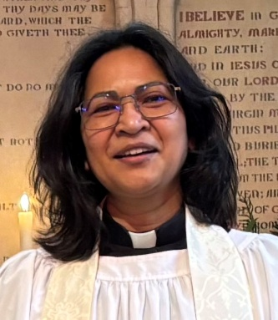
The Rector’s wonderings…

I wonder what image of God you hold…..?
All of us have our own particular image of God, and that image will have been affected by so many things - our parents, our church, authority figures in our lives, our coming to faith, our experiences.
Sometimes, that image can be deep down, and be very different from our expressed beliefs. So, for example, we can believe and even preach that God is loving, is in fact Love itself, and offers unconditional love, and yet we can still feel that we need to do things to earn God’s love.
We think there are the right prayers, right actions, right thoughts that will earn us God’s love. Somewhere in the recesses of our minds and hearts,
there is a battle between our images of God – a God who is all loving but is also a taskmaster we have to please.
Jesus demonstrated with everything in him, the deep love of God. A love that reaches out - accepts and draws in, rather than excluding. Everything he did and said reflects the heart of God - a God who is always searching for the lost and confused.
Julian of Norwich recognised this in her visions: “I saw to us he is everything that is good. He is our clothing. In his love he wraps us and holds us. He enfolds us for love and will never let us go.…. everything owes its existence to the love of God”
I invite you to reflect first of all on your own image of God.
And then, to measure it up against the words of Jesus - “if you have seen me you have seen the Father.”
Blessing
May the peace of God reign in this place, and the love of God forever hold you. May the Spirit of God flow through your life, and the joy of God uphold you. Amen
Revd Carol Bates
Rector
We wish Carol well as she leaves our benefice to join the Church Wigan Team this autumn to serve as Team and Hub Leader of the parish of Wigan North West.

The Acrise Festival on August 1^{st 2026}
As usual the Festival illustrated what can be achieved when everyone works together as a team to create a welcoming and friendly atmosphere. Last year we had a record attendance and this year was well attended with the extended car park very busy from 10.00am until 1.00pm. After several months of hot and dry weather we had quite a heavy rain shower in the early afternoon which probably deterred some people from coming. However, the festival was still a great success.
Many thanks to all our visitors and to all who helped and supported this community event. There was a great display of flowers in the church many of which were grown locally. As well as a programme of musical entertainment a new addition was a dance presentation from the local Mel Academy of Performing Arts which was much appreciated. There were the usual refreshments, stalls, games, and pony rides, tombola and raffle. However you helped, whether with preparations, donations, helping on the day, clearing up or just attending, we are grateful for your contribution.
The amount of money raised, after expenses, was £5,300, a little up on last year. What is most important is the social aspect of the event, meeting old friends and acquaintances and meeting and welcoming new people.
Thank you once again and we hope to see you in 2027 when the Festival will be on Saturday 7th August.
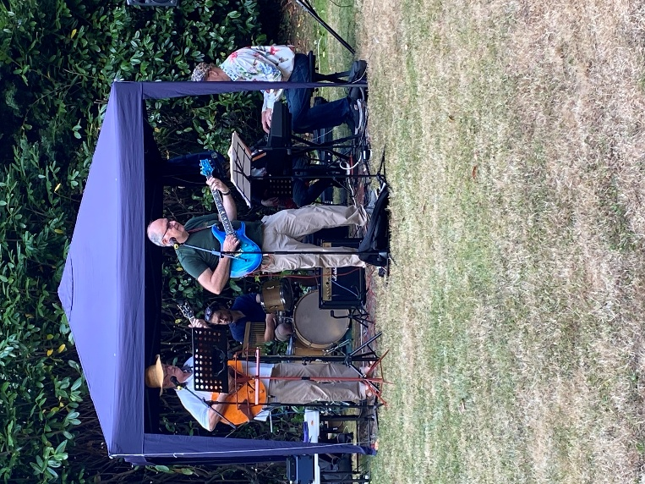
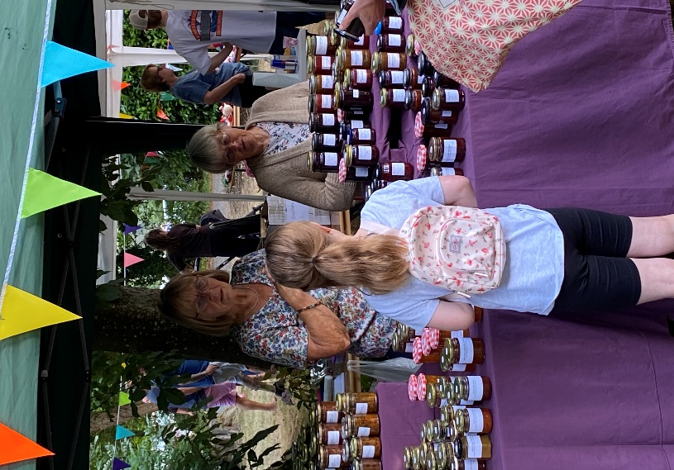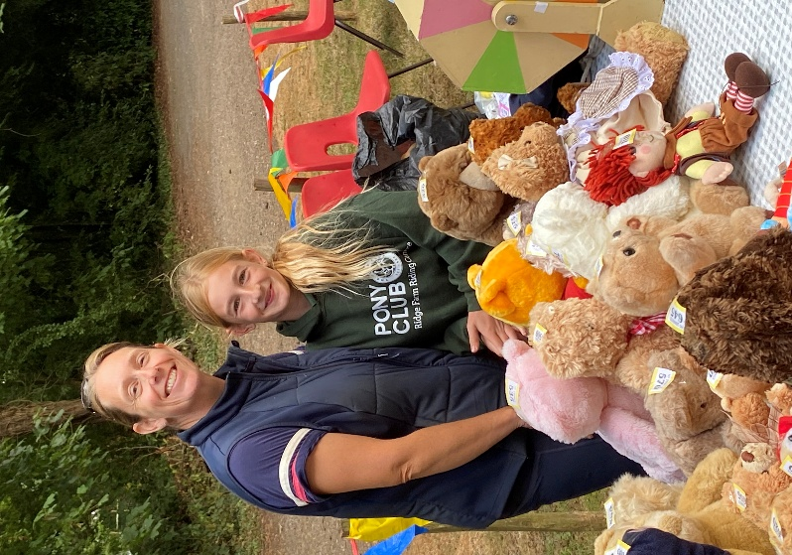

Ride and Stride for Kent Churches: Saturday 12th September
10.00am until 6.00pm. We hope to have volunteers to welcome any visitors to the church. We already have 12am - 2pm covered. If anyone else can help from 2pm – 4.pm or later please let Sue or Mike know.
We would be grateful for any sponsors for Sue and Mike or Richard and Simon. Half the money we raise comes back to our church funds.
Thank you.
Family Harvest Service: Sunday 27th September at 9.30am
It has been a difficult year for farmers, growers and gardeners because of the excessive heat and lack of rain so the topic of global warming and its effects will be recognised in our service, along with the usual prayers, readings, hymns, activities, and refreshments.
As has become customary, we would suggest that the children might like to bring donations to our local foodbank. At the beginning of September we will be sending out a letter about the service to families.
We look forward to welcoming all who are able to attend.
Harvest Festival Service will be on Sunday 4th October at 9.30am
We are not sure whether this will be Holy Communion or Morning Prayer, but it will have a harvest theme. It will also be another opportunity to donate to our local foodbank.
Shepway Foodbank: Folkestone Rainbow Centre.
The most needed items are: coffee, white cooking sauce, tinned veggie meals, long life juice/milk, tinned fruit/meat, sugar.
Also washing capsules, shampoo and conditioner, men’s deodorant.

Acrise Heritage Pond Project (Led by Stephen Scoffham)
Archaeological Talk
This talk about the archaeology of the ponds will be on Wednesday 16th September , 7.30pm at the Peggy Pike Room in Elham Village Hall.

Sargeant Drew Memorial Orchard
We have an invitation to visit the Memorial Orchard in the walled garden behind the Landmarc Yard in Acrise. This will need to be on a Friday between 10.00am and 2.00pm. Stepen is thinking of arranging this on 1st of October. I will confirm this in the next Acrise News.
Sergeant Drew was killed on 29th July 1944 when his aircraft crashed into the garden of Orchard Lea next to the woodyard. We also have also had the offer of a talk about Sargeant Drew, probably in the autumn.

Here is the report from the August 2022 Acrise News about the Dedication Service held for Sargeant Drew on 29th July 2022.

Service of Dedication for the Flight Sergeant Drew Memorial Orchard, Acrise
This took place on Friday 29th July 2022 in the walled garden which used to be part of Acrise Place and is located behind the MOD Acrise Estate, the base for Landmarc which manages the land of the MOD Cinque Ports region.
On July 29th 1944 Flight Sergeant Drew’s Tempest aircraft crashed into the garden of Orchard Lea cottage and he sadly lost his life. The dedication of the orchard, which has recently been planted with Kentish apple and cobnut trees, was in memory not just of Flight Sergeant Drew but of other pilots and personnel killed in combatting the V1 and V2 flying bombs. In fact, flight Sergeant Drew had destroyed two of these bombs on that day.
The service was attended by personnel from the Army and the RAF, Landmarc staff, descendants of Flight Sergeant Drew, and local people, mainly from St Martin’s Church.
Major Rick Bevan explained why the dedication was taking place. He is very supportive of the activities of St Martin’s Church, and we hope to develop links with the MOD concerning the use of Memorial Orchard, which is really a hidden treasure of Acrise.
Many thanks to Rev Deb who led the service which was a very moving and meaningful occasion. There was a delicious spread of food available afterwards, as well as the opportunity to make useful contacts with the military staff there.
