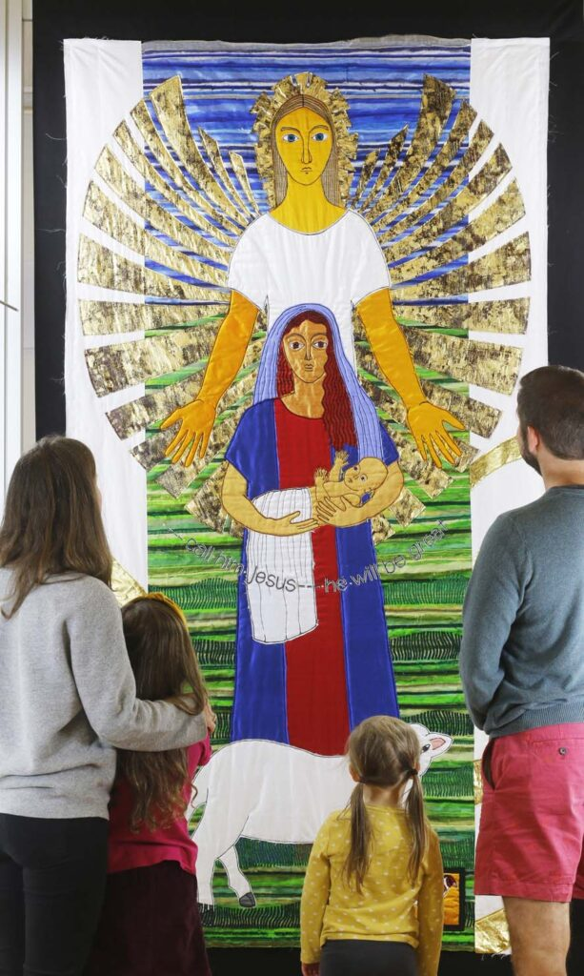
Threads through the Cross Tapestry

Holy Trinity Church Newsletter September 2026
Sunday and Wednesday Services are available to watch live or recorded on Facebook via the Holy Trinity Facebook page.

Events
Parish Trip to Southwark Cathedral: Saturday 26th September 2026
On Saturday 26th September Revd Rachel is leading a Parish Trip to visit Southwark Cathedral, which will include the chance to take in the ‘Cross’ section of the very beautiful ‘Threads through the Bible’ exhibition by tapestry artist Jacqui Parkinson (Threads through the Bible | Jacqui Parkinson Textile Artist_. There will be free time to explore the cathedral and have some time in London, before finishing the day back at the cathedral for Choral Evensong (tbc) at 4pm. Here are some key details for the day:
Timings (to be confirmed nearer the time):
0915: Meet at Bishop’s Stortford station to buy tickets to London Bridge to board the train at 0937
~1100: Arrive Southwark cathedral and visit the exhibition
~1300: Free time to find lunch and explore Southwark/South Bank etc
1600: Choral Evensong (hopefully, tbc nearer the time)
~1645: Gather after evensong and return to London Bridge to get train home
~1815: Arrive Bishop’s Stortford
Cost: There is no charge to visit Southwark Cathedral or the tapestry exhibition, however if you are able, please donate at the visitor points. If you have a Senior Railcard or a Network Railcard the return train ticket is likely to be less than £20. If you don’t have a railcard, please pair up with someone with a Network Railcard to benefit from this reduced price.
Booking: So that Revd Rachel can let the cathedral know the size of our group, and to enable Revd Rachel to let you know of any updates to the plans, please book here via Eventbrite: https://www.eventbrite.com/e/holy-trinity-day-trip-to-southwark-cathedral-tickets-1992767981677?aff=oddtdtcreator. If you can’t access the internet, please speak to Revd Rachel and she will add you to the list.
Notices
The next PCC meeting will be on 13th September with Archdeacon Janet presiding.
Prayer Ministry after the service will take place on 6th September instead of the 13th September and there will not be any refreshments after the service that on 13th
September.

27th September Archdeacon Janet is presiding at the 10.00 service to license Revd. Rachel Moate as Associate Minister of our Parish. Please keep Revd. Rachel in your prayers.

The Harvest service will take place on 4th October at 10.00am and the Pet Blessing Service led by Rev. Tim Weeks will take place at 2.30pm. on the same day to celebrate Gods Creation. Bring your pets in carriers or on leads please. All are welcome.

24th October Annual Quiz with Fish or Chicken Chip supper and Raffle. Invite your friends and family for an entertaining and informative evening.
Bring your own glasses and drinks.
£13.00 doors open at 7pm for 7.30 start. For tickets see John Wrentmore or email
JWrentmore@mullucks.co.uk

A new venture Open Church, lunchtimes on Wednesday after the service. The church will be Open for visitors from 11.30 -13.30 with two people serving refreshments and cake with music for visitors to look around, relax, chat, pray, play board games or eat lunch. Open on 9th,16th,30th September. Everyone is welcome. Feel free to come along.

Services in September

6th September 14th Sunday after Trinity 10.00-11a.m. Holy Communion with Hymns
Readings: Ezekiel 33: 7-11, Romans 13: 8-end, Matthew 18: 15-20
Prayer Ministry after the service at the main alter.
Stay and chat self-service refreshments after the service, please make your own drink and wash up your cup. Thank you.

9th September 10.00-10.45 a.m. Wednesday Holy Communion.
Open Church 11.30-13.30 with refreshments.
11th September 09.15 -09.45 a.m. Friday Morning Prayer.

13th September 15th Sunday after Trinity 10.00-11a.m. Holy Communion with Hymns
Readings: Genesis 50: 15-21, Romans 14: 1-12, Matthew 18: 21-35
Archdeacon Janet presiding. PCC meeting after the service with Archdeacon Janet as chairperson.

16th September 10.00-10.45 a.m. Wednesday Holy Communion.
Open Church 11.30-13.30 with refreshments.

18th September 09.15 -09.45 a.m. Friday Morning Prayer.

20th September 16th Sunday after Trinity 10.00-11a.m. Holy Communion with Hymns
Readings: Jonah 3: 10 – 4: end, Philippians 1: 21-end, Matthew 20: 1-16
Pastoral Meeting after the service.
Stay and chat self-service refreshments after the service, please make your own drink and wash up your cup. Thank you.

23rd September 10.00-10.45 a.m. Wednesday Holy Communion.
25th September 09.15 -09.45 a.m. Friday Morning Prayer.

27th September 17th Sunday after Trinity 10.00-11a.m. Holy Communion with Hymns
Readings: Ezekiel 18: 1-4, 25-end, Philippians 2: 1-13, Matthew 21: 23-32
Archdeacon Janet presides at the 10.00 service to license Revd. Rachel Moate as Associate Minister of our Parish. Stay and chat Refreshments are served after the service.

30th September 10.00-10.45 a.m. Wednesday Holy Communion.
Open Church 11.30-13.30 with refreshments.

Donations.
If you would like to donate to the church there is a donation box and card reader by the main door, also a basket is handed round during the offertory hymn, or you can make a direct debit offering monthly by contacting Jocelyn Churchwarden. Yellow Gift Aid envelopes are available in the back of the chairs if you are a taxpayer. If you use direct debit for giving, tokens are available to put in the offertory basket to be blessed at the altar.

Contact. If you would like to arrange a wedding, baptism, funeral or speak to a member of the ministry team, add someone to the intercessions prayer list or departed prayer list, have Home Communion or home visit, pray with someone or hire the church, please contact the church office at jgchurchwardenhtbs@outlook.com or call 01279 651671.

