Elham Valley Group Newsletter 13th September 2026
“Spreading the Gospel of Jesus Christ to all”
This week’s services : 15th Sunday after Trinity
8am – Said Holy Communion – St Mary & St Ethelburga, Lyminge
9.30am – Morning Service – St Mary the Virgin, Elham
9.30am – Matins – St Martin, Acrise
9.30am – Worship Service – All Saints, Stanford
9.30am – Eucharist – St Mary & St Radegund, Postling
11.15am – Wootton Worship – St Martin, Wootton
6pm – Evensong - St Mary & St Ethelburga, Lyminge
Tuesday 15th September – 8.30am – Morning Prayer – Elham
The Readings for 13th September
Genesis 50:15-21 ~ Psalm 103:1-13 ~ Romans 14:1-12 ~ Matthew 18:21-35
Almighty God,
whose only Son has opened for us
a new and living way into your presence:
give us pure hearts and steadfast wills
to worship you in spirit and in truth;
through Jesus Christ your Son our Lord,
who is alive and reigns with you,
in the unity of the Holy Spirit,
one God, now and for ever.
Amen.
(Prayer from the Church of England)
Please Pray for the Spencer family, Leah Laughland, Joseph, Mark, Val Pinder, Roger Goody, Jenni Lister, Wendy Cook, Millie Collins, Jill Fitch, Poppy Allard, Michael Kirk, Claire Laker.
Please contact the Benefice Administrator Alison Dale 07985025381 or beneficeadmin@elhamvalleygroupofchurches.co.uk to add people to the prayers.
Please pray for the departed, Marion Spencer, and those for whom an anniversary of death falls at this time, Doris Eames, James White, John Friend, Pamela Brown, Joan Adamson, Tinu Allard, Denis Osborne & David Giddy.
For Baptisms and Weddings please contact the Benefice Administrator as above.
To arrange for Funerals, Ashes Interments, Thanksgivings, Blessings, Renewal of Vows, and all other services please contact Revd Sharon Paine - 07503 290552 or email sharonpaine10@aol.com
NOTICES
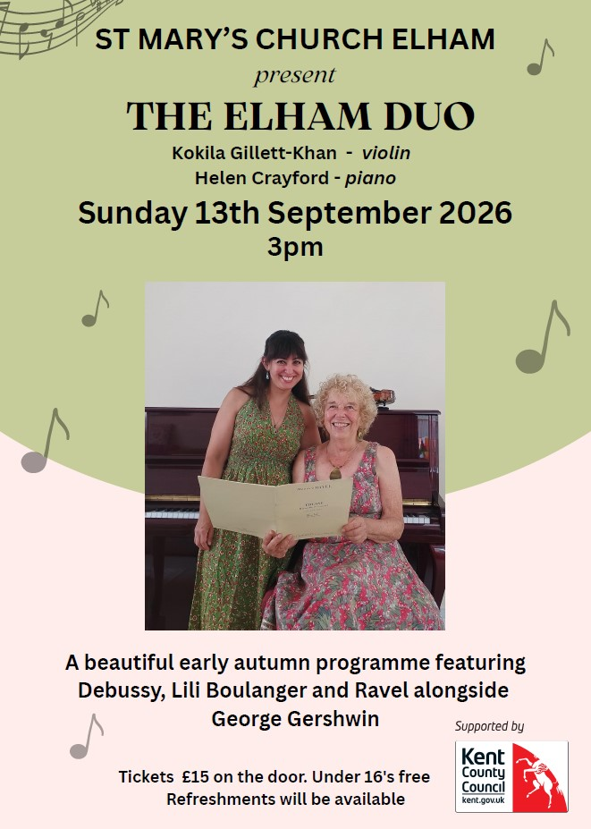

Benefice Prayer Meeting
For the last several months a few of us have met at Lyminge church at 9am on the 4th Thursday of each month. We pray for our benefice churches, the village communities, and any particular need we are aware of, both local and wider. It would be lovely to have representatives from other churches to join us in upholding these needs in prayer. Do feel free to join us. The next meeting is on the 24th September. If you have any questions, or prayer requests, do contact me on sharonpaine10@aol.com or 07503 290552. Rev. Sharon

Meeting with Archdeacon Darren – to discuss the vacancy in the Benefice. Thursday 24th September 7pm at Lyminge Church. Would PCC members please let their church warden know if they will be attending, for catering purposes. Churchwardens, please advise Alison Dale of the numbers.

Harvest Festivals
27th Sept. – Joint service at Elham Methodist Church -9.30am; Family Harvest Service at Acrise – 9.30am; Joint service at Lyminge Methodist Church – 11am

For church enquiries please contact the following people :
ACRISE - Simon Smith simon1210@outlook.com
DENTON & WOOTTON - Lesley Alexander lesley.j.alexander@icloud.com or Allyn Thomas allyndgthomas@aol.com
ELHAM - Deborah Bamforth dbdbamforth0@gmail.com or Lynda Vincent lyndaV46@gmail.com
LYMINGE with PADDLESWORTH - Mike Chinneck mike.chinneck@gmail.com or Lyle Arnold sunshowers33@yahoo.com
POSTLING - Peter Le Feuvre plefandsem@doctors.org.uk or Andrew Ferguson fergusons@mail.com
STANFORD - Christine Oliver christineaoliver@btinternet.com or Kathryn Druery kdruery@hotmail.co.uk

