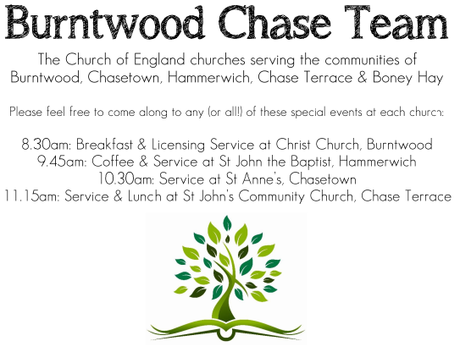
CHRIST CHURCH, BURNTWOOD
Registered Charity Nos: 1217129

SERVICE ON SUNDAY 23RD AUGUST 2026 AT 10AM

MORNING WORSHIP

The 12th Sunday after Trinity

First Bible Reading – Isaiah 51: 1-6

Listen to me, you who pursue righteousness, you who seek the Lord.
Look to the rock from which you were hewn and to the quarry from which you were dug.
² Look to Abraham your father and to Sarah, who bore you, for he was but one when I called him, but I blessed him and made him many.
³ For the Lord will comfort Zion; he will comfort all her waste places and will make her wilderness like Eden, her desert like the garden of the Lord; joy and gladness will be found in her, thanksgiving and the voice of song.
⁴ Listen to me, my people, and give heed to me, my nation, for a teaching will go out from me and my justice for a light to the peoples.
⁵ I will bring near my deliverance swiftly; my salvation has gone out, and my arms will rule the peoples; the coastlands wait for me, and for my arm they hope.
⁶ Lift up your eyes to the heavens and look at the earth beneath,
for the heavens will vanish like smoke, the earth will wear out like a garment, and those who live on it will die like gnats,
but my salvation will be forever, and my deliverance will never be ended.

Gospel Reading – Matthew 16: 13-20

¹³ Now when Jesus came into the district of Caesarea Philippi, he asked his disciples, “Who do people say that the Son of Man is?” ¹⁴ And they said, “Some say John the Baptist but others Elijah and still others Jeremiah or one of the prophets.” ¹⁵ He said to them, “But who do you say that I am?” ¹⁶ Simon Peter answered, “You are the Messiah, the Son of the living God.” ¹⁷ And Jesus answered him, “Blessed are you, Simon son of Jonah! For flesh and blood has not revealed this to you but my Father in heaven. ¹⁸ And I tell you, you are Peter, and on this rock I will build my church, and the gates of Hades will not prevail against it. ¹⁹ I will give you the keys of the kingdom of heaven, and whatever you bind on earth will be bound in heaven, and whatever you loose on earth will be loosed in heaven.” ²⁰ Then he sternly ordered the disciples not to tell anyone that he was the Messiah.

Collect for Today

Almighty and everlasting God, you are always more ready to hear than we to pray and to give more than either we desire or deserve: pour down upon us the abundance of your mercy, forgiving us those things of which our conscience is afraid and giving us those good things which we are not worthy to ask but through the merits and mediation of Jesus Christ your Son our Lord, who is alive and reigns with us, in the unity of the Holy Spirit, one God, now and for ever.

Amen

Forthcoming Services in Church

Wednesday 26th August Morning Prayer 9.30am

Sunday 30th August Holy Communion 10am

Wednesday 2nd September Morning Prayer 9.30am

Sunday 6th September Holy Communion 10am

Future Event For Your Diary
Saturday 14th November Christmas Fayre 2-4pm

Food bank

We are continuing to support this important ministry for people in need in our local community, for which the following items are always needed: ‘Long Life Milk, Custard, Rice Pudding, Cereals. Many thanks for your support. The Food Bank is very grateful for whatever you may be able to donate.

Floodlighting
If you would like to commemorate a special occasion by floodlighting our Church, please contact Chris Brown on 01543 683862 for details.

Prayer Chain

Christ Church is blessed with a very active prayer chain. If you, or anyone you know, feel that they would like others to pray for them, please speak to Chris Brown on 01543 683862.

Home Visits and Communion

For anyone who is unable to attend church and would like a Home Visit and Communion, please contact the Vicar and he will be able to carry this out.

Vicar’s Contact Details

Rev’d Stephen Morgan - Telephone: 07305 852152

Church Wardens Contact Details

Judith Rogers - Telephone: 01543 324718
Mike Holmes - Telephone: 01543 672970

Church Office Telephone: 01543 642187 [Please leave a message and we will respond in due course]

Church Web Site:www.christchurchburntwood.org.uk
Church Email: christchurchburntwood15@gmail.com
Facebook: www.facebook.com/group/christchurchburntwood/

Next Sunday’s Service – The 13th Sunday after Trinity

Sunday 30th August – Holy Communion at 10am
Bible Readings: Jeremiah 15: 15-21 and Matthew 16: 21-28

