Palm 105: 1 – 6, 16-22, 45b
Please stand, if able, and join in with the verses in bold italics

O give thanks to the Lord, call on his name,
make known his deeds among the peoples.
Sing to him, sing praises to him;
tell of all his wonderful works.
Glory in his holy name;
let the hearts of those who seek the Lord rejoice.
Seek the Lord and his strength;
seek his presence continually.
Remember the wonderful works he has done,
his miracles, and the judgements he has uttered,
O offspring of his servant Abraham,
children of Jacob, his chosen ones.

When he summoned famine against the land,
and broke every staff of bread,
he had sent a man ahead of them,
Joseph, who was sold as a slave.
His feet were hurt with fetters,
his neck was put in a collar of iron;
until what he had said came to pass,
the word of the Lord kept testing him.
The king sent and released him;
the ruler of the peoples set him free.
He made him lord of his house,
and ruler of all his possessions,
to instruct his officials at his pleasure,
and to teach his elders wisdom.

that they might keep his statutes and observe his laws.
Praise the Lord!

Glory be to the Father and to the Son and to the Holy Spirit,
as it was in the beginning, is now and ever shall be,
world without end. Amen
Summer Fayre – Thank You
Thank you to everyone who helped at our Summer fayre, although quitter than usual, it was still a lovely opportunity to sit and chat, while raising funds too. The exact total raised to be announced in church.
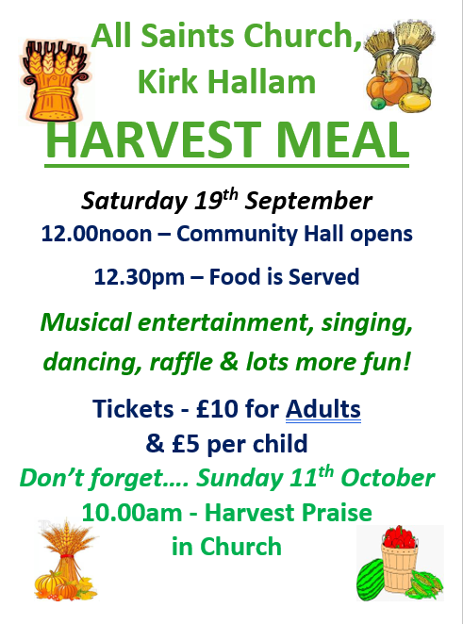

In our weekly prayers for our parish
This week we pray for God’s blessing on Eliot Drive, Earlham Close and Festival Road

All Saints Church
Distribution of Communion –currently the Priest will dip the communion wafer in the wine while we discern a safe way to bring the common cup back into worship, as we want everyone to feel included and safe. We also have gluten free wafers available.

Do you want this to carry on, or would you rather have the chalice? We will be asking everyone what they would like and take it to the PCC meeting in September.
Refreshments After the Morning Service
Please stay seated after the service and a hot drink will be brought to you in the pews. Do not get up and head to the back of church, it is becoming a hazard, and a risk as trays of hot drinks could be knocked over.
Church contact information
Contact: Rev’d Christine - revchristine@outlook.com
The Rectory, The Village, West Hallam, DE7 6GR
Landline 0115 646 1497
Rev’d Ailsa -revailsahunt@gmail.com
Tel - 07356064856

Churchwardens – Mrs Janet Wheeldon, -Tel: 0115 8771593
Mrs Linda Gregory – linda.gregory3@icloud.com
https://www.achurchnearyou.com/church/13402/
https://www.facebook.com/allsaintskirkhallam
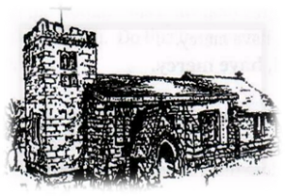
Kirk Hallam
Disabled Toilet in Friendship House.
Disabled Toilet in Friendship House.

Working with God to transform lives & communities.
Please can you ensure your mobile is on silence, or off during the service, it is affecting people with hearing aids and the loop system.

9th August – Tenth Sunday After Trinity
& Mary Sumner Day (Founder of the Mothers’ Union)
10.00am Iona Communion Service with Rev’d Christine
6.00pm Iona Evening Prayer with Eileen & Julie

Forthcoming Events
Tues 11th 10.00am Interring ashes of John Peet
Tues 11th 6.30pm Home Group in Friendship House
Weds 12th 9.30am Morning Prayer at UCAS
Fri 14th 6.00pm Choir in Friendship House
Sat 15th 10.00am Prayer Meeting in Friendship House

16th August – Eleventh Sunday After Trinity
10.00am CW Communion Service with Rev’d Ailsa
1.00pm Wedding Rehearsal in church
6.00pm BCP Holy Communion with Rev’d Christine

It’s Good to Talk! If you spot that someone is missing, please pop a news sheet through their door, & if you’ve time, call for a chat - just to check they’re OK & to let them know that they are not forgotten!
Little Words of Wisdom
Thank God for dirty dishes – at least you have food.

