
SJN Newsletter July 2026

- Churchyard tidy-ups
Continue on Wednesday mornings during the school holidays 10am to 12pm. All welcome.
- Little Haven Play Cafe
Continue Wednesday afternoons during the school holidays to 2nd September 1.30pm-3pm, FREE
- Eco-church
There will be a quick meeting after the service on Sunday 9th August to look at the initial survey and set further dates for all those interested in being involved.
- Rainbows
Our new Rainbows group will be starting in church on Tuesday 8th September from 5.30pm to 6.30pm for girls aged 4 - 7 years old. Hopefully you will be able to sign up via the Girlguiding website on the flyer, however there has been an issue setting the unit up so the option is not yet available but the tech team is working on it!
- Big Plant Giveaway (27th Sept, 4th Oct)
At the start of the university term, we are going to be opening the Church and welcoming new students with a free pot plant for their new accommodation. Please make a note of the dates for your diary if you want to help welcome on those Sunday afternoons. Also please be collecting/ growing pot plants that would be suitable to give away.

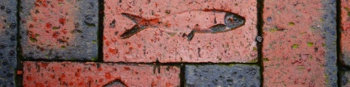

Heart4Hull
- Local Pilgrimage
Walk the King Charles III Coast Path taking in the Churches of Skeffling, Easington, and Holmpton, walking by the sea and the Humber. Approximately 8 miles in total but shorter lengths available if you wish.
To register your interest and stay in the loop for further details please contact pwwest@pwwest.karoo.co.uk . All are very welcome to join in!

