St John the Evangelist Church, Trent Vale
Newsletter Summer 2026

It is mid-July and we have come through heatwaves and the football World Cup, which proved to be both dramatic and educational.
Steve held a sweepstake, in which I drew Curaçao. We had to Google to find out where it was and discovered it is a Dutch island in the Caribbean.
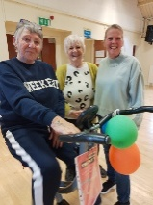
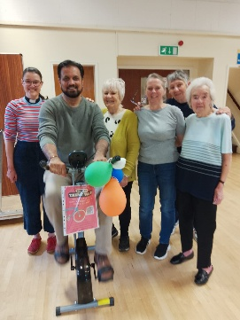
There has also been lots of action in Trent Vale as Revd Liz organised a sponsored exercise bike ride to raise funds for the restoration of the church south window which had been hidden behind the organ, unseen for many years. Liz, members of the church, the craft club and Cllr Waseem all peddled hard to cover the 241 miles, the distance to Canterbury. Approximately £1000 was raised so well done everyone, especially when a cushion was needed to cover the broken saddle!
Following the success of the Lent Course, Revd Liz and Revd Terry Bloor ran a 6-week ‘Pilgrim Course’ held on a Wed and Thu. These were well attended and we look forward to further courses in the future.
Revd Terry will be retiring in August, and we wish him a long and happy retirement.
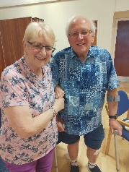
On Sunday 24th May we celebrated Pentecost with a Benefice service at St John’s. We were able to engage in various prayer stations in a service led by Revd Liz. It was good to have Lay Reader Mike Whittaker joining us after his recent knee surgery.
Josie Ankers joined us on Trinity, also after undergoing knee surgery.
The theme was a wonderful world. The song played during the service was a favourite of former Church Warden Betty Podmore….’What a Wonderful World’.
And it was good to have Jean Preston back; she with three generations of her family were missed from their usual front-row seats.
It was wonderful to have visits from Revd Mike and wife Revd Fran. Fran was looking so well, her recovery a true miracle.
Revd Liz is taking many services in the Benefice and we have had visits from Revd Alan Betts and Alex Wolvers.
On 21st June Revd Liz led the Father’s Day service and Sam gave moving prayers. The music included favourites ‘In Christ Alone’ and the beautiful ‘The Power of your Love’.
The following Sunday we went to Penkhull Church, arriving in a surprise shower of rain. Revd Liz led the service which included a presentation to Lay Reader Alan Smith on his retirement after over thirty years’ service. Church Warden Stephen Conroy also gave a message of appreciation for his long service and thanked all who had made that day’s service possible.
In attendance was Pastor Marcus from the Redeemed Church in Stoke that Alan and Josie Mountford also attend.
On Friday 5th June a group of us attended a service at Carmountside Crematorium led by Revd Liz for a dear friend Geoffrey Taylor. There were moving words from his family, and we later went to the Haven in Stoke for refreshments and the opportunity to add our messages to a Book of Memories.
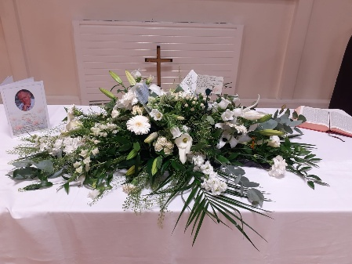
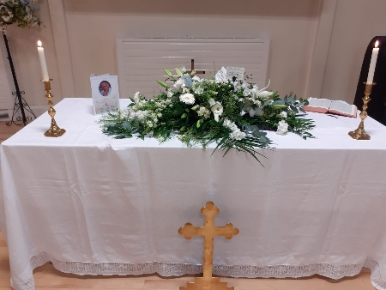
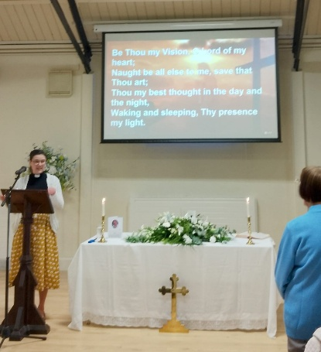
Wai, his wife, asked that the large white flower arrangement be given to the church. This was placed on the altar for the Sunday morning service where we were pleased to have Penkhull Village Brass providing the music.
The following day the arrangement was dismantled and made into eight posies and given to Geoff’s friends who all commented on the beautiful fragrance. A thoughtful gesture that was much appreciated.
The church and centre gardens are looking lovely in spite of the heat. A large group of delicate pale-pink poppies are growing on the corner of Woodland Road opposite the church and huge clumps of wheat are growing by the Black Lion bus stop, a reminder of Trent Vale’s rural character.
Congratulations to the creators of the Children’s Society Garden that won a Gold at Chelsea. It is now time for us to take our boxes to church for Sam to collect for the Society.
On a sweltering hot Saturday 11th July, we headed to PVB’s ‘Picnic on the Green’ at their beautiful headquarters at the former Trent Vale Bowling Club. Planters were overflowing with petunias, seats beneath the trees gave welcome shade. Stalls circled the green including our own Benefice gazebo with our leaflets and a display of crafts donated by John and Janet Capewell to be sold to raise money for our Church Funds.
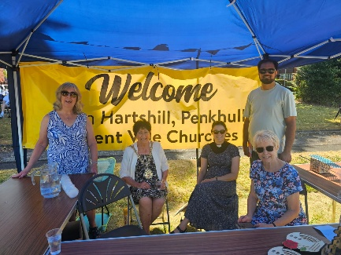
Cllr Joan Bell, the Lord Mayor of Stoke-on-Trent, took some of her valuable time to sit and chat with Revd Liz and those in the gazebo…and gave her a chance to take off her heels in the heat! We were also graced with the presence of Cllr Waseem who is very supportive of St John’s.
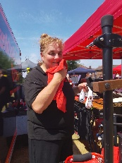
The younger members of the band opened the music along with the Beginners and the Juniors, some of whom are in our Congregation, playing first followed by the Band. We applauded both their playing and resilience in the heat.
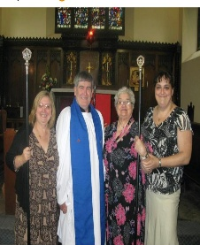
The band are incredibly busy having performed at Portmeirion in North Wales, the Victoria Hall with Foden’s Band, a brass band from Sandbach, and in Longton Park on Veterans Day.

John Capewell is celebrating forty-five years as a Lay Minister, beginning in Trent Vale and since 2012 in the Diocese of Leeds.

Work is progressing on the church building. The glass is being prepared by Pendle for the huge East window above the altar, to be completed at the end of September. The stonework is now completed.
Work is underway on the new Upper Room, kitchen and toilets. The path to the old entrance is being replaced.
Meetings are still being held and we are grateful for those who have worked tirelessly over the last four years to bring this complicated and long project to its brave conclusion.
Staunch church member Steve Copner has been off ill for a few weeks, and it was wonderful to see him back in church last Sunday. We wish him a speedy and complete recovery.
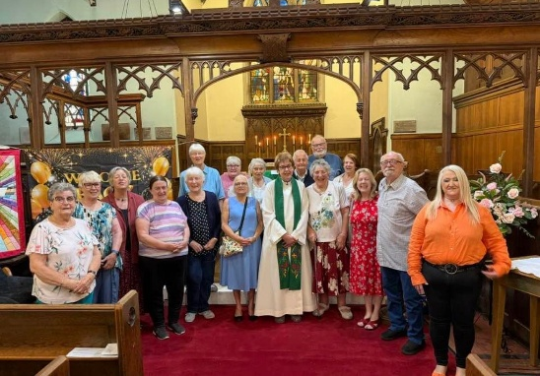
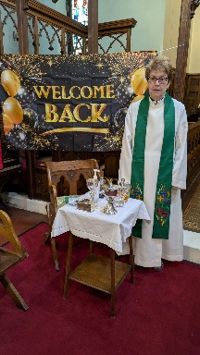
We were thrilled to see Revd Fran back at Penkhull Church last Thursday. It was good to see her after a long, drawn-out illness as she administered the Holy Communion. Fran was welcomed ‘home’ by a grateful congregation, and we look forward to seeing her in due course at all three churches as she continues her phased return. Welcome back Fran.
We have much to look forward to and Jackie is already collecting the Christmas Theatre ticket for ‘Uncle Eric’s’ show.
Before then we send you our love from St John’s hoping you enjoy the rest of the Summer.
Bobbie and all your friends at St John’s.



(Summer Newsletter 29 July 2026)

