The Parish of Elstree & Borehamwood
All Saints * Holy Cross * St Michael and All Angels * St Nicholas
https://www.achurchnearyou.com/benefice/32-091BJ

Sunday, August 30th
TRINITY 13
Welcome to Church – Today’s Services:

9.15am | St Nicholas | Holy Communion | Revd Steven Young
9.30am | Holy Cross | Service of the Word | Anne Smith LLW
9.30am | St Michael’s | Holy Communion | Revd Louise Collins
11.15am | All Saints | Holy Communion | Revd Steven Young
2.45pm | St Michael’s | Confirmation Class | Revd Louise Collins
PRAYER FOR THE DAY
Almighty God,
you search us and know us:
may we rely on you in strength
and rest on you in weakness
now and in all our days;
through Jesus Christ our Lord.
Amen.

PRAYER AFTER COMMUNION
God our creator,
you feed your children with the true manna,
the living bread from heaven: let this holy food sustain us through our earthly pilgrimage until we come to that place where hunger and thirst are no more;
through Jesus Christ our Lord.
Amen.

TODAY’S READINGS

Exodus 3.1-15
Moses was keeping the flock of his father-in-law Jethro, the priest of Midian; he led his flock beyond the wilderness, and came to Horeb, the mountain of God. ²There the angel of the Lord appeared to him in a flame of fire out of a bush; he looked, and the bush was blazing, yet it was not consumed. ³Then Moses said, “I must turn aside and look at this great sight, and see why the bush is not burned up.” ⁴When the Lord saw that he had turned aside to see, God called to him out of the bush, “Moses, Moses!” And he said, “Here I am.” ⁵Then he said, “Come no closer! Remove the sandals from your feet, for the place on which you are standing is holy ground.” ⁶He said further, “I am the God of your father, the God of Abraham, the God of Isaac, and the God of Jacob.” And Moses hid his face, for he was afraid to look at God.⁷Then the Lord said, “I have observed the misery of my people who are in Egypt; I have heard their cry on account of their taskmasters. Indeed, I know their sufferings, ⁸and I have come down to deliver them from the Egyptians, and to bring them up out of that land to a good and broad land, a land flowing with milk and honey, to the country of the Canaanites, the Hittites, the Amorites, the Perizzites, the Hivites, and the Jebusites. ⁹The cry of the Israelites has now come to me; I have also seen how the Egyptians oppress them. ¹⁰So come, I will send you to Pharaoh to bring my people, the Israelites, out of Egypt.”¹¹But Moses said to God, “Who am I that I should go to Pharaoh, and bring the Israelites out of Egypt?” ¹²He said, “I will be with you; and this shall be the sign for you that it is I who sent you: when you have brought the people out of Egypt, you shall worship God on this mountain.” ¹³But Moses said to God, “If I come to the Israelites and say to them, ‘The God of your ancestors has sent me to you,’ and they ask me, ‘What is his name?’ what shall I say to them?” ¹⁴God said to Moses, “I AM WHO I AM.” He said further, “Thus you shall say to the Israelites, ‘I AM has sent me to you.’” ¹⁵God also said to Moses, “Thus you shall say to the Israelites, ‘The Lord, the God of your ancestors, the God of Abraham, the God of Isaac, and the God of Jacob, has sent me to you’: This is my name forever, and this my title for all generations.
Psalm 105.1-7, 45b
O give thanks to the Lord, call on his name, make known his deeds among the peoples.
Sing to him, sing praises to him; tell of all his wonderful works.

Glory in his holy name; let the hearts of those who seek the Lord rejoice.
Seek the Lord and his strength; seek his presence continually.

Remember the wonderful works he has done, his miracles, and the judgments he uttered,
O offspring of his servant Abraham, children of Jacob, his chosen ones.

He is the Lord our God; his judgments are in all the earth,
Praise the LORD.

Romans 12.9-end

Let love be genuine; hate what is evil, hold fast to what is good; ¹⁰love one another with mutual affection; outdo one another in showing honour. ¹¹Do not lag in zeal, be ardent in spirit, serve the Lord. ¹²Rejoice in hope, be patient in suffering, persevere in prayer. ¹³Contribute to the needs of the saints; extend hospitality to strangers. ¹⁴Bless those who persecute you; bless and do not curse them. ¹⁵Rejoice with those who rejoice, weep with those who weep. ¹⁶Live in harmony with one another; do not be haughty, but associate with the lowly; do not claim to be wiser than you are. ¹⁷Do not repay anyone evil for evil, but take thought for what is noble in the sight of all. ¹⁸If it is possible, so far as it depends on you, live peaceably with all. ¹⁹Beloved, never avenge yourselves, but leave room for the wrath of God; for it is written, “Vengeance is mine, I will repay, says the Lord.” ²⁰No, “if your enemies are hungry, feed them; if they are thirsty, give them something to drink; for by doing this you will heap burning coals on their heads.” ²¹Do not be overcome by evil, but overcome evil with good.

Matthew 16.21-end

From that time on, Jesus began to show his disciples that he must go to Jerusalem and undergo great suffering at the hands of the elders and chief priests and scribes, and be killed, and on the third day be raised. ²²And Peter took him aside and began to rebuke him, saying, “God forbid it, Lord! This must never happen to you.” ²³But he turned and said to Peter, “Get behind me, Satan! You are a stumbling block to me; for you are setting your mind not on divine things but on human things.”²⁴Then Jesus told his disciples, “If any want to become my followers, let them deny themselves and take up their cross and follow me. ²⁵For those who want to save their life will lose it, and those who lose their life for my sake will find
it. ²⁶For what will it profit them if they gain the whole world but forfeit their life? Or what will they give in return for their life? ²⁷“For the Son of Man is to come with his angels in the glory of his Father, and then he will repay everyone for what has been done. ²⁸Truly I tell you, there are some standing here who will not taste death before they see the Son of Man coming in his kingdom.”
This Week …
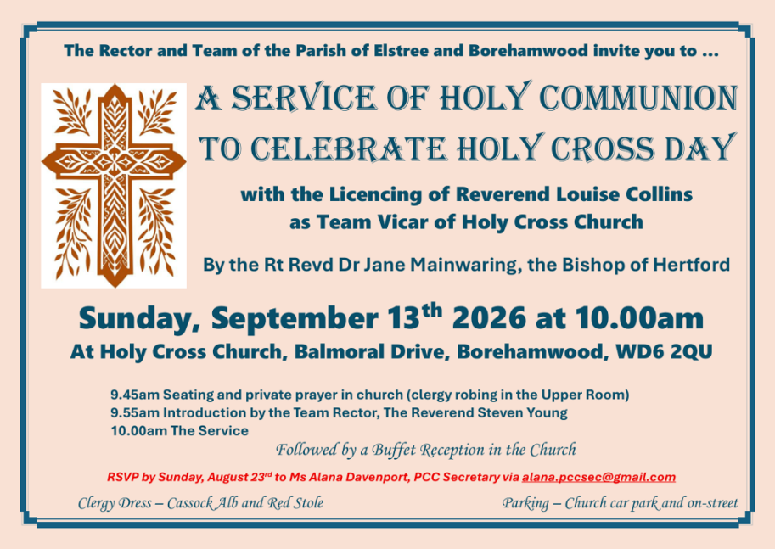
Monday, August 31st
No Morning Prayer, All Saints, sorry.
Tuesday, September 1st
- 12.00-2.00pm Lunchtime Prayers, All
Saints
- 3.00pm Holy Communion and Pop-In Café,
Holy Cross
Wednesday, September 2nd
- 10.00am Holy Communion, St Nicholas
- 2.00pm Contactless Giving, St Michael’s
Thursday, September 3rd
- 9.30am Morning Prayer, St Nicholas
- 12.00-3.00pm Welcome Café, St Michael’s
- 3.00pm Songs of Praise with Holy
Communion, St Michael’s
Friday, September 4th
- 12.00pm Holy Communion, All Saints
- 7.00pm-9.00pm Be:Loved
Holy Cross Patronal Service
Sunday, Sept 13th @ 10.00am at Holy Cross with the Bishop of Hertford
In this special Parish Service, Revd Louise Collins will be Licensed as Team Vicar with special responsibility for Holy Cross and St Michael’s. Followed by a “Bring-and-Share” Buffet Lunch. Please do sign up if you are coming, thank you.

NEXT WEEK’S SERVICE Sunday, September 6th
St Nicholas | 9.15am | Holy Communion
Holy Cross | 9.30am | Service of the Word
St Michael | 9.30am | Holy Communion  Holy Baptism
All Saints | 11.15am | Holy Communion
