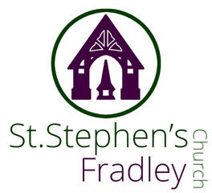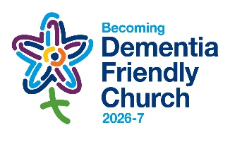
BULLETIN
16^{h} August 2026 The Eleventh Sunday after Trinity
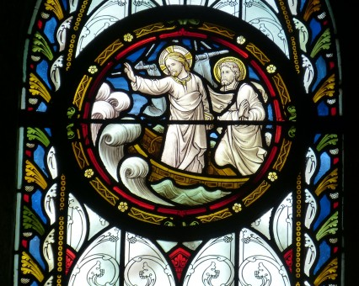
10.30am Family Communion and Baptism with the Music Group
Welcome to our Worship today. If you are visiting for the first time, please introduce yourself so that we may welcome you personally. Refreshments are served after the service
ST. STEPHEN’S CHURCH IS OPEN 10am-3pm daily for Private Prayer and Reflection
Collect  God of glory,  the end of our searching,  help us to lay aside  all that prevents us from seeking your kingdom,  and to give all that we have  to gain the pearl beyond all price,  through our Saviour Jesus Christ.  Readings  Isaiah 56: 1,6-8 Romans 11:1-2a,29-32  Matthew 15: [10-20]21-28  Post Communion  Lord of all mercy,  we your faithful people have celebrated that one true sacrifice  which takes away our sins and brings pardon and peace:  by our communion  keep us firm on the foundation of the gospel  and preserve us from all sin;  through Jesus Christ our Lord.  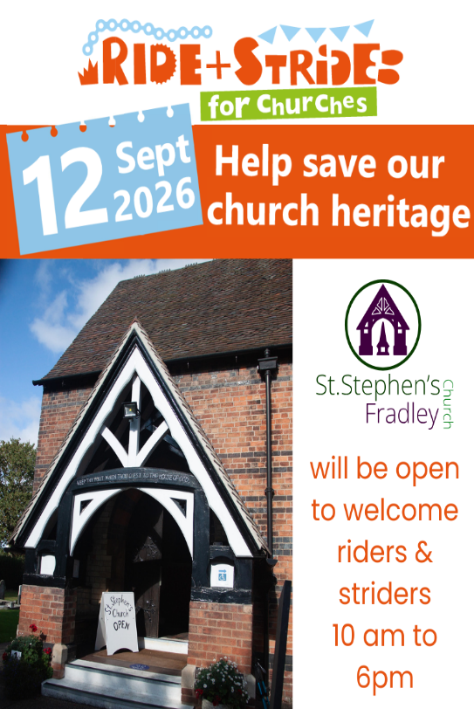  PLEASE NOTE:  The Craft Group will not meet again until Monday 7th September  *************  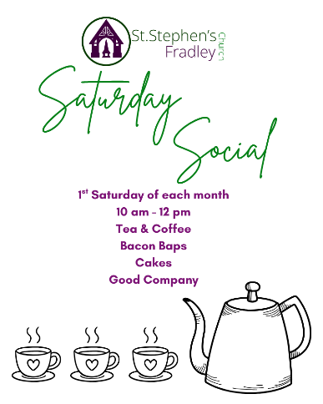 | Diary Dates  August  Sunday16th within morning service  Baptism of Arthur Alexander Jones  Wednesday 19th  2-4 Wednesday Welcome  Friday 21st  11am-12noon Funeral followed by burial of Michael Higginson    St. Stephen’s & St Chad’s  Walking Group    Join us for our next walk  Saturday 29th August  A local walk of approximately 5.5 miles  walking Fradley- Alrewas Loop  Meet at  St Stephen’s Church  Fradley WS13 8NL  at 10.00am  There is also the opportunity for those who do not wish to walk the loop but maybe go as far as Alrewas, to leave a car there and meet the group again at Fradley Junction. Coffee shop in Alrewas and also three choices for refreshment at Fradley Junction.  Bring a packed lunch if you wish. Sturdy shoes required.  The walk is led by Catherine.  More details- contact  Contact Angela 07913 563901
Notices for inclusion in the bulletin please email me by Tuesday of each week
Officeststephenfradley@gmail.com Please take bulletin away with you
If you would like to support St Stephen’s Church at this time donations can be made via our Just Giving Page. We are grateful for donations large or small
https://www.justgiving.com/fundraising/ststephensfradley
Contact us
Priest in Charge: Rev. Jonathan Nicholas vicar@alrewasallsaints.church 01283 384 000 Mobile:07920239190
Churchwardens Marian Derry 01283 79157Katie Williams07776182760warden.ststephens.fradley@gmail.com
St Stephen’s Administrator: Di Cooper 07930162991 officeststephenfradley@gmail.com
Find us on ACNY https://www.achurchnearyou.com/church/4123/
Facebook www.facebook.comststephensfradley

