ST MARY THE VIRGIN BRAUGHING
Sunday 2nd August 2026
9th Sunday after Trinity
Welcome to our All Age Service which will be led by our Priest-in-Charge, Rev’d Lynn Hayler. The first part of the service is informal inclusive worship and lasts about 40 minutes followed by refreshments. Those who wish are then invited to move up to the Chancel for a shortened Holy Communion.
Our communion celebration is open to all who know Jesus as Lord. Please indicate at the communion rail if you would like our Vicar to dip (intinct) your wafer in the wine. If you don’t wish to receive the bread and wine you are welcome to come up for a blessing. Please indicate by keeping your hands by your side
HYMNS:
384 Let us praise God together
181 Gather round for the table is spread
550 Praise my soul the King of heaven

408 Lord Jesus Christ
612 Tell out my soul

NOTICES
Wheelbarrow Teas Thank you to everyone who baked a cake or helped out on the day with wheelbarrow teas, we were very busy all afternoon and raised £643 for our funds
Incumbents Boards A huge thank you to Jane Davalle for refurbishing our old Incumbents’ Board and producing a beautiful new one to compliment the original so we can now include ALL our incumbents. Both boards are on the North Wall (by the door to the Stannard Room)
Organ Concert This is planned for Sat 3rd October in St Mary’s Church, Braughing, the evening. It will be a celebration of our newly refurbished organ with various organists and musicians featuring organ pieces, readings and hymns/songs for us all to join in. Free entry (retiring collection). Watch out for further information
Braughing Home Group Bible Study We meet on a Tuesday evening during term time at 7.00pm so we are currently taking a summer break but we will restart on Tuesday 8th Sept. All are invited to join us as we explore God’s word together. To register your interest or get some more information, please contact: sara.holland1965@hotmail.co.uk

Choir Over the Christmas period we had a wonderful Pop-up Choir but throughout the year, we have a small Church Choir who sing at Sunday services. We are always delighted for new members to join us. Our next Choir Practice is on Thursday 27th August from 7-8pm in St Mary’s Church Braughing.

Refreshments We are delighted to be able to offer tea, coffee, squash, biscuits and sometimes even cake after our service. We don’t charge for this but are always grateful to receive a small donation (in the pot on the coffee table). This helps us to maintain our supply of drinks and snacks.

Stolen Lamps You will remember Church End was very dark last winter after the 4 lamps along the churchyard boundary were stolen. The police have now charged a man from Barkway with the theft of 45 streetlamps worth £1 million. He will appear at Stevenage Magistrates Court on 5th August.

Bike ‘n Hike This year’s Bike ‘n Hike takes place on Saturday 12th September from 9-5pm. This annual event is organised by the Beds and Herts Historic Churches Trust. You are encouraged to get sponsored and cycle, walk or ride around as many churches as you can. The money raised goes half to the Trust and half to your local church (ie us!). Many churches provide refreshments for participants and most of them are open for you to wander round if you wish. Sponsor forms are on line this year: https://bedshertshct.org.uk/media/bohbvqrd/bh5-2026-sponsor-leaflet-combo.pdf

Thank you Event We will be holding a Thank You afternoon on Saturday 12th September from 3-5pm in the Church Hall for all of those wonderful volunteers who help out in our church and churchyard. All members of our congregation are also welcome to share in this celebration. We will be serving tea, cake and Prosecco. Offers of help on the day/cake making much appreciated. Please speak to Lynn, Jackie or any member of the PCC

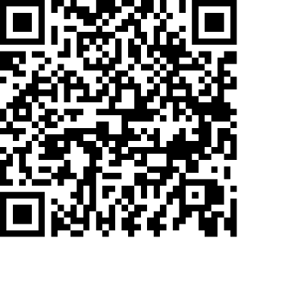
If you would like to support the work of our church but you don’t have any cash with you, we do have a “sum-up” machine which takes cards (please see the Sidesperson at the back of the church).
Alternatively you can scan the QR code opposite and make a direct donation.
Anything you can give, no matter how small, is much appreciated.

FUTURE SERVICES:

Sun 9th Aug HOLY COMMUNION with BAPTISM Braughing 10.30
Sun 16th Aug CAFÉ CHURCH 9.30 Furneux Pelham
Sun 23rd Aug HOLY COMMUNION 10.30 Furneux Pelham
Sun 30th Aug HOLY COMMUNION 10.30 Stocking Pelham
Sun 6th Sept ALL AGE SERVICE Braughing 10.30 Shortened Holy Communion 11.30

Contact information for Braughing Church:
Email – churchoffice@btinternet.com Phone – 01920 823832 (please leave a message)
revlynnhayler@outlook.com 07721 637682

