The Winterbournes and Compton Valence

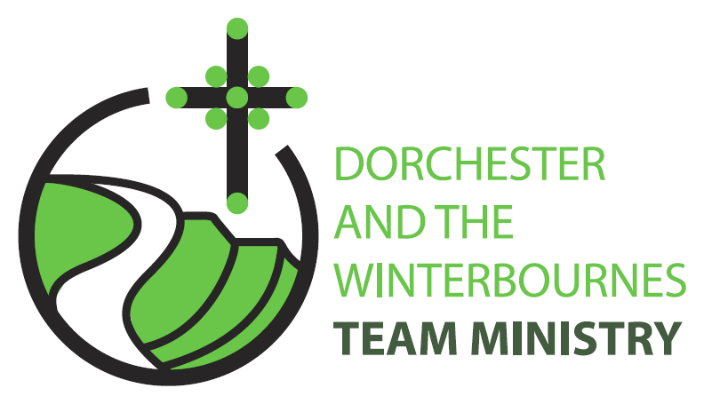

Trinity 12
23rd August 2026

Welcome to this service in the Ordinary Season. The readings set for this Sunday remind us that we are all called to serve God and His Kingdom using the gifts that God has given to each of us. So on this day we pray especially for those who lead the church and those who are exploring God’s call to ministry. We also continue to pray for The Winterbourne Churches that we may, in the words of St Paul ‘discern what is the will of God’ for The Winterbournes.

Collect
God of constant mercy,
who sent your Son to save us:
remind us of your goodness,
increase your grace within us,
that our thankfulness may grow,
through Jesus Christ our Lord.
All: Amen

Reading: Romans 12:1-8

12 I appeal to you therefore, brothers and sisters, by the mercies of God, to present your bodies as a living sacrifice, holy and acceptable to God, which is your spiritual worship.
2 Do not be conformed to this world, but be transformed by the renewing of your minds, so that you may discern what is the will of God-what is good and acceptable and perfect.
3 For by the grace given to me I say to everyone among you not to think of yourself more highly than you ought to think, but to think with sober judgement, each according to the measure of faith that God has assigned.
4 For as in one body we have many members, and not all the members have the same function,
5 so we, who are many, are one body in Christ, and individually we are members one of another.
6 We have gifts that differ according to the grace given to us: prophecy, in proportion to faith;
7 ministry, in ministering; the teacher, in teaching;
8 the exhorter, in exhortation; the giver, in generosity; the leader, in diligence; the compassionate, in cheerfulness.

This is the word of the Lord.
All: Thanks be to God.

Gospel Reading: Matthew 16: 13-20

Hear the Gospel of our Lord Jesus Christ according to Matthew.
All: Glory to you, O Lord.

13 Now when Jesus came into the district of Caesarea Philippi, he asked his disciples, Who do people say that the Son of Man is?
14 And they said, Some say John the Baptist, but others Elijah, and still others Jeremiah or one of the prophets.
15 He said to them, But who do you say that I am?
16 Simon Peter answered, You are the Messiah, the Son of the living God.
17 And Jesus answered him, Blessed are you, Simon son of Jonah! For flesh and blood has not revealed this to you, but my Father in heaven.
18 And I tell you, you are Peter, and on this rock I will build my church, and the gates of Hades will not prevail against it.
19 I will give you the keys of the kingdom of heaven, and whatever you bind on earth will be bound in heaven, and whatever you loose on earth will be loosed in heaven.
20 Then he sternly ordered the disciples not to tell anyone that he was the Messiah.

This is the Gospel of the Lord.
All: Praise to you, O Christ.

Post Communion Prayer
God of all mercy,
in this eucharist you have set aside our sins
and given us your healing:
grant that we who are made whole in Christ
may bring that healing to this broken world,
in the name of Jesus Christ our Lord.
All: Amen

NOTICES
Help save the Winterbourne Churches-Have you returned your Parish Giving Scheme form & are you encouraging your neighbours and friends to do the same? Please join our campaign to save our churches, and ask everyone you know to be a friend to the Winterbournes and to give a little regularly.

Heritage Open Day 12th September 10am-2pm- Are you available to be a welcomer to visitors to our churches at the Open Day, or could you bake a cake. Please contact Rev Teresa – revteresa@outlook.com

PRAYERS FOR THE WEEK

From Common Worship- Intercessions for all forms of ministry

We pray for the flourishing of God’s gifts to his Church

God our Father, you give us gifts that we may work together
in the service of your Son: bless the leaders of your Church,
that they may be firm in faith, and humble before you.

Bless those who teach and preach, that they may increase our understanding, and be open to your word for them.

Bless those who minister healing, that they may bring wholeness to others,
yet know your healing in themselves.

Bless those who suffer and those who grieve, that they may know your healing presence in their lives. We pray especially for Andreas, Maggie and Bruce, Baby Wren & Baby Ronnie and their families, John & Mandy, Rev Conner and all who watch the suffering of those they love. We pray for the grieving families of Eric, Jack, Tanya Penfold, Ian Shaw, Bob Wilkins, Cerry McQueen, Ken Symmonds, Brenda Deverill and Bill Pashen.

Bless those through whom you speak, that they may proclaim your word in power, yet open their ears to your gentle whisper.

Bless those who work in your world today, that in the complexity of their daily lives they may live for you, fulfil your purposes, and seek your kingdom first.

Bless those who are uncertain of their gifts and those who are powerless in this world’s eyes, that they may be made strong in your gift of the Holy Spirit.

Lord of the Church,
hear our prayer,
and make us one in heart and mind
to serve you with joy for ever. Amen.

