
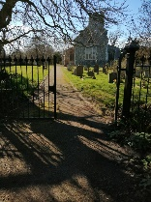
Sept 26 Mendham Message

All Saints Church Open 9am-dusk daily. Food & household essentials for anyone to take if needed! Weds 10am prayers for village in pub; hot drink/chat 10.30am
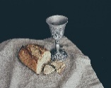
Sun 20th Sept 9.30am Holy Communion in Creationtide. Refreshments after.
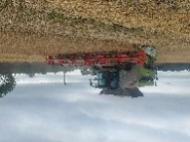
Traditional Harvest Service with farmers Sun 27th Sept 6.30pm. Refreshments after.
Come and show your support to our local farmers. Collection for farmers’ charity.



Thank you to all who helped in churchyard strimming around graves, scything and supporting Waveney Volunteers for Nature. (see their facebook page). £140 raised by books whilst sharing memories of Denis!


Exciting news: All Saints venue for two Sept weddings with two booked for next year!

Bell-ringing practices returning to All Saints.
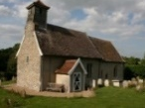
St Mary Magdalene, Withersdale recently featured in diocese e-news and on website!
Sun 13th Sept 9am BCP Holy Communion to celebrate Harvest Thanksgiving.

Sir Alfred Munnings Hotel 01379 854861

Mendham and Withersdale Village Hall.
Cash BINGO 13th Sept at 8pm Tickets online, or ring Becky 01379 586739.

Thurs 19th Sept 2 -4pm Good Afternoon Club. Chat/company. £1. Refreshments.
Boules and outdoor table tennis available.

Mendham and Withersdale Parish Council 21st Sept 7pm at Mendham School.

Mendham Parochial Church Council August date changed to 30th Sept at 7.30pm.

Rector post being readvertised in Sept.

Thank you for donating to All Saints Church Mendham.

Sept 26 Mendham Message
All Saints Church Open 9am-dusk daily. Food & household essentials for anyone to take if needed! Weds 10am prayers for village in pub; hot drink/chat 10.30am
Sun 20th Sept 9.30am Holy Communion in Creationtide. Refreshments after.
Traditional Harvest Service with farmers Sun 27th Sept 6.30pm. Refreshments after.
Come and show your support to our local farmers. Collection for farmers’ charity.

Thank you to all who helped in churchyard strimming around graves, scything and supporting Waveney Volunteers for Nature. (see their facebook page). £140 raised by books whilst sharing memories of Denis!

Exciting news: All Saints venue for two Sept weddings with two booked for next year!

Bell-ringing practices returning to All Saints.
St Mary Magdalene, Withersdale recently featured in diocese e-news and on website!
Sun 13th Sept 9am BCP Holy Communion to celebrate Harvest Thanksgiving.

Sir Alfred Munnings Hotel 01379 854861

Mendham and Withersdale Village Hall.
Cash BINGO 13th Sept at 8pm Tickets online, or ring Becky 01379 586739.
Thurs 19th Sept 2 -4pm Good Afternoon Club. Chat/company. £1. Refreshments.
Boules and outdoor table tennis available.

Mendham and Withersdale Parish Council 21st Sept 7pm at Mendham School.

Mendham Parochial Church Council August date changed to 30th Sept at 7.30pm.

Rector post being readvertised in Sept.
Thank you for donating to All Saints Church Mendham.

