The Winterbournes and Compton Valence

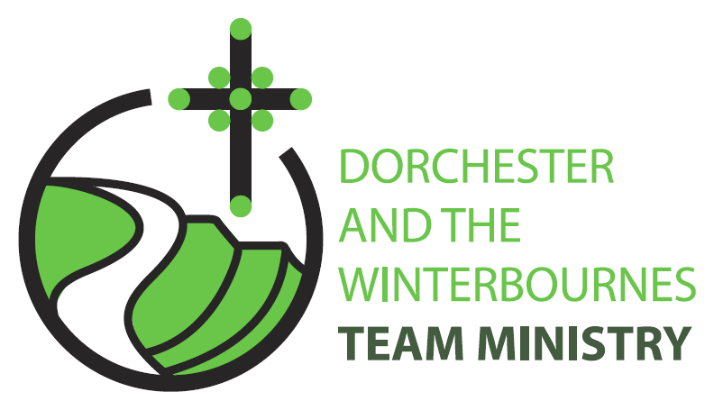

Trinity 11
16th August 2026

Welcome to this service in the Ordinary Season. Today we are celebrating the life of Mary, the Mother of our Lord. In the church calendar the 15th of August is the Feast of the Assumption of Mary and churches dedicated to Mary keep this feast in her honour. Today we remember Mary and her example of obedience to God’s call, her love for Jesus and her faithfulness even in the midst of suffering. Today we pray for St Mary’s Church, Winterbourne Abbas and St Mary’s Dorchester, and we pray for all who are exploring a calling to God’s ministry.

Collect
Almighty and everlasting God,
who stooped to raise fallen humanity
through the child-bearing of blessed Mary:
grant that we, who have seen your glory
revealed in our human nature
and your love made perfect in our weakness,
may daily be renewed in your image
and conformed to the pattern of your Son
Jesus Christ our Lord,
who is alive and reigns with you,
in the unity of the Holy Spirit,
one God, now and for ever.
All: Amen

Reading: Romans 11.1–2a, 29–32

11 I ask, then, has God rejected his people? By no means! I myself am an Israelite, a descendant of Abraham, a member of the tribe of Benjamin.
2 God has not rejected his people whom he foreknew. Do you not know what the scripture says of Elijah, how he pleads with God against Israel?
29 for the gifts and the calling of God are irrevocable.
30 Just as you were once disobedient to God but have now received mercy because of their disobedience,
31 so they have now been disobedient in order that, by the mercy shown to you, they too may now receive mercy.
32 For God has imprisoned all in disobedience so that he may be merciful to all.

This is the word of the Lord.
All: Thanks be to God.

Gospel Reading: Matthew 15: 10-20, 21-28

Hear the Gospel of our Lord Jesus Christ according to Matthew.
All: Glory to you, O Lord.

10 Then he called the crowd to him and said to them, Listen and understand:
11 it is not what goes into the mouth that defiles a person, but it is what comes out of the mouth that defiles.
12 Then the disciples approached and said to him, Do you know that the Pharisees took offence when they heard what you said?
13 He answered, Every plant that my heavenly Father has not planted will be uprooted.
14 Let them alone; they are blind guides of the blind. And if one blind person guides another, both will fall into a pit.
15 But Peter said to him, Explain this parable to us.
16 Then he said, Are you also still without understanding?
17 Do you not see that whatever goes into the mouth enters the stomach, and goes out into the sewer?
18 But what comes out of the mouth proceeds from the heart, and this is what defiles.
19 For out of the heart come evil intentions, murder, adultery, fornication, theft, false witness, slander.
20 These are what defile a person, but to eat with unwashed hands does not defile.]
21 Jesus left that place and went away to the district of Tyre and Sidon.
22 Just then a Canaanite woman from that region came out and started shouting, Have mercy on me, Lord, Son of David; my daughter is tormented by a demon.
23 But he did not answer her at all. And his disciples came and urged him, saying, Send her away, for she keeps shouting after us.
24 He answered, I was sent only to the lost sheep of the house of Israel.
25 But she came and knelt before him, saying, Lord, help me.
26 He answered, It is not fair to take the childrens food and throw it to the dogs.
27 She said, Yes, Lord, yet even the dogs eat the crumbs that fall from their masters table.
28 Then Jesus answered her, Woman, great is your faith! Let it be done for you as you wish. And her daughter was healed instantly.

This is the Gospel of the Lord.
All: Praise to you, O Christ.

Post Communion Prayer
God most high,
whose handmaid bore the Word made flesh:
we thank you that in this sacrament of our redemption
you visit us with your Holy Spirit and overshadow us by your power;
strengthen us to walk with Mary the joyful path of obedience
and so to bring forth the fruits of holiness; through Jesus Christ our Lord.
Amen

NOTICES
Help save the Winterbourne Churches-Have you returned your Parish Giving Scheme form & are you encouraging your neighbours and friends to do the same? Please join our campaign to save our churches, and ask everyone you know to be a friend to the Winterbournes and give a little regularly.
Heritage Open Day 12th September 10am-2pm- Are you available to be a welcomer to visitors to our churches at the Open Day, or could you bake a cake. Please contact Rev Teresa – revteresa@outlook.com

PRAYERS FOR THE WEEK

From Common Worship- Intercessions for the Feast of the Virgin Mary

Lord, your angel declared to Mary that she was to be the mother of the Saviour. Help every Christian person to be open to your word and obedient to your will.

Lord, Mary bore a son of David’s line, a king whose reign would never end.
Bless all the nations of the world with Christ’s gift of peace.

Lord, Jesus grew as a child in wisdom and stature in the home of Mary and Joseph. Strengthen our homes and families and keep under your protection all those whom we love.

At the foot of the cross of Christ stood his mother, and from the cross she received his lifeless body in her arms. Lord, give comfort and healing to Andreas, Maggie and Bruce, Baby Wren & Baby Ronnie and their families, John & Mandy, Rev Conner and all who suffer, and all who watch the suffering of those they love.

The apostle John saw a vision of a woman in heaven, robed with the sun.
Lord, bring us with Eric, Jack, Tanya Penfold, Ian Shaw, Bob Wilkins, Cerry McQueen, Ken Symmonds, Brenda Deverill and Bill Pashen and all those who have died in the faith of Christ to share the joy of heaven with Mary and all the saints. In Jesus’ name we pray. Amen

