The Winterbournes and Compton Valence

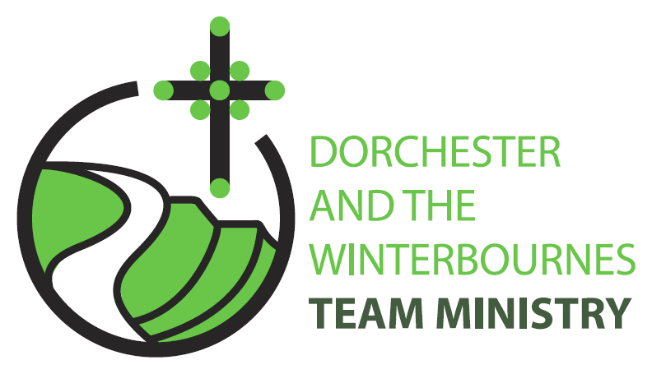

Trinity 10
9th August 2026

Welcome to this service in the Ordinary Season. Today we hear of Jesus’ rescue in the midst of a storm, and we remember St Pauls words the ‘everyone who calls on the name of the Lord will be saved’. We are therefore encouraged to pray faithfully in a world scarred by war and division; to wait with patience and courage for the coming Kingdom; and never to lose hope. In our prayers, we remember the victims of war and persecution, all affected by climate change, and— as we hear of Jesus calming the storm—especially migrants crossing dangerous seas to reach Europe.

Collect
Lord of heaven and earth,
as Jesus taught his disciples to be persistent in prayer,
give us patience and courage never to lose hope,
but always to bring our prayers before you;
through Jesus Christ our Lord.
All: Amen

Reading: Romans 10: 5-15

5 Moses writes concerning the righteousness that comes from the law, that the person who does these things will live by them.
6 But the righteousness that comes from faith says, Do not say in your heart, Who will ascend into heaven? (that is, to bring Christ down)
7 or Who will descend into the abyss? (that is, to bring Christ up from the dead).
8 But what does it say? The word is near you,
on your lips and in your heart(that is, the word of faith that we proclaim);
9 because if you confess with your lips that Jesus is Lord and believe in your heart that God raised him from the dead, you will be saved.
10 For one believes with the heart and so is justified, and one confesses with the mouth and so is saved.
11 The scripture says, No one who believes in him will be put to shame.
12 For there is no distinction between Jew and Greek; the same Lord is Lord of all and is generous to all who call on him.
13 For, Everyone who calls on the name of the Lord shall be saved.
14 But how are they to call on one in whom they have not believed? And how are they to believe in one of whom they have never heard? And how are they to hear without someone to proclaim him?
15 And how are they to proclaim him unless they are sent? As it is written, How beautiful are the feet of those who bring good news!

This is the word of the Lord.
All: Thanks be to God.
Gospel Reading: Matthew 14: 22-33

Hear the Gospel of our Lord Jesus Christ according to Matthew.
All: Glory to you, O Lord.

22 Immediately he made the disciples get into the boat and go on ahead to the other side, while he dismissed the crowds.
23 And after he had dismissed the crowds, he went up the mountain by himself to pray. When evening came, he was there alone,
24 but by this time the boat, battered by the waves, was far from the land, for the wind was against them.
25 And early in the morning he came walking towards them on the lake.
26 But when the disciples saw him walking on the lake, they were terrified, saying, It is a ghost! And they cried out in fear.
27 But immediately Jesus spoke to them and said, Take heart, it is I; do not be afraid.
28 Peter answered him, Lord, if it is you, command me to come to you on the water.
29 He said, Come. So Peter got out of the boat, started walking on the water, and came towards Jesus.
30 But when he noticed the strong wind, he became frightened, and beginning to sink, he cried out, Lord, save me!
31 Jesus immediately reached out his hand and caught him, saying to him, You of little faith, why did you doubt?
32 When they got into the boat, the wind ceased.
33 And those in the boat worshipped him, saying, Truly you are the Son of God.

This is the Gospel of the Lord.
All: Praise to you, O Christ.

Post Communion Prayer

God of our pilgrimage,
you have willed that the gate of mercy
should stand open for those who trust in you:
look upon us with your favour
that we who follow the path of your will
may never wander from the way of life;
through Jesus Christ our Lord.
Amen

NOTICES
Help save the Winterbourne Churches-Have you returned your Parish Giving Scheme form and are you encouraging your neighbours and friends to do the same? Please be part of our campaign to save our churches and encourage everyone to be a friend to the Winterbournes and give a little regularly.
Heritage Open Day 12th September 10am-2pm- Are you available to be a welcomer to visitors to our churches at the Open Day, or could you bake a cake. Please contact Rev Teresa – revteresa@outlook.com

PRAYERS FOR THE WEEK

A Prayer for Those Crossing the Sea: Lord, you are the refuge of all who are in distress. We lift up to you our brothers and sisters who make perilous journeys across the open sea in search of safety and a better life. Calm the winds and the waves, protect them from peril, and guide them to welcoming shores. Comfort those who fear, sustain those who are weary, and open our hearts to show true compassion and solidarity.

Prayers for coastguards and naval personnel involved in rescue crews: Lord, grant strength, courage, and clear vision to all who labour on the water and coastlines to pull the drowning to safety.

Prayers for global leaders: Lord bestow wisdom and justice upon authorities and nations, that they may build pathways of peace and honour the inherent dignity of every human being.

Prayers for our congregation: Lord, we know that you will stand with all those who face the storms of life so we name before you our sisters and brothers in distress: Andreas, Maggie and Bruce, Baby Wren & Baby Ronnie and their families, John & Mandy, Rev Conner

We pray for all who grieve and ask that you will give them your comfort. We pray for Jack who has recently died and for his family and we also remember the families of those whose years mind occurs this month Tanya Penfold, Ian Shaw, Bob Wilkins, Cerry McQueen, Ken Symmonds, Brenda Deverill and Bill Pashen

In Your name we pray. Amen

" Everyone who calls on the name of the Lord shall be saved.” Romans 10: 13

