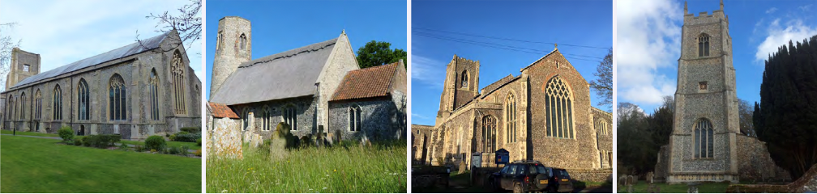

N.E.W.
North Walsham
Edingthorpe
Worstead and Westwick
NEWS
The Magazine for the North Walsham Benefice September 2026 40p
Transformed by Christ: Prayerful, Pastoral, Prophetic

Editor’s Bit

Contents in this issue:
- Vicar’s Page
- From the assistant curate
- Dates from the Diary
- September service Dates
- Upcoming Events
We hope to see you at our services, you are all welcome.

Please note the date for items to go in the October edition of NEWS needs to be at the Parish office by September 21st latest.

Financial Information

Please may we remind you, that if you are giving us a cheque for any of the Churches, they need to be made payable to the following:
St Nicholas’ Church – North Walsham PCC
All Saints’ – Edingthorpe PCC
St Mary’s – Worstead PCC
St Botolph’s – Diocesan Churches Trust

Please may we ask if you are sending any payments to us via an online service that you put a meaningful reference on the payment to ensure we know where the payment should go to.

Live-streamed services are available on YouTube - please search St Nicholas North Walsham. Do you participate in our live-streamed services - we would love to hear your feedback: contact David on 07506 723946 or davidnorthwalsham@gmail.com

If you are considering a change to your Committed Giving for St. Nicholas, please inform Chris Sherman (Committed Giving Officer)
Please support St. Nicholas Church, North Walsham on #easyfundraising, you can raise FREE donations when you shop online with over 5,000 retailers. It is simple and only takes 2 minutes to sign up! Plus, once you have raised your first £15, easy fundraising will match it!
Sign up now: https://www.easyfundraising.org.uk/causes/stnicholaschurchnw/

The Vicar’s page:
From David:
September is always a month for new starts. Those things we may have put off for the summer and those things that seemed such a long way away and are suddenly upon us. The start of new School terms begins so much in the annual cycle.
As a parish community we are accustomed to ends and beginnings: the Christian life is one of ends and beginnings new starts and challenges on the way.
We give thanks for the success of the Worstead festival. It was great to see so many people both on the field and in church enjoying the many displays and activities there: a huge thank you to the church team for their fundraising efforts on that weekend.
Edingthorpe continues to explore the exciting range of wildlife that lives in the churchyard and even a small wildfire on the hedge outside has only led to an increased interest and development in our churchyard care plan.
At North Walsham events continue and we look forward to working with our new treasurer Sam. We continue to give thanks for Anna and all that she has given in support to the PCC over the years.
At the end of August, we celebrated the confirmation of Sarah-Jane, Sam and Alan at Worstead. It was wonderful to have Bishop Ian with us and a great experience as we heard a little of the faith of these three folk who have joined our community. Ends and beginnings: the ending of an old life and the beginning of a new life in Christ.
Whatever this September holds for you, it will be a time of ends and beginnings, of new starts and the conclusion of things that we may move away from someone with joy and others with sadness.
On 6th September we celebrate the new feast day of the ‘creation in Christ.’ New feast days don’t come along all that often but General Synod has decided that we should celebrate the particular work of Christ in the creation of the world and in the ongoing life of creation.
As we pray for those less fortunate than ourselves and those in particular need, let us look to the gift of creation and remember our part in it and indeed Christ’s part in maintaining all that is and has been and shall be.
David

The Curate’s Page
Summer is almost at its end, which means that Autumn, my favourite time of the year, is fast approaching!
There is something very mystical and beautiful in Autumn time; falling leaves remind us of passing time and change in all life, shorter days can present us with a more reflective mood, and the colder weather gives us an opportunity to drink even more tea than usual.
In the life of the Church, it is a time of Remembrance, Thanksgiving for Harvest, remembering and rejoicing in the Communion of All the Saints, Advent and the fast-approaching welcoming of our Newborn Saviour at Christmas.
But summer is not finished yet, just like my reflection on my Priestly Ordination.
Each time I preside at the Celebration of the Holy Communion, I am reminded of two most beautiful truths in our life: that Jesus died on the Cross to save us, and that He gives Himself to us in each celebration on the altar.
These gifts are given to us for free, out of God’s Love and Compassion, available to EVERYONE, as long as we wish to take part.
This summertime also gave me a lot of time to reflect on the importance and beauty of our Christian family in the Benefice. The amount of support and goodwill flowing from your hearts towards me was and remains one of the biggest joys of my ministry.
We have something extraordinary here in North Walsham and beyond, so let us continue to build these relationships, to strengthen our love for one another and to be the helping hand to those around us, especially those who are most in need.
I invite you all to join this coming Autumn in the life and celebrations of the Church, to give your time and prayer to God’s work, and together, to bring His Kingdom closer.
Dan


Edingthorpe Village news for September
Services
6th September. Pet Service. 4pm.
13th September. Holy Communion 9.15am.
27th September. Harvest Thanksgiving Service. 4pm

Thursday 27th August we will be having a market stall at the Church entrance in North Walsham from 8.30am onwards. There will be cakes, jams, bric a brac, books and many more items to purchase. Please come along and support us.
Sunday 6th September at 4pm is our Pet Service. All pets of any shape or size are welcome.
Saturday 12th September. Norfolk Churches Trust Bicycle Ride. If you would like to participate in the event please contact Chris Martin on 07787561850 for sponsorship forms.
Sunday 27^{h} September, Harvest Floral & Produce Display 11am to 3.30pm followed by Harvest Thanksgiving Service at 4pm. There will be a display of tractors, ploughs etc and also an exhibition of Edingthorpe Village Life with photograph displays. There will also be a cakes and preserves and bric a brac sales. Do come along and have a light lunch.
Do call in for a chat and a cup of coffee on the 2nd Thursday of each month at St. Benet’s Hall, North Walsham. A warm welcome awaits plus homemade cakes, scones etc.
All events about the Church are on https://www.achurchnearyou.com/church/10076/ or the village website www.edingthorpe.village.org.uk
June Hannant 01692 402337
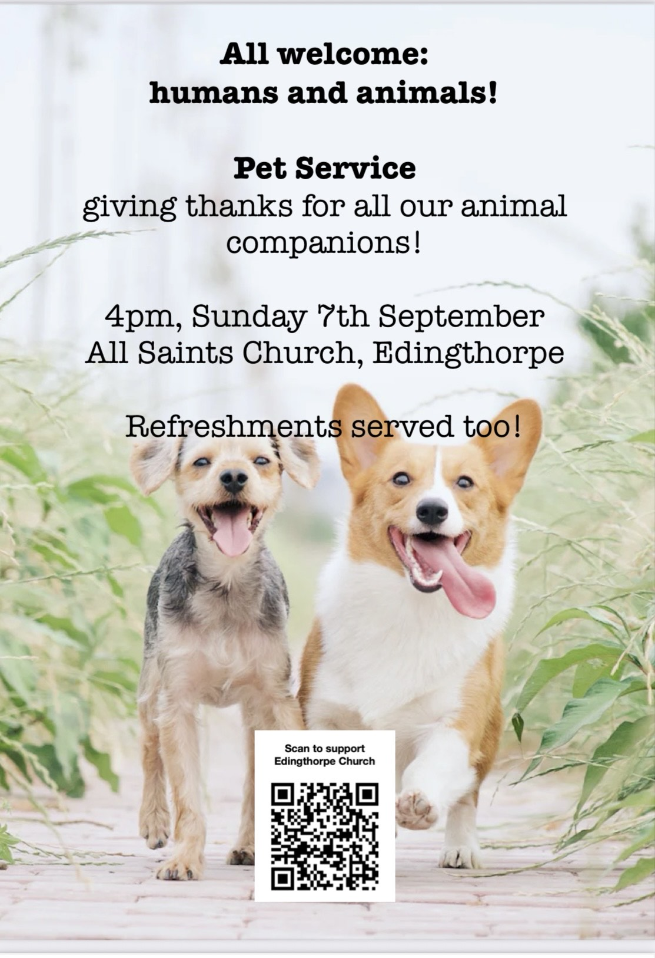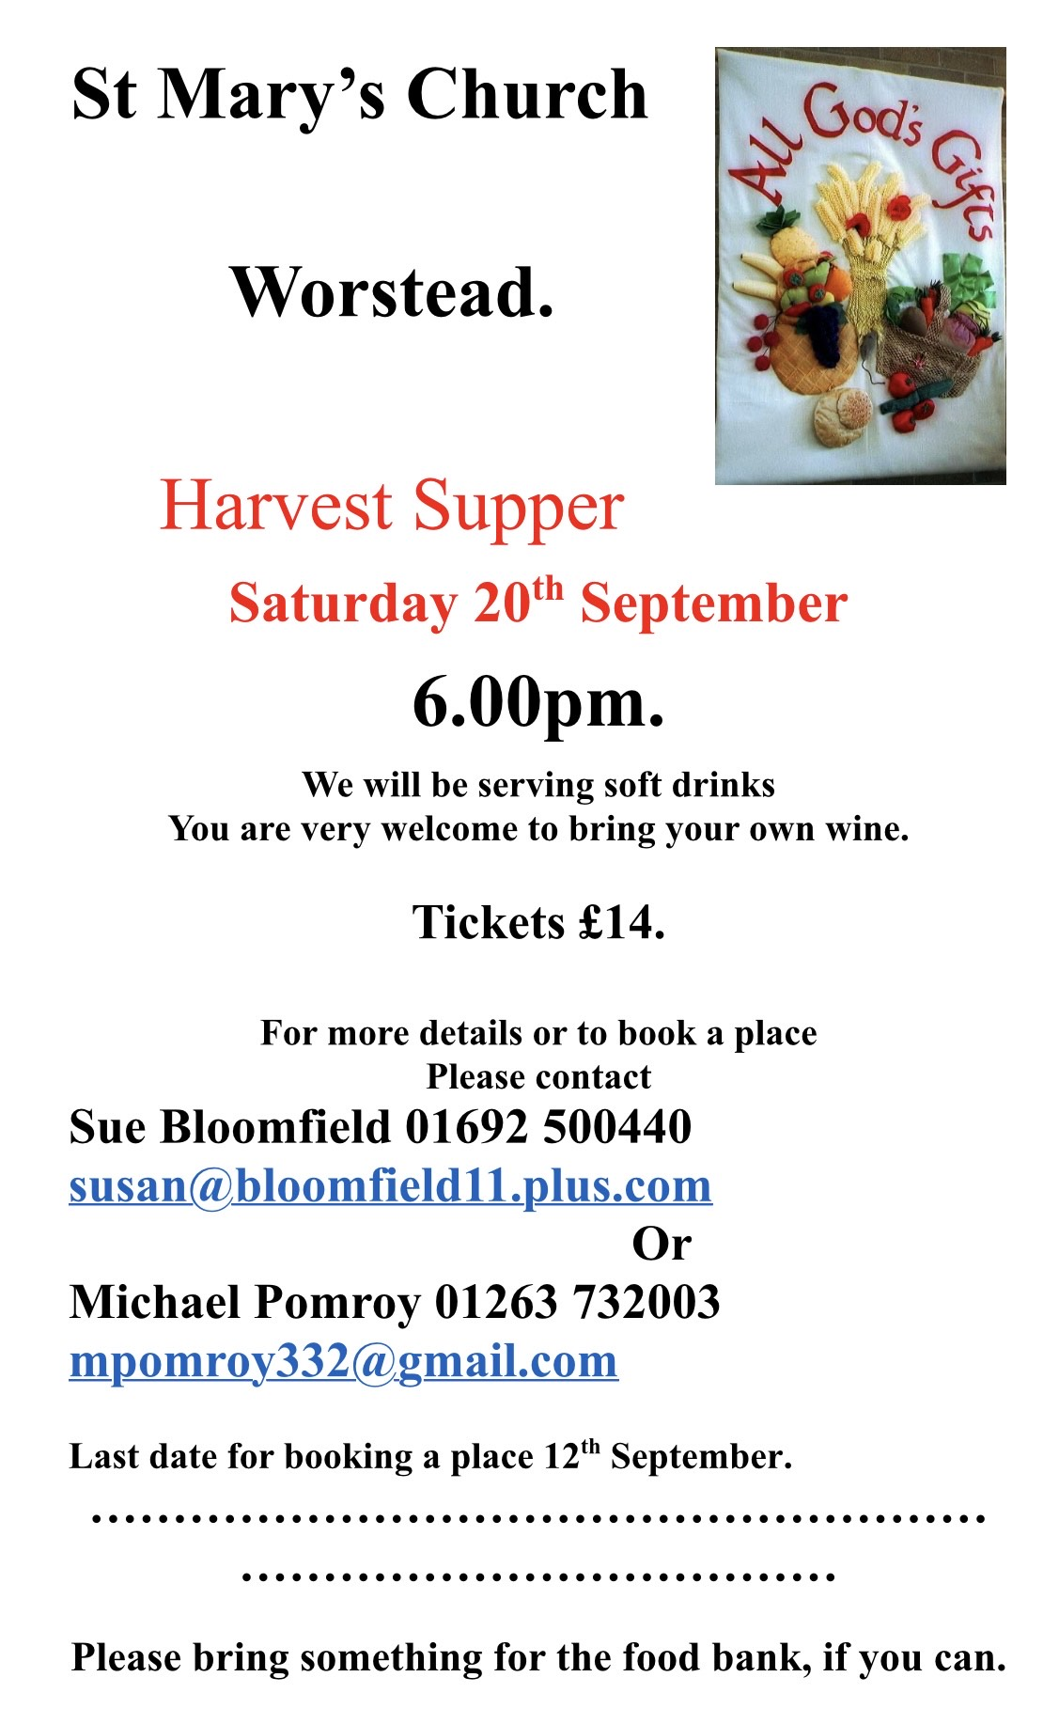
ST MARY’S - WORSTEAD
Summer is still very much with us and the busy life of St Mary’s goes on.
As promised, our kitchen was freshly decorated in time for the Festival and is looking so much better as a result.
Once again, the Festival was an outstanding success and, very much, the highlight of the year. Expectations were exceeded with refreshments leading the way, as ever. The weather was kind to us and visitors descended on the Church in their veritable hordes.
They were able to admire the beautiful flower displays, explore the many Craft Stalls, try their luck with the Tombola, buy lots of books, and, finally, enjoy a much-needed cup of tea or coffee, sample our homemade cakes, scones & sausage rolls. We are grateful to our small band of volunteers who gave so readily of their time to cook, bake and then serve these delicacies.
Our newly-ordained Curate, Dan, conducted his first wedding here at St Mary’s on July 30th. He ran a flawless service and didn’t miss a beat. The Happy Couple were most complimentary, afterwards, so we’re looking forward to his next one, whenever that may be.
Looking towards the autumn, by which time we hope it will have rained, we already have a date for your social calendars. We will be welcoming back the Cawston Band on Saturday, October 24th. The theme of their performance will be “The Last Night of The Proms,” so be sure to bring your Union Jacks. There will be lots of flag-waving in which to indulge. More details will follow.
Don’t forget our Harvest Supper on Saturday, 19th September at 6.00 pm. Tickets, at £15.00, from the Church Wardens, Sue or Michael. Their contact details can be found on the inside of the front cover.
Diary Dates:
Sunday, 6th September - Morning Prayer - 9.15 am
Sunday, 20th September - Harvest Thanksgiving Holy Communion – 9.15 am
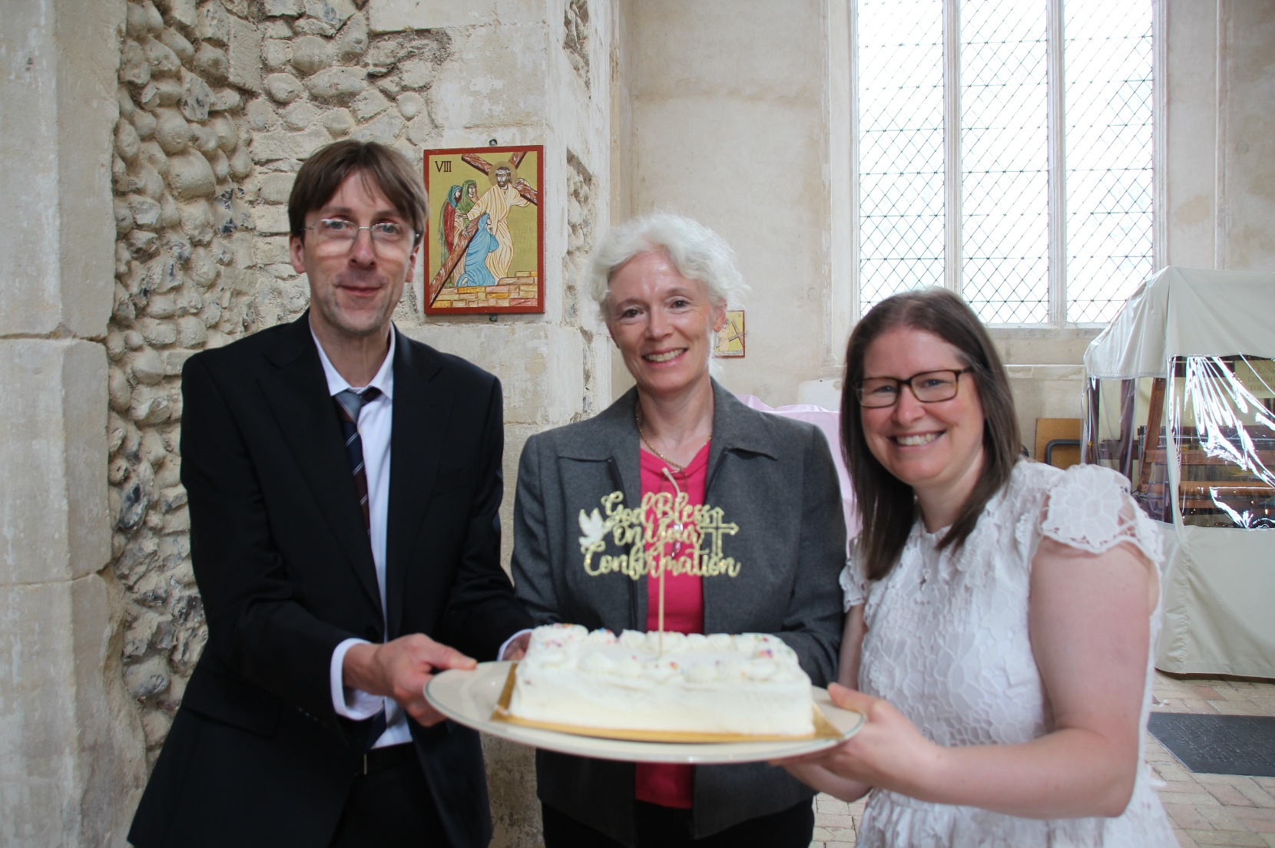

We congratulate Sarah-Jane, Sam and Alan on their Confirmation!

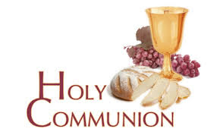
You may have read items in the press relating to the use of 'gluten free' wafers at Holy Communion - for those who require them, we use wafers which are approved and recommended for use by Coeliac UK - more information here. If you need a gluten free wafer, please advise the churchwardens/welcomers when you arrive for the service, and please indicate to the clergy distributing Holy Communion.
The Church teaches that receiving Holy Communion in both kinds (wafer and wine), or in one kind (the wafer or the wine) are acceptable and contain the fulness of the Sacrament. There are many reasons why this will be the case at different times in our lives, and there will be times when we cannot physically receive but join in an Act of Spiritual Communion (as those who watch online do - see below).

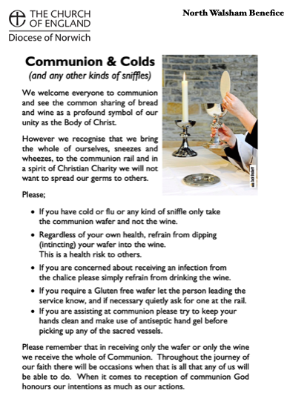
​Intinction (that is, dipping your wafer into the wine) is not permitted, both for hygiene reasons and because it might introduce gluten to the wine, which could be consumed by someone who is allergic to it.
If you wish to discuss any of this, please speak to David.

An Act of Spiritual Communion
In union, O Lord, with the faithful at every altar of your Church, where the Holy Eucharist is celebrated, I desire to offer you praise and thanksgiving. I present to you my soul and body with the earnest wish that I may always be united to you. And since I cannot now receive you sacramentally, I ask you to come spiritually into my heart.
I unite myself to you and embrace you with all the affections of my soul. Let nothing ever separate you from me. May I live and die in your love. Amen.


Why not come along to Sunday Kids and find out how to learn about what we do? We meet on the 1st and 3rd Sunday of the month at St Nicholas Church during the 10.30am service. You are most welcome.

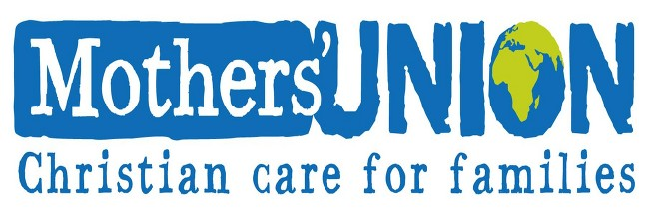

North Walsham Mothers’ Union. We meet in St Nicholas Room on the second Tuesday of the month at 2.00 p.m. Following a short act of worship and a few notices our speaker then takes the floor, after which, over tea and biscuits, there is an opportunity to ask questions and socialise. We usually finish about 3.30 pm.
Benefice Prayer Cycle

Every day we pray for our community - today we’re especially praying for…

1. Bishops of Norwich, Thetford and Lynn and their families and PAs
2. Archdeacons of Norwich, Norfolk and Lynn and their families and PAs
3. Cathedral, the Dean and Canons, staff and community
4. Parish Support Team
5. Deanery
6. Vicar & Assistant Curate: David and Dan and their families
7. Assistant clergy: Nigel, Maggie, Penny and their families
8. Authorised Pastoral Assistants: Felicity, Lois, Chris, Elizabeth, Sue
9. North Walsham Churchwardens, PCC & congregations
10. Worstead Churchwardens (Michael & Susan), PCC & congregations
11. Edingthorpe Churchwardens (Chris), PCC & congregations
12. Westwick
13. Diocesan Safeguarding Team (Sue & Peter) and Benefice Safeguarding Officer (Lois)
14. PCC Treasurers (Sam, Erica, Michael)
15. Musicians (Tim, Matthew) and choirs
16. Servers, welcomers and coffee teams
17. Flower arrangers, cleaners, polishers
18. Funeral directors, crematorium and cemetery staff
19. Baptism, wedding and funeral families
20. Churches Together in North Walsham
21. Veterans Organisations: RBL, RAFA
22. Schools: Paston, NW High, Millfield, North Walsham, Worstead
23. Nurseries, Cuddles and Catch-up, Sunday Kids
24. Hospitals, Hospices and Dr’s Surgeries, Hospital Chaplains
25. Emergency services: Police, Ambulance, Fire, Coastguard, RNLI, Air Ambulance
26. Care homes, home communicants, all we visit
27. Online worshippers
28. Church hall users, Foodbank and Community resources
29. Town, Parish, District and County Councils and MP, public services
30. Businesses
31. Charities

If the month doesn’t have enough days, all the remaining petitions
are made on the last day of the month

Services for September
Tuesday 1st September
9am Morning Prayer at North Walsham
Wednesday 2nd September
9am Morning Prayer at North Walsham
10am Knitting Group in North Walsham Church
10am Worstead Wednesday coffee morning at the Village Hall
3.15pm Worstead PCC
7pm Edingthorpe PCC
Thursday 3rd September
9am Morning Prayer at North Walsham
9.30am Market Day coffee morning in the St Nicholas Room
9.30am Quiet Prayer at North Walsham
10.30am Holy Communion at North Walsham
Friday 4th September
9am Morning Prayer at North Walsham
Sunday 6th September – Creation in Christ
8am Holy Communion (1662) at North Walsham
9.15am Morning Prayer at Worstead
10.30am Holy Communion at North Walsham
4pm Pet service at Edingthorpe
No 5pm service
Tuesday 8th September
9am Morning Prayer at North Walsham
2pm Mothers’ Union in St. Nicholas’ Rooms
Wednesday 9th September
9am Morning Prayer at North Walsham
10am Worstead Wednesday coffee morning at the Village Hall
7pm North Walsham PCC

Thursday 10th September
9am Morning Prayer at North Walsham
9.30am Market Day coffee morning in the St Nicholas Room
9.30am Quiet Prayer at North Walsham
10.30am Holy Communion at North Walsham
Friday 11th September
9am Morning Prayer at North Walsham
Sunday 13th September – Trinity XV
8am Holy Communion (1662) at North Walsham
9.15am Holy Communion at Edingthorpe
10.30am Holy Communion at North Walsham with act of remembrance for Battle of Britain Sunday
5pm Choral Evensong at North Walsham
Monday 14th September
9am Morning Prayer at North Walsham
Wednesday 16th September
9am Morning Prayer at North Walsham
10am Worstead Wednesday coffee morning at the Village Hall
10am Knitting Group in North Walsham Church
Thursday 17th September
9am Morning Prayer at North Walsham
9.30am Market Day coffee morning in the St Nicholas Room
9.30am Quiet Prayer at North Walsham
10.30am Holy Communion at North Walsham
Friday 18th September
9am Morning Prayer at North Walsham
Saturday 19th September
Harvest Supper at Worstead
Sunday 20th September - Harvest
8am Holy Communion (1662) at North Walsham
9.15am Holy Communion at Worstead
10.30am Holy Communion at North Walsham
5pm Evening Prayer at North Walsham
Monday 21st September
9am Morning Prayer at North Walsham
Tuesday 22nd September
9am Morning Prayer at North Walsham
Wednesday 23rd September
9am Morning Prayer at North Walsham
10am Worstead Wednesday coffee morning at the Village Hall

Thursday 24th September
9am Morning Prayer at North Walsham
9.30am Market Day coffee morning in the St Nicholas Room
9.30am Quiet Prayer at North Walsham
10.30am Holy Communion at North Walsham
Friday 25th September
9am Morning Prayer at North Walsham
Sunday 27th September – Trinity XVII
8am Holy Communion (1662) at North Walsham
9.15am Morning Prayer at Edingthorpe
10.30am Holy Communion at North Walsham
4pm Harvest Service at Edingthorpe
No 5pm service at North Walsham
Monday 28th September - Michael & all angels
9am Holy Communion at North Walsham
Tuesday 29th September
9am Morning Prayer at North Walsham
Wednesday 30th September
9am Morning Prayer at North Walsham
10am Knitting Group in North Walsham Church
10am Worstead Wednesday coffee morning at the Village Hall
Thursday 1st October
9am Morning Prayer at North Walsham
9.30am Market Day coffee morning in the St Nicholas Room
9.30am Quiet Prayer at North Walsham
10.30am Holy Communion at North Walsham
Friday 2nd October
9am Morning Prayer at North Walsham
Sunday 4th October 19th Sunday after Trinity
8am Holy Communion (1662) at North Walsham
9.15am Morning Prayer at Worstead
10.30am Holy Communion at North Walsham
5pm Choral Evensong at North Walsham
Monday 5th October
9am Morning Prayer at North Walsham
Tuesday 6th October
9am Morning Prayer at North Walsham
Wednesday 7th October
9am Morning Prayer at North Walsham
10am Worstead Wednesday coffee morning at the Village Hall
Thursday 8th October
9am Morning Prayer at North Walsham
9.30am Market Day coffee morning in the St Nicholas Room
9.30am Quiet Prayer at North Walsham
10.30am Holy Communion at North Walsham
Friday 9nd October
9am Morning Prayer at North Walsham
Sunday 11th October 20th Sunday after Trinity
8am Holy Communion (1662) at North Walsham
9.15am Holy Communion at Edingthorpe
10.30am Holy Communion at North Walsham
5pm Choral Evensong at North Walsham

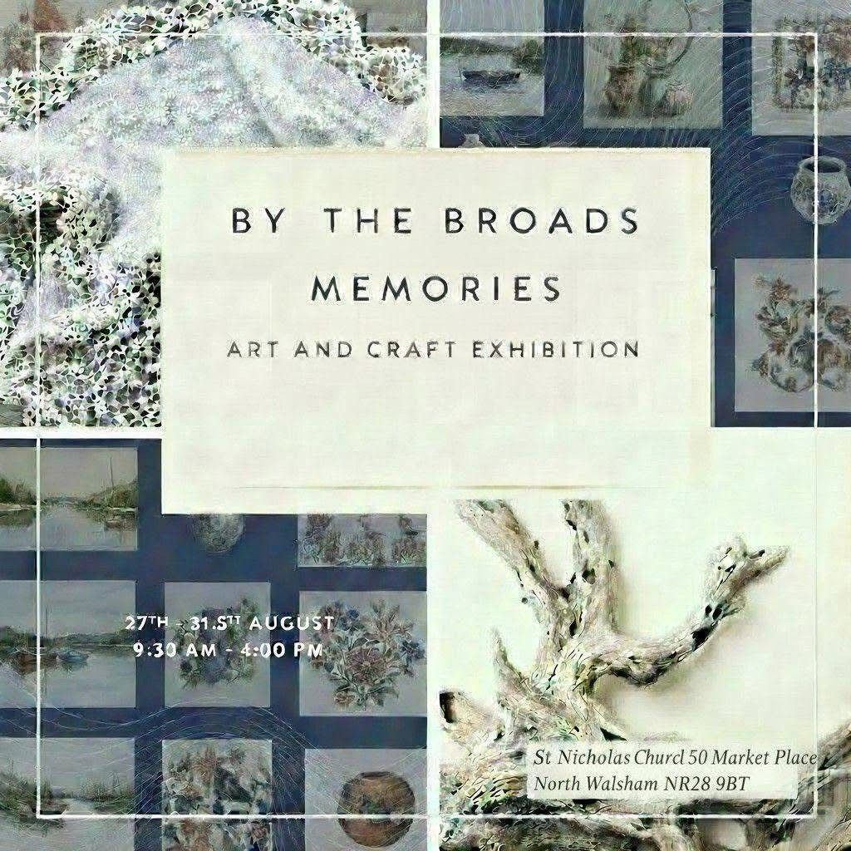
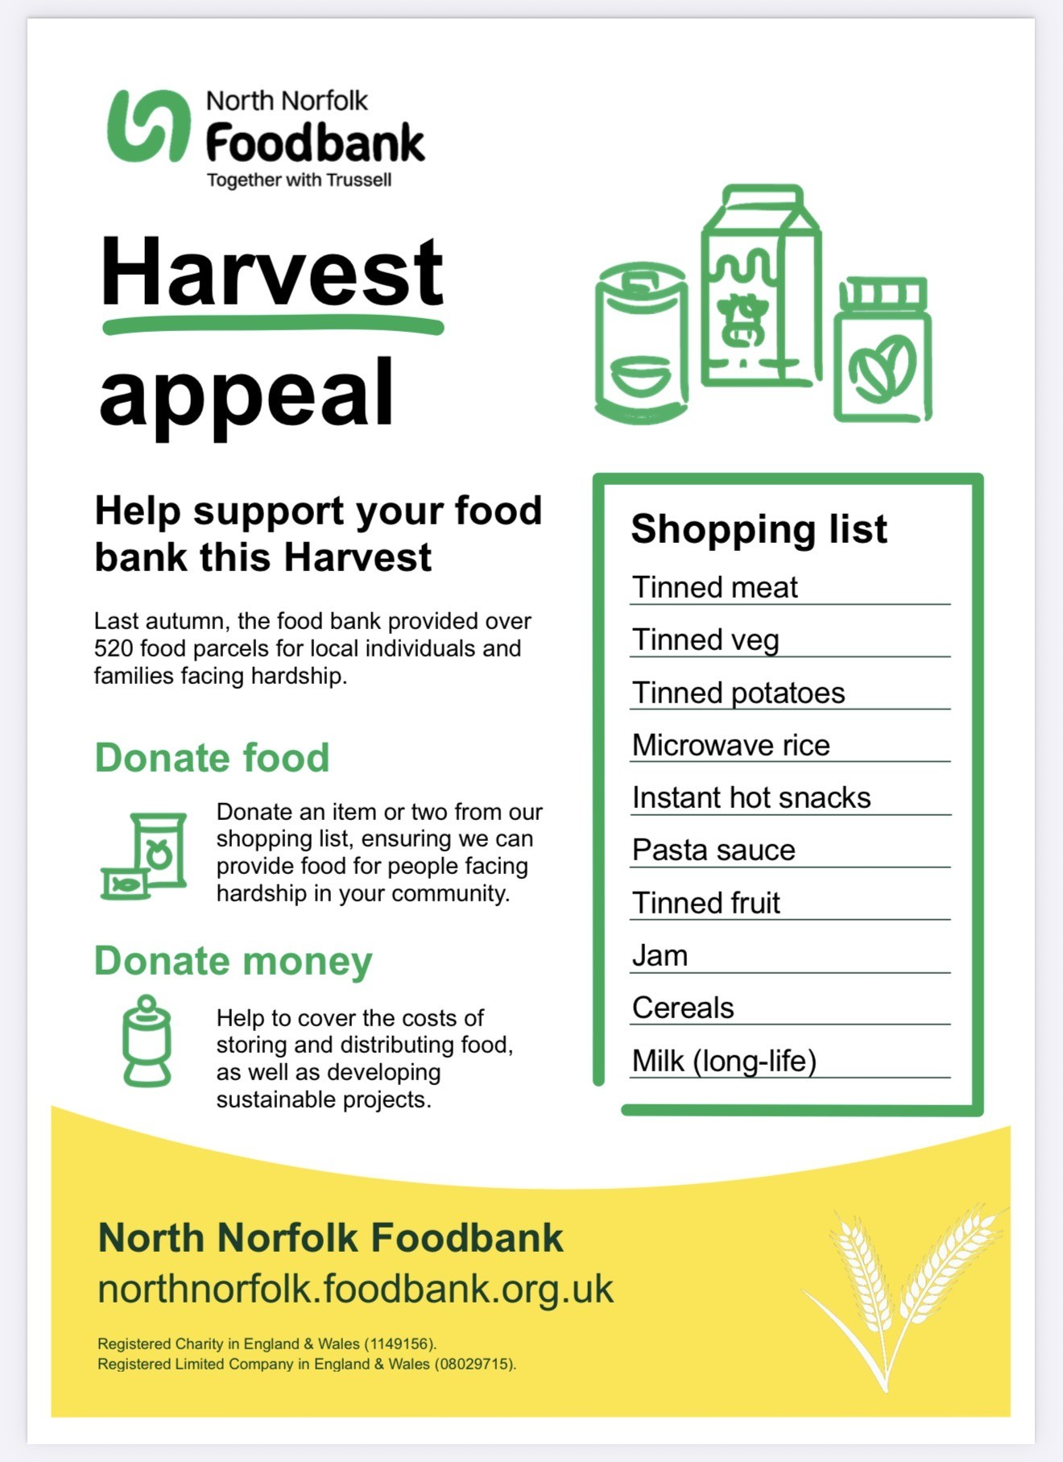
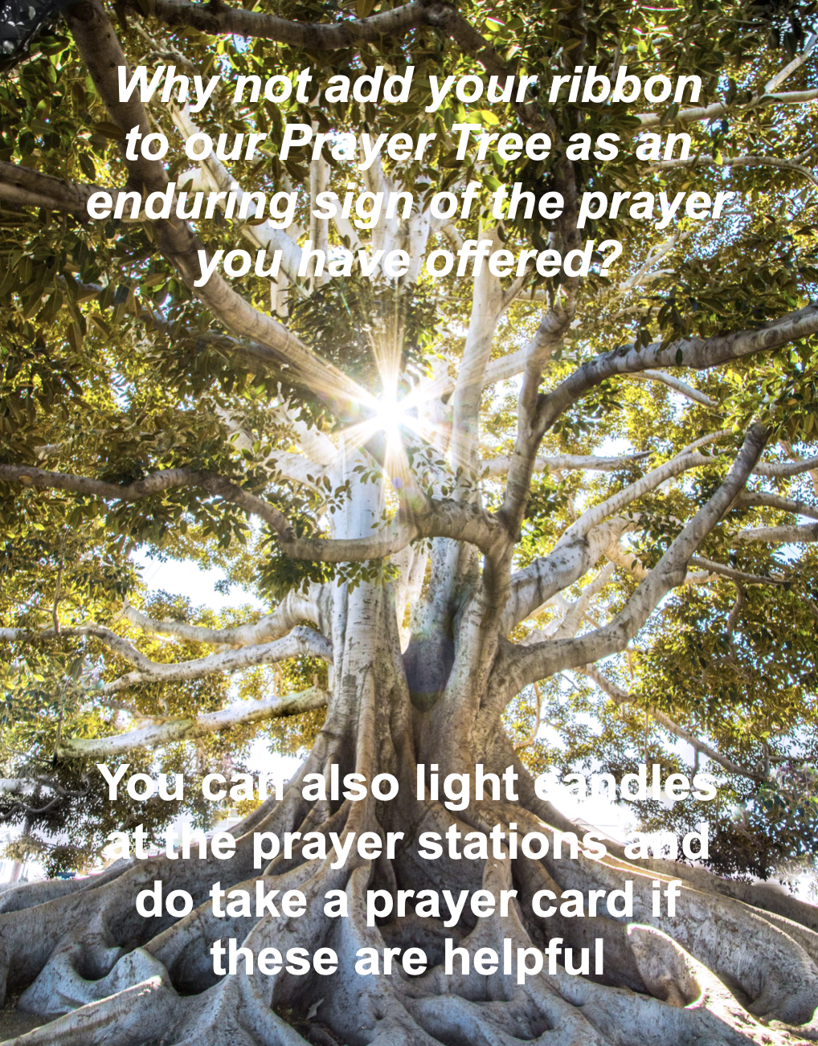

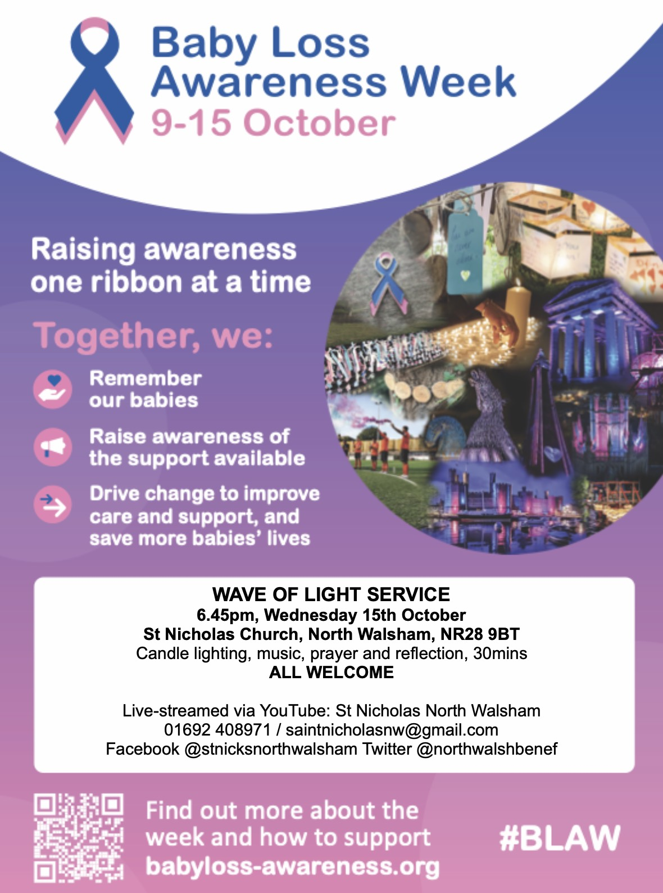
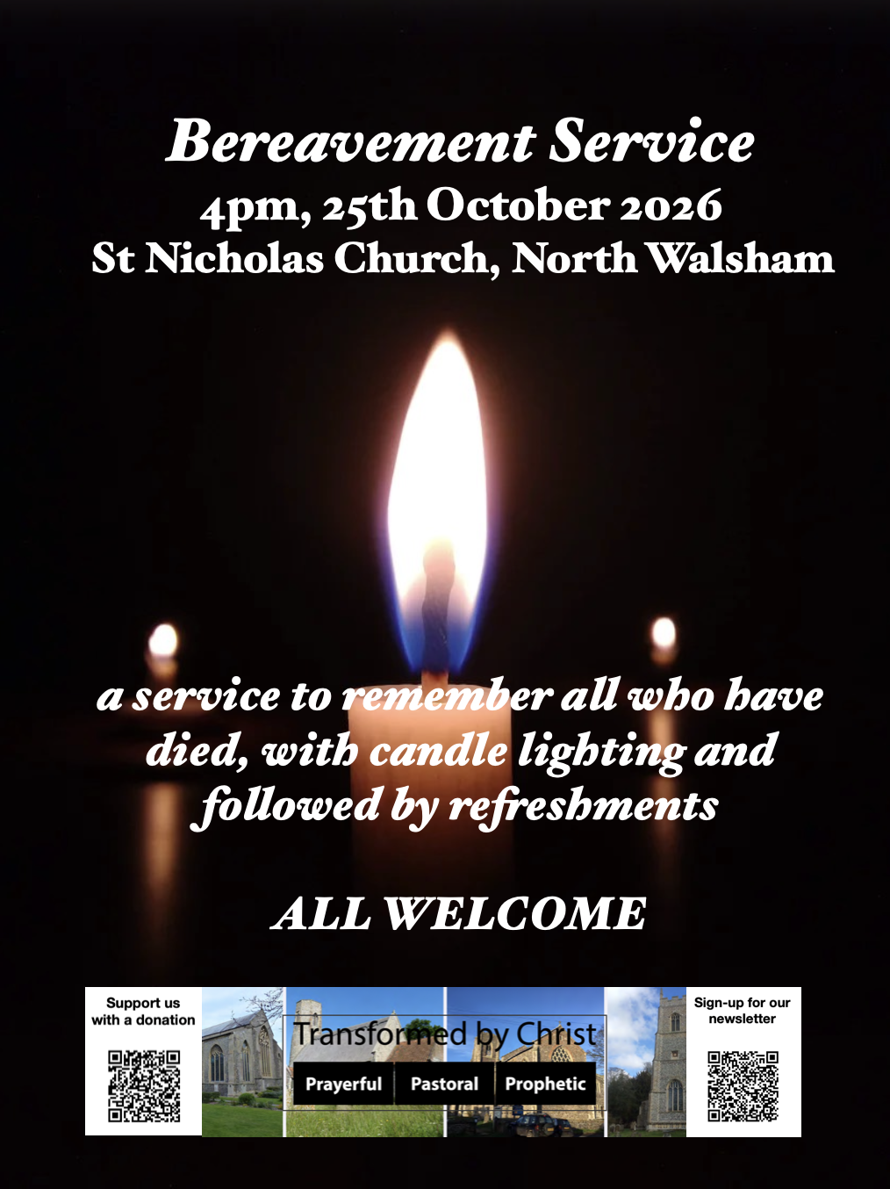
************************************************************************************

We are privileged to hold special
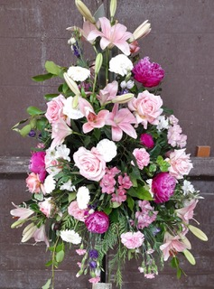
services at any of our churches
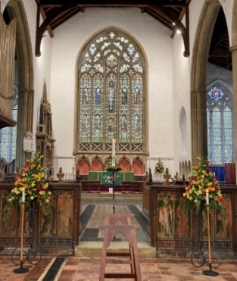
All who live in the benefice are entitled to a baptism, wedding or funeral service in church, and our clergy can officiate at the crematorium and cemeteries too. The church is here for you, through every moment of life.

From the Diary

Baptisms
Oscar Sadler
Theo Brown

Funerals
Barry Hooker
Nikki Page
Tara Oakley

Weddings
Brian Maritz and Anna Markova
Cameron Panting and Louise Latham
Matthew Stolworthy and Kathryn Smallwood
Matthew Mutton and Madison Piggott

Please hold those above and their families in your prayers.

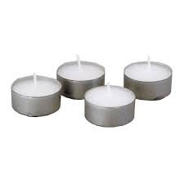
*************************************************************************************TThanks to all who’ve provided tealights for prayer stations at St Nicholas!
All donations of white, unscented tealights gratefully received!





We're pleased that our weekly coffee mornings at North Walsham and Worstead are now registered with Warm Welcome Spaces
North Walsham Market Day Coffee Morning
Thursdays 9.30 – 12.00noon
The space is open to all (and their well-behaved dogs on leads), every Thursday! A warm welcome and refreshments available

Thank you to everyone for raising donations for St. Nicholas Church, North Walsham with #easyfundraising! If you have not signed up yet, it is easy and completely FREE. 8,100 brands will donate to us when you use easy fundraising to do your everyday online shopping - at no extra cost to you! Every donation you raise makes a difference to us so please sign up & share today. https://join.easyfundraising.org.uk/stnicholaschurchnw/XT7MPH/at/TSX8RX7z/RTND2/facebook/



Please support the work of our Churches, by using the contactless giving point at St Nicholas or St Mary’s, leaving your gift on the offering plates or in the wall safes, or through these QR codes. Thank you.

Do you have a Business you would like to advertise in this magazine?
Whole, half or quarter page space is available.
Full Page £ 150.00
Half Page £ 75.00
Quarter Page £ 50.00
Please contact the Benefice office on 01692 408971
or email saintnicholasnw@gmail.com
for details and prices

Church Postcodes
Edingthorpe NR28 9TN, North Walsham NR28 9BT, Worstead NR28 9AL, Westwick NR10 5BW

Benefice dates

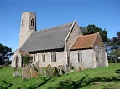
All Saints’ Edingthorpe
13th September 9:15 Holy Communion
27th September 4:00 Harvest Thanksgiving

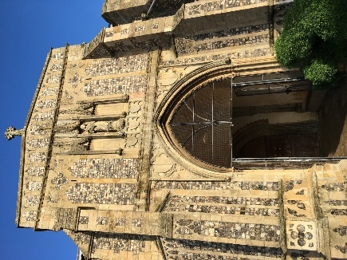
St. Mary’s, Worstead
6th September 9:15 Morning Prayer

20th September 9:15 Holy Communion

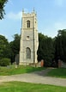
St Botolph’s Westwick

No service in September

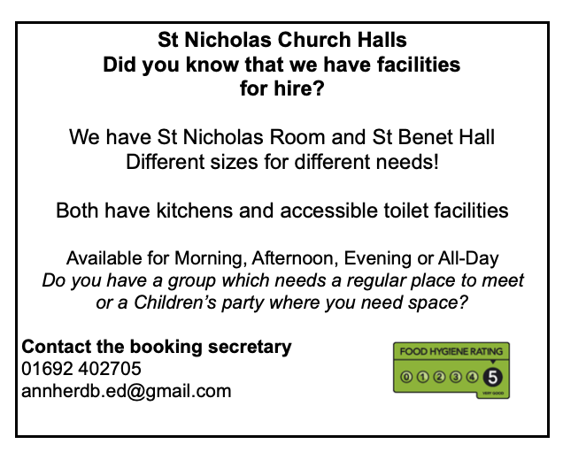
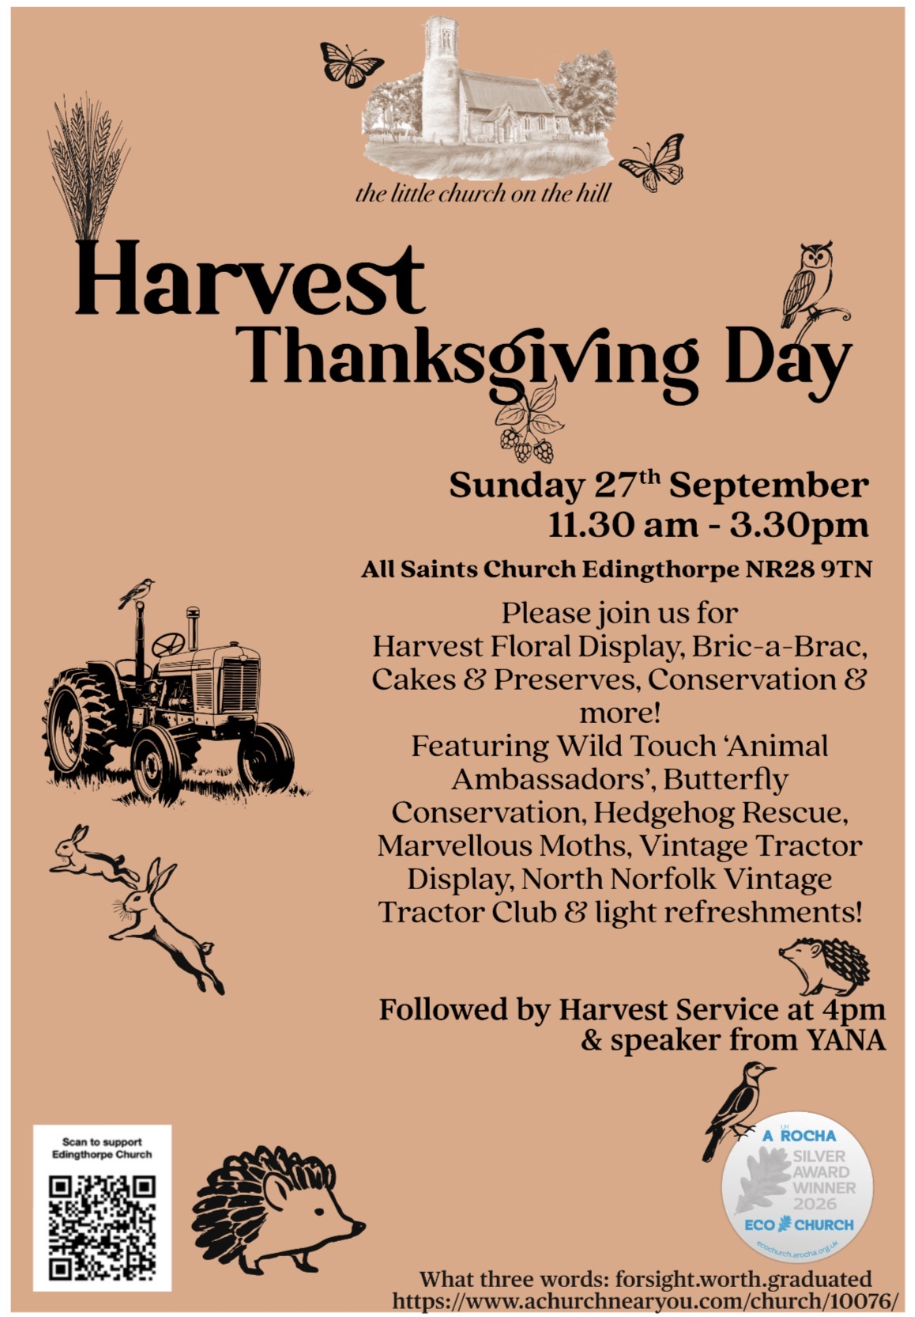

Ready to tick off your list – Will Made?
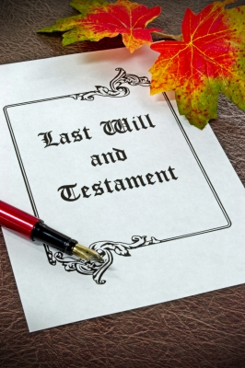
"The Church of England have teamed up with Farewills to provide a free will writing service: Online Will Writing Service | Legal Will In 15 Minutes . Anyone can use this service and it is not compulsory to leave something to your church, but it would be nice if you did. It is important for each one of us to leave our earthly matters in good order so why not take advantage of this opportunity now? It is good to remember a gift in your will to a charity is tax free. If you already have a will, you could consider leaving a legacy to the church by adding a codicil. https://farewill.com/norwich-diocese

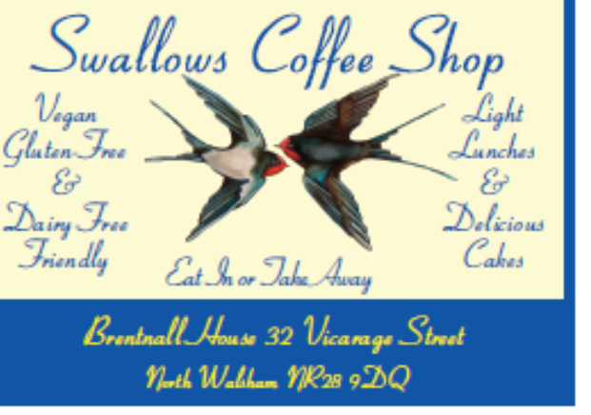

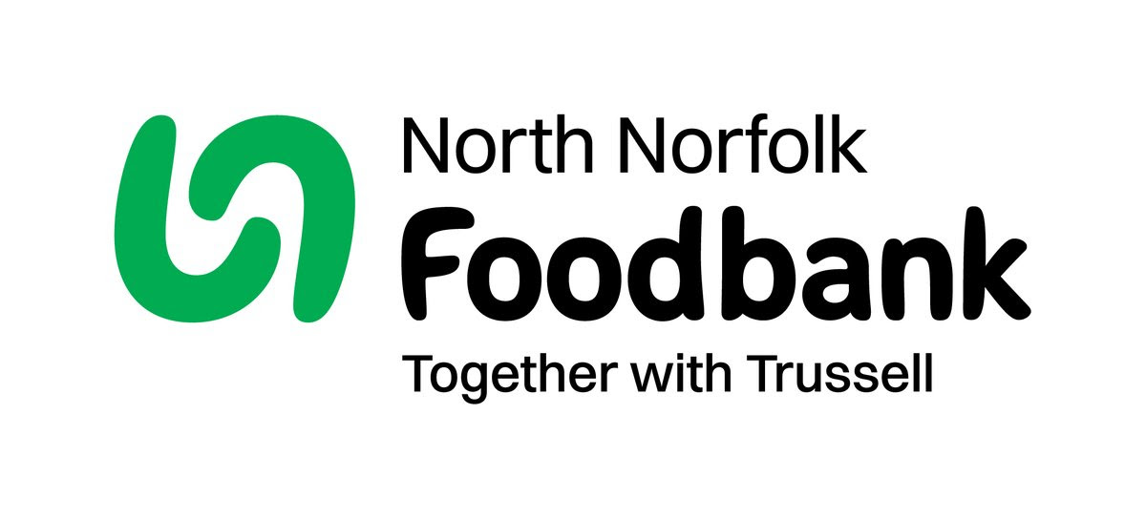
Dear Foodbank supporter,
Thank you for your donations from St Nicholas of 36.70 kg in July.
As a small charity we rely on donations, both food and financial, to operate and we are extremely grateful when people choose to support us.
During 2024 we fulfilled 2085 food vouchers, providing food for 4695 people, 2925 adults and 1770 children.
Whilst Trussell campaigns to end the need for foodbanks, we will be here helping those who need us right now. But that can only be done with kind donations from our supporters.
To see what we need most right now, our wish list is published on our website and social media, and the list gets updated throughout the month on our donation page
https://northnorfolk.foodbank.org.uk/give-help/donate-food/
Thank you for thinking of us and enabling us to serve the people facing hardship across our district.
Kind regards
Jules, Rebecca and the Foodbank team
North Norfolk Foodbank
Cromer Methodist Church Hall, West Street, Cromer, NR27 9DT
07826 376343

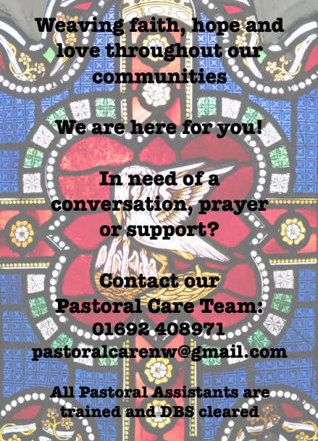

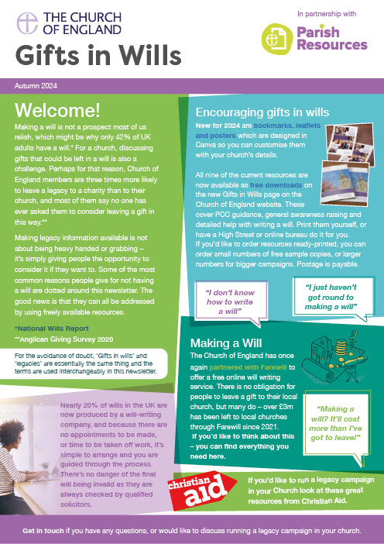
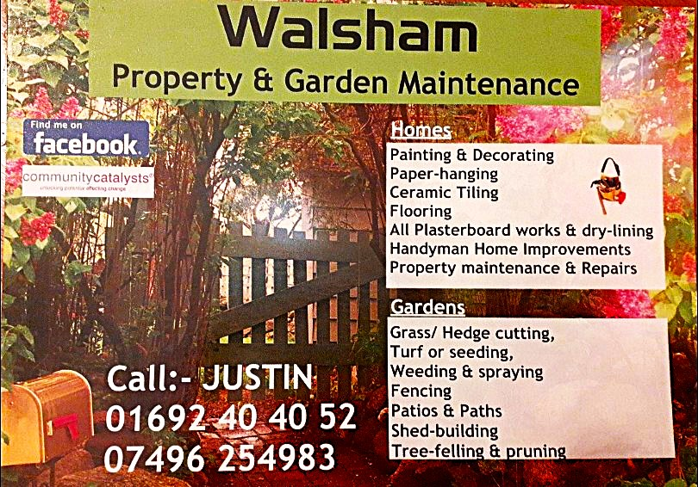

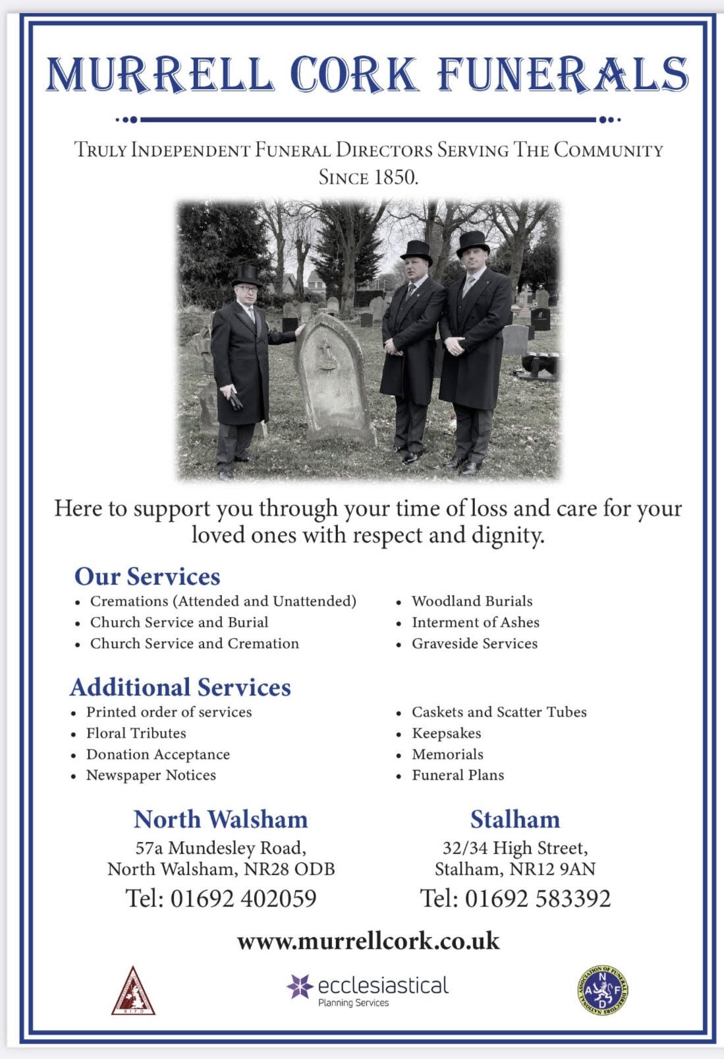
r Sale and Wants Page




Money Matters …
A regular report for our readers written by James Reginald Drake at ClearView Financial Consultants
Burgh Road, Aylsham - 01263 734859, Station Road, Hoveton - 01603 273590 and North Walsham 07773 626662

Lasting Powers of Attorney – Why are they so Important?
Lasting Powers of Attorney (LPA’s) are documents that give an individual you trust (your attorney) the legal authority to make decisions on your behalf should you either lose the mental capacity to make them, or you no longer wish to make these decisions yourself. Lasting Powers of Attorney come in 2 forms, these coming under the heading of ‘Property & Financial Affairs’ and ‘Health & Welfare’
So, how can they help?
The Property & Financial Affairs LPA covers things such as running your bank and savings accounts, making or selling investments, paying bills, buying or selling property and applying for benefits.
The Health & Welfare LPA covers things such as the type of health care and medical treatment you receive (including decisions on life sustaining treatment), where you live, as well as the type of care that you receive in areas such as diet and daily routine.
Given the wide range of areas that these documents cover, it becomes quite obvious as to why they are so important. However, according to ‘The Office of the Public Guardian’ via an article produced in 2022, less than 1% of the UK population have a Lasting Powers of Attorney in place.
So, why do so few people have them in place? One of the most commonly mentioned reasons is that people assume that their spouse will automatically have the right to make decisions for them should they ever reach the stage where they are unable to. This however is a common misconception and it is very often discovered far too late that they actually have no legal authority at all. Cost is another reason people put it off, I can assure you are costs for this type of work are minimal, in the hope this is not a reason to delay.
What should you do?
Well, the answer to this one is quite simple……. get on and set up both types of LPA as soon as you can. It is never too soon to set one up, but it certainly can be too late. By law, once your mental capacity has gone, so has your opportunity to appoint attorneys to act on your behalf. At this point your loved ones will be required to go down a different route and apply to the Court of Protection for a Deputyship order. This requires more forms, more cost and more time, which can all be easily avoided with a bit of forward planning.
So, if setting up Lasting Powers of Attorney(s) is something that you think would benefit you and your loved ones, please feel free to contact me and we can discuss how they can be put in place in a way that is best suited to your own personal requirements.
This short article in no way should be taken by readers as advice.
James can be contacted on either of the above landline numbers or via email at support@smithifa.co.uk
ClearView Financial Consultants is a trading name of Martin Smith Independent Financial Adviser Ltd, a company registered in England
under number 11439150 and authorised and regulated by the Financial Conduct Authority under number 944677.





