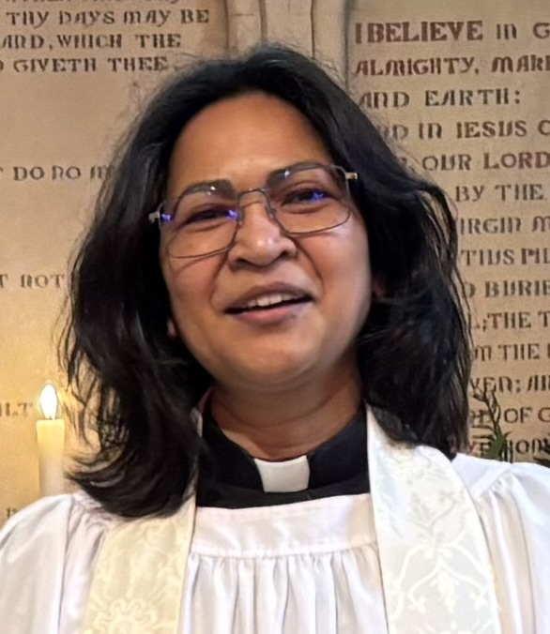
The Rector’s wonderings…

I wonder what image of God you hold…..?
All of us have our own particular image of God, and that image will have been affected by so many things - our parents, our church, authority figures in our lives, our coming to faith, our experiences.

Sometimes, that image can be deep down, and be very different from our expressed beliefs. So, for example, we can believe and even preach that God is loving, is in fact Love itself, and offers unconditional love, and yet we can still feel that we need to do things to earn God’s love.

We think there are the right prayers, right actions, right thoughts that will earn us God’s love. Somewhere in the recesses of our minds and hearts,
there is a battle between our images of God – a God who is all loving but is also a taskmaster we have to please.

Jesus demonstrated with everything in him, the deep love of God. A love that reaches out - accepts and draws in, rather than excluding. Everything he did and said reflects the heart of God - a God who is always searching for the lost and confused.

Julian of Norwich recognised this in her visions: “I saw to us he is everything that is good. He is our clothing. In his love he wraps us and holds us. He enfolds us for love and will never let us go.…. everything owes its existence to the love of God”

I invite you to reflect first of all on your own image of God.
And then, to measure it up against the words of Jesus - “if you have seen me you have seen the Father.”

Blessing
May the peace of God reign in this place, and the love of God forever hold you. May the Spirit of God flow through your life, and the joy of God uphold you. Amen

Revd Carol Bates
Rector

