SUNDAY MORNING READING SHEET 30th August 13th Sunday after Trinity

9 am only
A reading from Paul’s letter to the Romans
Let love be genuine; hate what is evil, hold fast to what is good; love one another with mutual affection; outdo one another in showing honour. Do not lag in zeal, be ardent in spirit, serve the Lord. Rejoice in hope, be patient in suffering, persevere in prayer. Contribute to the needs of the saints; extend hospitality to strangers.
Bless those who persecute you; bless and do not curse them. Rejoice with those who rejoice, weep with those who weep. Live in harmony with one another; do not be haughty, but associate with the lowly; do not claim to be wiser than you are. Do not repay anyone evil for evil, but take thought for what is noble in the sight of all. If it is possible, so far as it depends on you, live peaceably with all. Beloved, never avenge yourselves, but leave room for the wrath of God; for it is written, ‘Vengeance is mine, I will repay, says the Lord.’ No, ‘if your enemies are hungry, feed them; if they are thirsty, give them something to drink; for by doing this you will heap burning coals on their heads.’ Do not be overcome by evil, but overcome evil with good. Romans 12:9-21

GOSPEL
From that time on, Jesus began to show his disciples that he must go to Jerusalem and undergo great suffering at the hands of the elders and chief priests and scribes, and be killed, and on the third day be raised. And Peter took him aside and began to rebuke him, saying, ‘God forbid it, Lord! This must never happen to you.’ But he turned and said to Peter, ‘Get behind me, Satan! You are a stumbling-block to me; for you are setting your mind not on divine things but on human things.’ Then Jesus told his disciples, ‘If any want to become my followers, let them deny themselves and take up their cross and follow me. For those who want to save their life will lose it, and those who lose their life for my sake will find it. For what will it profit them if they gain the whole world but forfeit their life? Or what will they give in return for their life? ‘For the Son of Man is to come with his angels in the glory of his Father, and then he will repay everyone for what has been done. Truly I tell you, there are some standing here who will not taste death before they see the Son of Man coming in his kingdom.’ Matthew 16:21-28

BEDS & HERTS HISTORIC CHURCHES TRUST SPONSORED BIKE ‘N HIKE - SATURDAY 12TH SEPTEMBER 2026: Last year we in Royston we raised over £ 2,000 which was divided between BHHCT and our own parish funds. This earned us a Gold Certificate and we were one of only 11 churches that raised more than £ 2,000. We hope to do just as well or better this year. Select your own route for cycling or hiking between the churches – there are over 600 churches to choose from so make it as long or as short as you wish. Most churches will be open on the day. The Sponsorship Packs are now available and if you would like a sponsor form, please go online www.bedshertshct.org.uk or contact Mike Maze (245606 or mikefmaze@aol.com) There is always the easier option which is to sponsor one of the participants using their Sponsor form or if online giving suits you best, please visit:- Sponsor Rodney & Matt Dyer or Sponsor Mike Maze


If you wish to make a donation to the church, then please hold Your phone’s camera over this image then touch the link that appears:

Royston Parish Church
Where all are welcome and God’s love is shared
Sunday 30th August 2026 –13th Sunday after Trinity

If you would like regular copies of the Notice Sheet emailed to you please email the
Parish Office at admin@roystonparishchurch.org.uk

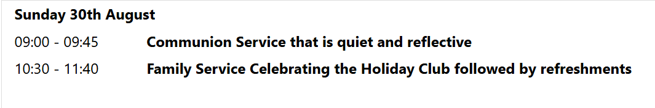
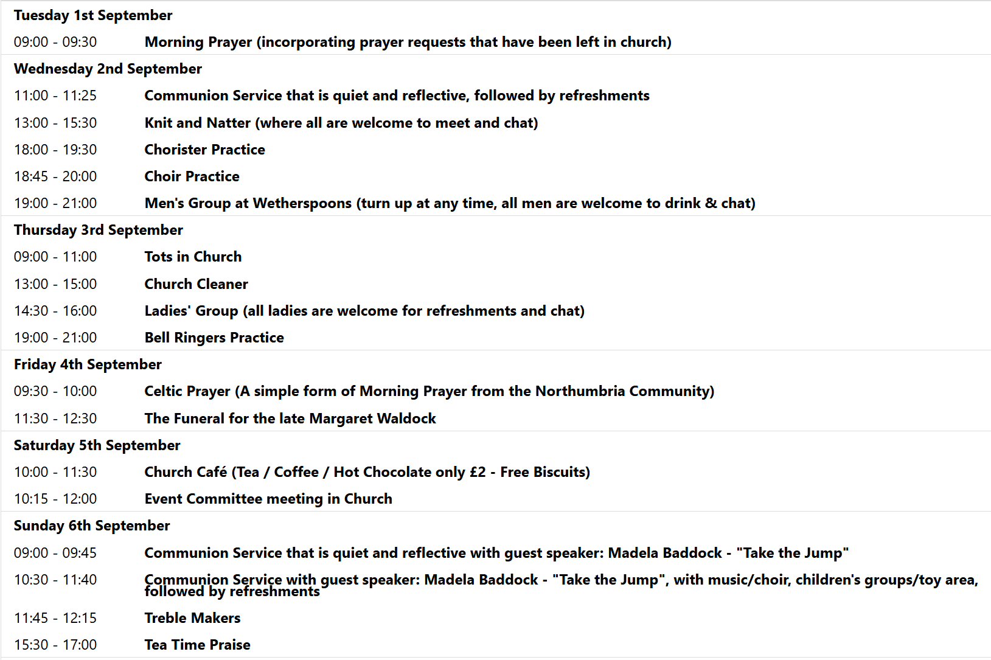
CREATIONTIDE BEGINS

We pray for all Christians worldwide:
For all Christians in Cape Verde, The Gambia, Guinea, Guinea-Bissau, Senegal
For all who worship at Royston Parish Church of St. John the Baptist: All who minister and worship in this Church
For the work of our mission partners: The Bible Society
Pray for the community of Royston:
For our local health centres
For all our local Babies and Toddler Groups and all those returning to school in the coming week
We pray for our world and ECO projects:
We pray for farmers and gardeners harvesting their crops

We pray for the sick and suffering:
2nd August | 9th August | 16th August | 23rd/30th August
Emma Thompson | Pat Tidey | Val Brown | Peter Coates
Jackson Herbert | Mike Brown | Angie & Ken Rushall | Sandra Cornwell
Marion |  | Paula Walker | Peter Foster
Peggy Dawes | Max Elliott | Clare Rice | Keith & Elaine Edwards

We pray for those who have died in the faith of Christ:
Deceased Bereaved
Baby David Family and friends
Margaret Waldock Family and freinds
We pray for those whose anniversaries fall at this time:
Joanna Jones, Daphne Charter, Clifford Trayler

NOTICES

ROYSTON PARISH CHURCH GAINS “ECO CHURCH SILVER AWARD”!
Royston Parish church has been participating in the A Rocha Eco Church scheme since 2021. This includes completing a survey to consider what actions our church is taking to care for creation and reduce our carbon footprint. The survey covers five categories: worship & teaching, buildings & energy, land & nature, community & global engagement, and lifestyle. We achieved the bronze award in 2022, and since then have been using the survey as a framework to inspire us to take further action. We are excited to announce that our church community has just been awarded “Eco Church Silver”. Our speaker for creationtide, Madela Baddock, will be presenting us with the plaque to celebrate this achievement on Sunday 6th September.

PLASTIC BOXES: Chris would be very pleased to receive any plastic boxes, that fruit come in, the size used for grapes. Please just leave on the Jam table. Thank you

SPEAKER FOR CREATIONTIDE: MADELA BADDOCK FROM "TAKE THE JUMP"
Our Creationtide speaker this year is Madela Baddock, an ambassador for "Take the Jump", a grass-roots climate-action movement that encourages people to adopt six practical shifts for a more sustainable lifestyle. She will be speaking to us at both the 9am and the 10:30am services on Sunday 6th September. Creationtide is the period in the church calendar from 1st September (the World Day of Prayer for Creation) to 4th October (the Feast of St Francis of Assisi, patron saint of ecology). Our previous guest speakers for this season have included Oliver Franklin-Wallis speaking about his book, "Wasteland", and Professor Rachel Warren who spoke on "Climate Change: Science and Solutions". We look forward to welcoming Madela on 6th September.
For more information about "Take the Jump", see their website: www.takethejump.org


HARVEST SUPPER: SATURDAY 3rd OCTOBER 6:00 pm: In Church, Tickets £12 individual / £30 family. Supper includes casserole, cottage pie or vegetarian alternative, with fruit crumble for dessert. Drinks available to buy. Entertainment included. To book please go to https://tickets.myiknowchurch.co.uk/gb/NzcwMi0zNw/t
or scan the QR code

SAVE THE DATES: We have a HERITAGE OPEN DAY in Church on Saturday 12th September 10 am – 4 pm. Free entry. Join us for a day of discovery about where we live. The Royston Tapestry on full display at the Parish Church, as well as demonstration of the organ and bells and tours of the church and refreshments. Donations welcome on the day.


ALSO : FRIDAY 25TH SEPTEMBER 7.30 PM – 9 PM, ARTS FESTIVAL ORGAN RECITAL: in Church, with Steven Sivyer playing the Organ. Tickets in advance are £10 for adults or £3 for under 18s in advance at https://bit.ly/ArtsFestivalOrgan or scan the QR code
Doors open from 7 pm, refreshments will be served.
AND; SATURDAY 26TH SEPTEMBER 10 AM TO 4 PM, ARTS FESTIVAL BOOK FAYRE: in Church,

HELP WANTED! We have 2 events coming up during September, for which we'd like donations of cakes, and help to serve refreshments. We have the Heritage Open Day on Saturday 12th, and the Arts Festival is running a book fayre in our church building on Saturday 26th, during which we'll be selling refreshments, the proceeds of which will go to church funds. If you're able to spare an hour or more to help, or can make a cake or batch of scones for either event, please can you sign up on the sheets at the back of church. Thank you from the Events Committee.

A DAY OUT IN NORFOLK Jilly Hall, a former member of our congregation who has recently moved to Norfolk, has invited us to share in a day she is organising on Wednesday September 23rd. called "Celebrating God's Creation on Massingham Heath". The morning will be a walk in the beautiful countryside, followed by lunch, then an afternoon of creative work : drawing, painting, writing, photography. All materials provided, no expertise necessary, the day and the lunch are free.
Massingham is about an hour-and-a-half to reach by car. The day starts at 10.30. If interested, please contact Duncan Rodgers for further details.
duncanstuartrodgers@gmail.com

