Palm 133
Please stand, if able, and join in with the verses in bold italics

How very good and pleasant it is
when kindred live together in unity!
It is like the precious oil on the head,
running down upon the beard,
on the beard of Aaron,
running down over the collar of his robes.
It is like the dew of Hermon,
which falls on the mountains of Zion.
For there the Lord ordained his blessing,
life for evermore.

Glory be to the Father and to the Son and to the Holy Spirit,
as it was in the beginning, is now and ever shall be,
world without end. Amen
Summer Fayre – Thank You
Thank you to everyone who helped at our Summer Fayre, together we raised £780 towards the new building fund.
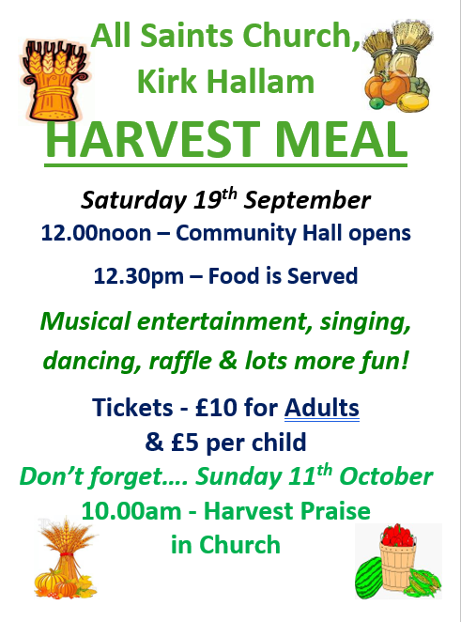
Mother’s Union Celebrations

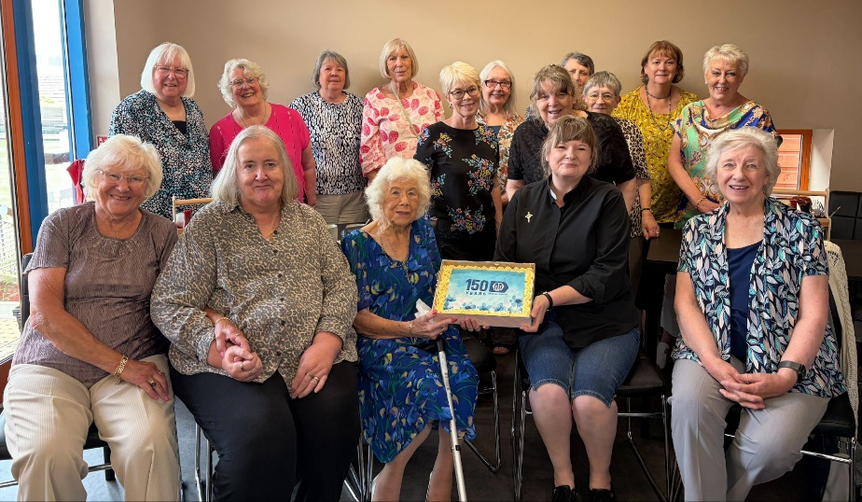

Thank you to Janet and Jane for organising our MU lunch out together, and thanks to the staff at the Community Café – it was lovely to be sat down for a change, rather than running around doing everything.

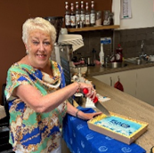

In our weekly prayers for our parish
This week we pray for God’s blessing on Friars Court, Gisby Road and Glendon Road

All Saints Church
Distribution of Communion –currently the Priest will dip the communion wafer in the wine while we discern a safe way to bring the common cup back into worship, as we want everyone to feel included and safe. We also have gluten free wafers available.

Do you want this to carry on, or would you rather have the chalice? We will be asking everyone what they would like and take it to the PCC meeting in September.
Refreshments After the Morning Service
Please stay seated after the service and a hot drink will be brought to you in the pews. Do not get up and head to the back of church, it is becoming a hazard, and a risk as trays of hot drinks could be knocked over.
Church contact information
Contact: Rev’d Christine - revchristine@outlook.com
The Rectory, The Village, West Hallam, DE7 6GR
Landline 0115 646 1497
Rev’d Ailsa -revailsahunt@gmail.com
Tel - 07356064856

Churchwardens – Mrs Janet Wheeldon, -Tel: 0115 8771593
Mrs Linda Gregory – linda.gregory3@icloud.com
https://www.achurchnearyou.com/church/13402/
https://www.facebook.com/allsaintskirkhallam
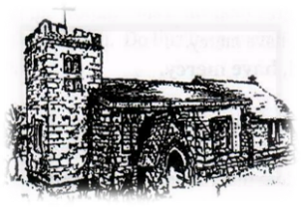
Kirk Hallam
Disabled Toilet in Friendship House.
Disabled Toilet in Friendship House.

Working with God to transform lives & communities.
Please can you ensure your mobile is on silence, or off during the service, it is affecting people with hearing aids and the loop system.

16th August – Eleventh Sunday After Trinity
10.00am CW Communion Service with Rev’d Ailsa
1.00pm Wedding Rehearsal in church
6.00pm BCP Holy Communion with Rev’d Christine

Forthcoming Events
Tues 18th 11.00am Interring ashes of Marina Charlton
Tues 18th 6.30pm Home Group in Friendship House
Weds 19th 9.30am Morning Prayer at UCAS
Weds 19th 7.00pm Scouts meeting in Friendship House
Fri 21st 1.00pm Wedding of Craig Robinson
and Katie Flinders
Fri 21st 6.00pm Choir in Friendship House
Sat 22nd 10.00am Prayer Meeting in Friendship House

23rd August – Twelfth Sunday After Trinity
10.00am CW Communion Service with Archdeacon Emma
1.00pm Baptism of Polly Padget
6.00pm BCP Evening prayer with Eileen

It’s Good to Talk! If you spot that someone is missing, please pop a news sheet through their door, & if you’ve time, call for a chat - just to check they’re OK & to let them know that they are not forgotten!
‘Let everything that has breath praise the Lord. Praise the Lord’ Psalm 150:6

