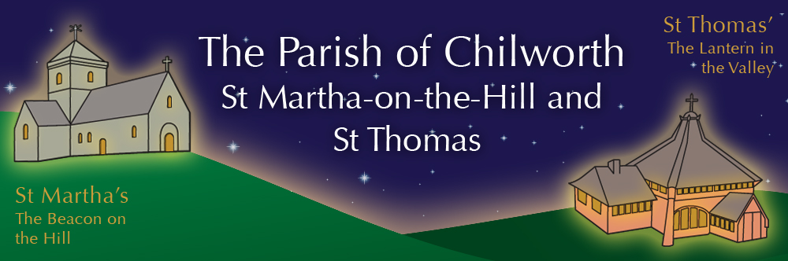

NOTICES: - 23rd AUGUST 2026
Priest David Oakden – Revdavid@parishofchilworth.org.uk - 01483 534293 (day off Friday)
Do let me know of anybody or anything that you would like to be prayed for.
www.parishofchilworth.org.uk and find us on https://www.achurchnearyou.com

**********Matthew 16:15-18 (NRSVA)******
He said to them, ‘But who do you say that I am?’ Simon Peter answered, ‘You are the Messiah, the Son of the living God.’ And Jesus answered him, ‘Blessed are you, Simon son of Jonah! For flesh and blood has not revealed this to you, but my Father in heaven. And I tell you, you are Peter, and on this rock I will build my church, and the gates of Hades will not prevail against it.
***********************************

Opportunities to pray together: -
Ecumenical Prayer Breakfast 1st Saturday of the month at the Vicarage, from 9am, prayer, coffee and croissant. Next is the 5th of September – Thursday evening (for ALPHA) at St Thomas at 7:00 pm for an hour. 20th August and 3rd September.

This Sunday Services: – 12th after Trinity
09:30 St Peter & St Paul, Albury Holy Communion.
11:15 St Martha’s Holy Communion.

Next Sunday Services: - 30th of August
09:30 St Thomas, Holy Communion.
11:15 St Martha’s Fifth Sunday.

Looking further ahead: -
Tots and Toddlers: St T’s Monday 9:15am
Broad Horizon: St M’s 25th August at 7pm
Meeting of Parishioners: St T’s 27th August 7pm
ALPHA Course: St T’s 7pm Thursdays from 10th Sept.

Food & Hygiene Bank: -
The Foodbank Larder box is located in the porch of St Thomas Church. Please help!
'Thank you to all who have donated recently putting us in a better situation.
Donations of LL milk, tinned meat, fish, veg & beans, sachets rice, toiletries and cleaning products always needed. We have sufficient pasta for the moment.
We also supply 6 families, 4 single households with monthly deliveries of fresh food at a cost £300-£400 a month.'
Chilworth Tinies and Toddler Group: -
Mondays from 9:15 -10:30 meet in St Thomas, play chat, pray and support.

ALPHA Course starting 10th SEPTEMBER: -
We are starting an ALPHA course in September at St Thomas Church, there will be food a short video and an opportunity to think and chat about the topic for that night in an open and friendly atmosphere, it is free and everyone is welcome.
Launches 10th September, we meet and eat at 7pm, then watch a video and have open discussions after.
There is no charge, but it is helpful to know how many are coming for catering purposes. Email me if you would like to know more or to let me know you intend to come at revdavid@parishofchilworth.org.uk
Also let me know if you can help or be involved in ensuring this all works well.

Meeting of Parishioners 27th August: -
Thursday 27th August at 7pm at St Thomas Church for the election of Richard Melhuish as Churchwarden.
This will be followed by his swearing in.

Broad Horizon Book Club: -
All are welcome at any or all of the monthly informal book discussion group sessions at the benches at St Martha’s (dress warmly!)
25 August – Cuddy (Ben Myers)
15 Sept – Don’t forget we’re here forever (Lamorna Ash)

