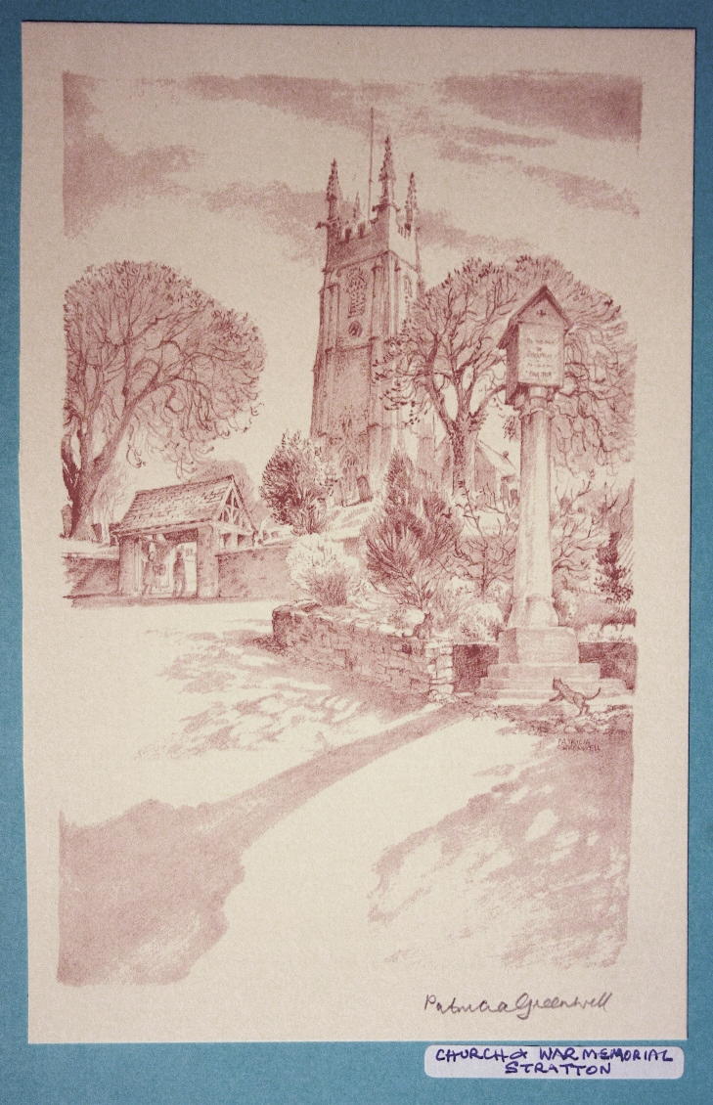 | The Parish Church  of St Andrew, Stratton  Priest in Charge  The Revd Teresa Folland  Tel: 01288 352599  e-mail: revteresa.folland@gmail.com  Churchwarden  Mrs Diana Ohlson  Tel: 01288 354441  e-mail: dohlson24@gmail.com
SEPTEMBER 2026

Prayer for the month

Let there be love and understanding among us;
Let peace and friendship be our shelter from life’s storms.
Eternal God, help us to walk with good companions,
to live with hope in our hearts and eternity in our thoughts,
that we may lie down in peace and rise up to find our hearts waiting to do your will. Amen.

Services at St Andrew’s September 2026

Wed  2nd | Christian Meditation 9.30am  Midweek Mass Wed. 10.30am – Officiant: Rev Teresa Folland
Sun  6th | 14th Sunday after TRINITY The Festival of Creation in Christ  Readings: Isaiah 55:12-end Psalm 96; Colossians 1:15-20; John 1:1-14 or Matthew 8:23-27.  Morning Worship 9.30am – LWLs Judy Dunne and Val Hopper  Evensong 6pm with LWL Sheila Waring Cantor: Dafydd Thomas  Psalm: 108 or 115  Readings:Ezekiel 12.21 – 13.16 Acts 19. 1-20 Reader: Andrew Davey
Wed 9th | Christian Meditation 9.30am  Midweek Mass Wed. 10.30am – Officiant: Rev Jane Bradbury
Sun  13th | 15th Sunday after TRINITY  Readings: Genesis 50:15-21; Psalm 103:1-13 (or 8-13); Romans 14:1-12; Matthew 18:21-35.  Parish Mass 9.30am – Officiant: Rev Teresa Folland
Wed  16th | Christian Meditation 9.30am  Midweek Mass Wed. 10.30am – Officiant: Rev Richard Ward Smith
Sun  20th | 16th Sunday after TRINITY  Readings: Jonah 3:10-4 end; Psalm 145:1-8; Philippians 1:21-end; Matthew 20:1-16.  Morning Worship: 9.30am – LWLs Judy Dunne and Val Hopper
Wed  23rd | Christian Meditation 9.30am  Midweek Mass Wed. 10.30am – Officiant: Rev Teresa Folland
Sun  27th | 17th Sunday after TRINITY  Readings: Ezekiel 18:1-4, 25-end;Psalm 25:1-8; Philippians 2:1-13; Matthew 21:23-32.  Parish Mass 9.30am – Officiant: Rev Jane Bradbury
Wed 30th | Christian Meditation 9.30am  Midweek Mass Wed. 10.30am – Officiant: Rev Jane Bradbury
Dates for your diary
Mon 7th Sept | MU meeting 2pm Stamford House
Thurs 10th Sept | School Children in the Church am.
Sat 12th Sept | Craft afternoon 2-4pm. 6 Old Drovers Way. Quilling
Thurs 17th Sep | School Children in the Church am.
Thurs 24th Sep | FoStA committee meeting 3pm at Stamford House
Fri 25th Sept | Hot Lunch in Church 12.30pm
Wed 7th Oct | Craft afternoon 2-4pm. 6 Old Drovers Way.
Sat 10th Oct | 7pm at the Community Hall, Harvest supper & Quiz
Fri 16th Oct | Craft afternoon 2-4pm. 6 Old Drovers Way.
Sat 24th Oct | Craft afternoon 2-4pm. 6 Old Drovers Way
Thurs 12th Nov | Craft afternoon at Upfield, Smallridge Lane, Diddies from 2-4pm. Felt Xmas tree decorations with Jennie.


Mothers’ Union.

The 150th banner exhibition in the cathedral was a great success. The banner from St Andrew’s Church was among the display, along with St James the Great Kilkhampton and St Michael’s Bude.
There is a copy of the MU Christmas catalogue in church with a selection of cards and gifts. If you would like to make an order this can be done directly online; just log onto Mothers’ Union MUE. You are also able to select Truro diocese which enables MU here in Cornwall receive 10% back towards our diocesan work. Alternatively contact Sheila Waring.

Next Meeting
Monday 7th September 2pm at Stamford House, Stamford Hill.
A celebration of creation with a collection of items for the Food Bank.
We welcome everyone to our meetings.
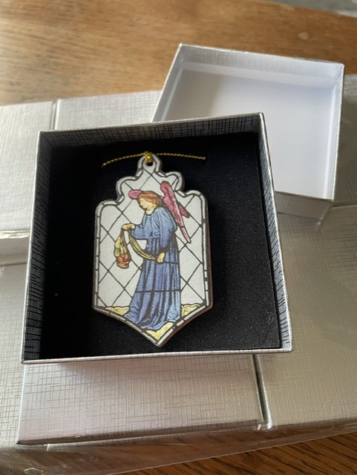
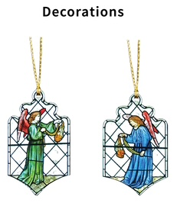
These Hanging Ornaments were handmade in Cornwall by Stockwell Ceramics, a crafts company who produce high quality, handmade jewelry and decorations which are sold in various places including the V and A Museum, Chatsworth House and in many other gift shops around the country.
The ornaments are a bespoke product made to our own special requirements. It is a way in which (FoStA) the Friends of St Andrew’s Church, Stratton wished to offer a lasting memento of the conservation work, undertaken by Holywell Glass of Wells, on our important stained glass East Window.
Each ornament comes in a presentation box making them an ideal keepsake or gift especially at Christmas time as they make perfect Christmas tree ornaments. There are blue and green angels as can be seen at the top of the East Window.
The cost is £10 each or £17.50 for a pair, i.e. 1 blue and 1 green. Each ornament measures approx.. 7.5 x 4cms and the box 8.5 x 8.5cms.
They may be purchased now by contacting Val Barker, Chair of FoStA , at 01288 353435 or email ianandvalstratton@hotmail.co.uk Thank You.
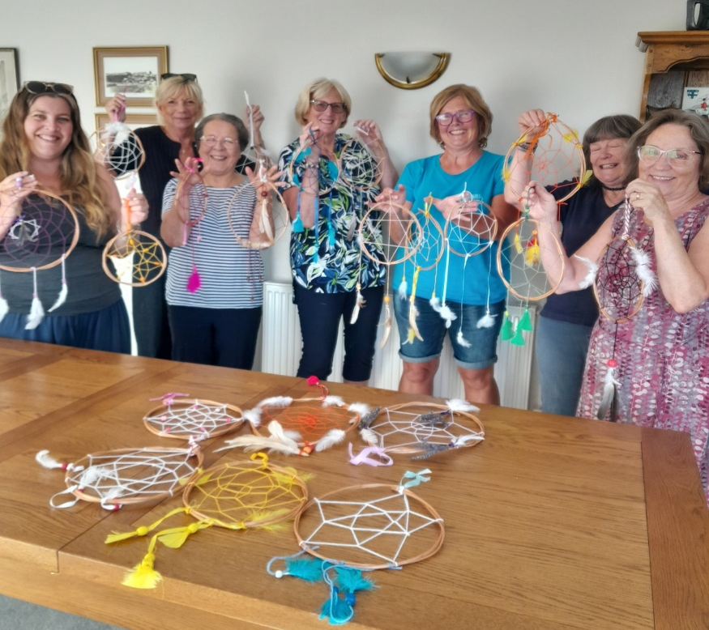

Craft Afternoons
The first of our craft making sessions took place on Aug 10th, and 21 dream catchers were made. It was a fun afternoon for all and we hope to sell these catchers, and all the other craft items, on a stall on our Gift Day in November.
Further sessions will be held on August 27th when we will be making macrame leaves as wall hangings, and on Sat Sept 12th, when cards for all occasions will be made from quilling paper strips. Two further dates are booked for Wed Oct 7th and Fri Oct 16th, with other crafting ideas, to make an interesting range of gifts and Christmas decorations. These 4 sessions will be held at 6 Old Drovers Way from 2pm ‘til 4pm and are open to anyone , no previous crafting skills necessary, but please let me know on 01288 359108 if you would like to come, so that sufficient materials can be organised. There is no charge for the sessions, but donations towards the cost of materials would be greatly appreciated.
Hot Lunches
Our popular lunches begin again on Sept 25th, with other dates on Oct 30th and Jan 1st. We look forward to welcoming you at 12 o clock in St Andrews Church, to a delicious 2 course meal with tea or coffee after, for £10 per ticket. Please book in either by signing the sheet in the church or by ringing me on 01288 359108. Gluten free and vegetarian option available.
Judy Dunne
Harvest Supper and Quiz
Advance notice of this event to be held in the Community Hall from 7pm on Oct 10th. Tickets are £15 each, or £5 for children under 10 yrs, available from the shop or church members. There will be a fun quiz to entertain you, a wine or punch stall, a raffle and of course a delicious harvest themed 2 course supper with a hot drink. We hope to see you and your neighbours at this happy event.
Churchyard Hay Making
Very many thanks to all those who have worked in the churchyard to tidy it up and prepare for the autumn. It is hard work but many hands make light work and the happy band soon got things done.
Aso, many thanks to Alan McIntosh for completing the work on the Lych Gates which now look very smart again.
Wanted

Do you have any old wooden cotton reels lurking in your needlework box? Those made of other material will be alright but we don’t want the slim reels that are often sold these days. Jennie is planning a craft making day in the late autumn and needs several cotton reels. If you can help we would be grateful – every single one counts. There will be a box in church and any you can spare may be left there. If you are at home and would like them collected just get in touch with one of the editors. Contact details below. Thank you

For the month of September
We remember in our prayers all those living in:
Week beginning:
Sunday 6th Sept | Stapleton Road, Traly Close, Catherine Close
Sunday 13th Sept | Kernow Crescent, The Rowans, Manor Road and the parts of Berries Avenue & Briar Rd within the Parish
Sunday 20th Sept | St Annes, Grove, Thorn, Hele and the parts of Kings Hill and Bedehaven Close within the Parish
Sunday 27th Sept | Redwood Grove, Elm Drive, Elm Lea and the parts of Holnicote Road within the Parish

Those who have asked for our prayers:
Allan Gouldson, Molly Hooper, Karen Hunting, Mick Carter, Gloria Braund, Stephen and family, Baby Alice
We bring before God, especially at this time, all who work in our local hospitals, the inpatients and all undergoing investigations and outpatient treatment. We remember too those of our church family who are ill at home or housebound.

The recently departed: May they rest in peace and rise in glory.

For the month of September
Those in our Year’s Mind:
Week beginning:
Sunday 6th Sept | Gerald Evans, Marjorie Grills, Christine Worland, Peter Stephens, Kathleen Peardon, Olive Ridgeman, Terence Barnard, Eric Worth, Moira Cann, Gwendoline Baldwin.
Sunday 13th Sept | Nell Varley, Ruth Saltern, Barbara Piper, John Morgan, Eleanor Burley, Doris Pooley, Joyce Fowler, Gladys Pearce
Sunday 20th Sept | Francis Worth, Shirley Philp, Mark Peardon, Margery Nartowski, Jean Gorman, John Going, Henry Pearce
Sunday 27th Sept | Ivy Hough, Charles Bryant, Fred Copeland, Kenneth Hopgood, Thelma Copeland, Susan Pearce, Ellen Davey, Edith Dodgson, Stanley Cook, Olga Painter, Edna Bigginj

News Sheet Editors:
Val Barker Tel: 01288 353435 and Sheila Waring Tel: 01288 ,714338

If you have anything for inclusion in the next news sheet for please send it to the editors by the 10th of the month.
Please submit all documents in Calibri (Body) Font, size 12. Thank you.

