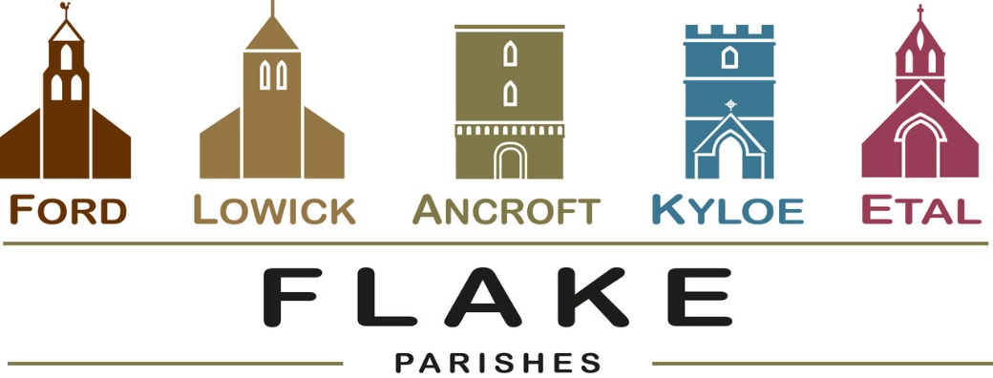
A very warm welcome to you, especially if you are visiting. Please take this sheet home with you and use it as a basis for prayer.
Sunday 9th August 2026
Lowick 9.15 Holy Communion
Ford 11am Holy Communion

Sunday 16th August 2026
Lowick 9.15 Holy Communion
Ford 11am Holy Communion

Sunday 23rd August 2026
Lowick 9.15 Holy Communion
Ford 11am Holy Communion

Sunday 30th August 2026: Flake Service
10am at Lowick with Revd Canon Dr Rob Kelsey

Sunday 6th September 2026
Lowick 9.15 Holy Communion
No service at Ford due to Etal Show


AUGUST
- Sunday 30th August Flake Service 10am Lowick with Revd Canon Rob Kelsey.
No other services that day.
SEPTEMBER
- Sunday 6th September Etal Show
12pm, no service at Ford
5pm Lowick Village Hall ‘Let’s Talk About It’
All most welcome to come and try this
- Monday 7th September
10.30am Lowick Church Start of Term Service
- Saturday 12th September 12-1.30pm
- Soup Saturday LVH
Wedding at Ford of Jamie and Jessica
- Sunday 13th September Lowick Vicarage Garden
Pet Blessing 4pm with refreshments
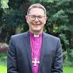
Contact Alex for details
- Friday 18th September
‘Looking through Lowick’s windows’
6pm -7.30pm Drinks, nibbles, donations
- Saturday 19th September 9am -1pm
Etal Village Hall Vision Morning 2 with Rt Revd Mark Wroe, Bishop of Berwick
- Tuesday 22nd September 1.30pm Ancroft PCC
- Saturday 26th September 7pm Lowick Village Hall
Harvest Supper with live music

September and October Sundays at 5pm-7pm
Lowick Village Hall
Questions of Life and Faith

Starting on Sept 6th – finish Oct 25th 8 days/16 hours of your life to revisit some of the questions we all ask at one time or another. Bring your friends – and let’s explore together. A short video, open conversation, light refreshments. No pressure, no judgement. Come along and say what you think and hear what others think.
Is there more to life? Who is Jesus? Why did Jesus die? How can I have faith?

A CHRISTMAS CELEBRATION THE GLASSHOUSE INTERNATIONAL CENTRE FOR MUSIC

A Songs of Praise Special Event
Join Aled Jones and some very special guests at the iconic Glasshouse for a spectacular Christmas concert. Bring your singing voice and Christmas jumper for an evening of classic carols and traditional hymns.
WHEN: Tuesday 6th October 2026 – start at 19:00
Doors open at 18:00

In our prayers
All who suffer in body, mind or spirit, especially Heather Piper, George Hall, Gail Calder, Don and Sam Quilty, Alison Murray. We pray for those who mourn, and for all who mark anniversaries of death at this time of year.

Flake Parishes Contacts

Revd Charlotte Osborn (Vicar) 01289 388591 ceosborn@mail.com 07957 367457

Revd Alex Firman (Assistant Curate) 07935 732811 alex_firman@hotmail.co.uk

Our other licensed clergy

Revd Margaret Sentamu 077871 204745
Canon Nick Sagovsky
Revd Marion Penfold 01289 305664

Church Contacts

Ancroft Leigh Yorke 07716 116739
Etal Andrew Joicey 01890 820540
Ford Kathleen Holmes 07951 099668
Lowick John Dickson 07967 343211

Parish Administrator
Sheena Atkinson
admin@flakeparishes.org

Safeguarding Officer
Philip Greene
safeguarding@flakeparishes.org
07555 412284

