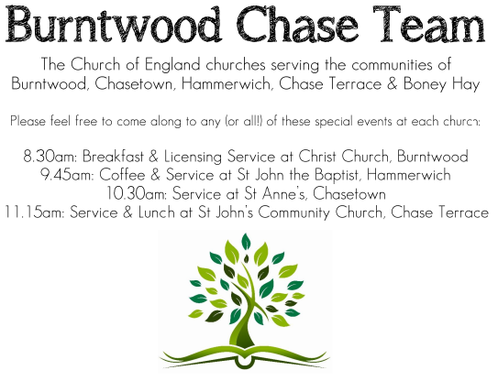 CHRIST CHURCH
SUNDAY 10th August 2025 at 10am

SERVICES:
Sunday 10th August 2025
Morning Worship
8th Sunday after Trinity

Readings:
Hebrews 11: 1-3, 8-16

Now faith is the assurance of things hoped for, the conviction of things not seen. ² Indeed, by faith our ancestors received approval. ³ By faith we understand that the worlds were prepared by the word of God, so that what is seen was made from things that are not visible.
By faith Abraham obeyed when he was called to set out for a place that he was to receive as an inheritance; and he set out, not knowing where he was going. ⁹ By faith he stayed for a time in the land he had been promised, as in a foreign land, living in tents, as did Isaac and Jacob, who were heirs with him of the same promise. ¹⁰ For he looked forward to the city that has foundations, whose architect and builder is God. ¹¹ By faith he received power of procreation, even though he was too old—and Sarah herself was barren—because he considered him faithful who had promised. ¹² Therefore from one person, and this one as good as dead, descendants were born, ‘as many as the stars of heaven and as the innumerable grains of sand by the seashore.’
¹³ All of these died in faith without having received the promises, but from a distance they saw and greeted them. They confessed that they were strangers and foreigners on the earth, ¹⁴ for people who speak in this way make it clear that they are seeking a homeland. ¹⁵ If they had been thinking of the land that they had left behind, they would have had opportunity to return. ¹⁶ But as it is, they desire a better country, that is, a heavenly one. Therefore God is not ashamed to be called their God; indeed, he has prepared a city for them.
Luke 12: 32-40
Do not be afraid, little flock, for it is your Father’s good pleasure to give you the kingdom. ³³ Sell your possessions, and give alms. Make purses for yourselves that do not wear out, an unfailing treasure in heaven, where no thief comes near and no moth destroys. ³⁴ For where your treasure is, there your heart will be also.
³⁵ ‘Be dressed for action and have your lamps lit; ³⁶ be like those who are waiting for their master to return from the wedding banquet, so that they may open the door for him as soon as he comes and knocks. ³⁷ Blessed are those slaves whom the master finds alert when he comes; truly I tell you, he will fasten his belt and have them sit down to eat, and he will come and serve them. ³⁸ If he comes during the middle of the night, or near dawn, and finds them so, blessed are those slaves.
³⁹ ‘But know this: if the owner of the house had known at what hour the thief was coming, he would not have let his house be broken into. ⁴⁰ You also must be ready, for the Son of Man is coming at an unexpected hour.’

COLLECT FOR TODAY

Almighty Lord and everlasting God,
we beseech you to direct, sanctify and govern
both our hearts and bodies
in the ways of your laws
and the works of your commandments;
that through your most mighty protection,
both here and ever,
we may be preserved in body and soul;
through our Lord and Saviour Jesus Christ,
who is alive and reigns with you,
in the unity of the Holy Spirit,
one God, now and for ever.

WHAT’S GOING ON
Upcoming Services

Wednesday 13th August Morning Prayer 9.30am
Sunday 17th August Holy Communion 10am
Wednesday 20th August Morning Prayer 9.30am
Sunday 24th August Morning Worship 10am

Reconditioned piano
The church has purchased a new reconditioned piano, any donations would be welcomed. Many thanks for all donations already received.

MOB AGM
Wednesday 13th August at St. Mathews 7.00 for 7.30pm , a buffet will be available.

FLOODLIGHTING
If you think about commemorating a special occasion by floodlighting our Church. Please contact Chris Brown on 01543 683862 for details.

PRAYER CHAIN
Christ Church is blessed with a very active prayer chain. If you, or anyone you know, feel that they would like others to pray for them, please speak to Chris Brown on 01543 683862.

HOME COMMUNION
For anyone who is unable to attend church and would like Home Communion,
Steve Morgan is able to carry this out.

VICAR CONTACT DETAILS
Stephen Morgan Tele: 07305 852152
CHURCH WARDENS CONTACT DETAILS
Judith Rogers Tele: 01543 324718
Mike Holmes Tele: 01543 672970
Church Office Tele: 01543 642187 [leave a message and we will respond]
Church Web Site:www.christchurchburntwood.org.uk
Church Email: christchurchburntwood15@gmail.com
Facebook: www.facebook.com/group/christchurchburntwood/

Other Contacts
Matt Wallace St. John’s, Chase Terrace— Tele: 01543 670078
Richard Westwood St. Anne’s, Chasetown—Tele: 01543 686111

NEXT SUNDAY SERVICE
Sunday 17th August at 10am
Holy Communion
Hebrews 11: 29-12:2
Luke 12: 49-56
9th Sunday after Trinity

