
SPIRE & LIGHT United Churches
United Benefice of St Keverne, St Ruan with St Grade & St.Wynwallow (The Lizard)

*If you do not wish to receive these notices, please let your Churchwarden know*

16th August 2026

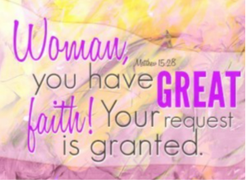
Readings
Isaiah 56:1, 6-8
Psalm 67
Romans 11:1-2a, 29-32
Matthew 15:21-28

9.30am – Holy Communion - St.Peter’s, Coverack
9.30am – Holy Communion - St.Wynwallow, The Lizard
11am – Morning Prayer – St.Keverne
11.15am – Family Service – St.Ruan, Ruan Minor

Next week – Sunday August 23rd
9.30am – Morning Prayer - St.Peter’s, Coverack
9.30am – Holy Communion - St.Ruan, Ruan Minor
11am – Creation Sunday - St.Keverne
11.15am – Café Church – St.Wynwallow, The Lizard

August 30th – United Benefice service of Holy Communion
11am St.Peter’s Church, Coverack

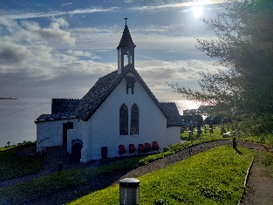

The Prayer Spot
The Diocese of Truro’s Prayer Diary for this week

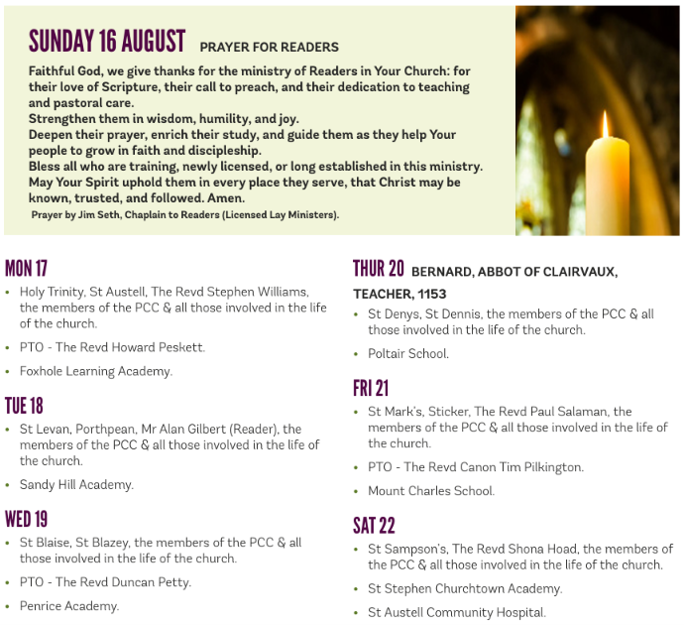

We pray for the Deanery that we belong to and we thank you for the faithful people you have brought together here. Remind us that we have each been brought to faith by Our Saviour Jesus Christ.
Lord Jesus, we thank you for your presence in our lives and the love you give us to share with others. Keep us strong in our faith and close to you.
Help us to be always there for others in their time of need, you have given us each gifts to use to reach out to others and to give comfort to those around us.
Heavenly Father we live in a world slowly destroying itself, through greed, hatred, and with no concern for others. Remind us that we can bring love, care and understanding into the world, by reaching out into our communities and showing your love to all we meet. Loving God, be with us always. Remind us that we are brothers and sisters in Christ Jesus, that God is ever present in our lives, through his wonderful Holy Spirit that he has given to you as a free gift to us all.
Mighty God, everything you do reveals your Majesty. Open our eyes to see what you are doing in our lives. Let us marvel at your good gifts and your wise provision. Your acts are amazing Lord. We cannot comprehend the number of blessings you pour out to us from day to day. As we gather today around your name, we pray that you will fill our hearts, our minds and our souls. Transform us Lord and make us more like you. Through Jesus Christ our Lord. Amen
God bless you all. Samuel Buchanan

On the Way Prayers

Summer suns are glowing over land and sea, happy light is flowing bountiful and free. Everything rejoices in the mellow rays; all earth’s thousand voices swell the psalm of praise. Let’s just be still for a moment and thank God for warm summer weather which maybe makes us slow down.

Help us to remember that holidays were originally Holy Days. We know that we all need a break sometime, that we all need to recharge our batteries and to broaden our minds in pastures new. Help us Lord to put our trust in you as we travel, as we entertain family and friends, and as we try to relax and refresh ourselves. “Come unto me, all ye that labour and are heavy laden, and I will give you rest. “

We pray for our Deanery, now we at last know the outcome of the Church Commissioners’ hearing. Help us now to go forward together as we prepare to welcome Stewart in the autumn and as we continue to find new ways of growing your church here in Kerrier. We particularly pray for the combined Wild Church at St Martin this coming Sunday as we celebrate Lammastide and for Susie who is leading it. She has also organised for a group of our number to be trained in Out of the Box storytelling and that takes place next week. We pray that all those being trained will then be able to spread your Word within our schools and church groups.

As our young people start receiving their examination results we pray for them; for those who will be celebrating their successes and those who must come to terms with disappointment and having to make new plans. Dear Lord be with each of them as they reach a new crossroad in their life and help them prepare for the next stage of their life’s journey.

Let us now turn our prayers to the wider world where earthquakes, drought, war, famine and disease seem overwhelming. We pray for all firefighters coping with the wildfires springing up everywhere. And we continue to pray for peace, in the Middle East, in Ukraine and in so many parts of Africa. Tonight Europe will experience an eclipse of the sun. We thank you Lord for the marvels of creation and for these momentous events which bring nations together in moments which can feel very spiritual and moving.

And now we take a moment to pray for anyone who needs the comfort of our collective prayers right now or for anything that is uppermost in our minds and in need of God’s help.

