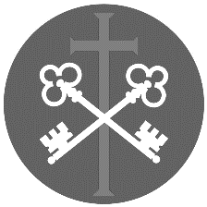
St Peter and the Holy Apostles, Plymouth
Sunday 30th August 2026-
The Twenty-Second Sunday in Ordinary Time (Year A)
Welcome to the Parish Mass
Welcome to St Peters Church. This sheet provides all that you will need for today’s Mass. If you need any assistance before, during or after the service or need a large print copy of this order of service please speak to one of our welcome team. (identifiable by a lanyard)
Please respond to the words in non-italic Bold, The Hymns are sung by all. Please inform the people on the door when you enter if you require a Gluten Free Host
………………………………………………………………………………
We Stand for The Entrance Hymn
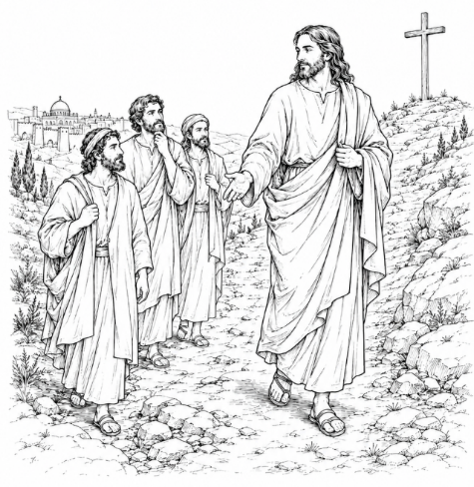
1. All praise to thee, for thou, O King divine,
didst yield your glory that of right was thine,
that in our darkened hearts thy grace might shine: Alleluia, Alleluia!
2. Thou cam'st to us in lowliness of thought;
by thee the outcast and the poor were sought,
and by thy death was God's salvation wrought: Alleluia, Alleluia!
3. Let this mind be in us which was in thee,
who wast a servant that we might be free,
humbling thyself to death on Calvary: Alleluia, Alleluia!
4. Wherefore, by God's eternal purpose, thou
art high exalted o'er all creatures now,
and given the name to which all knees shall bow:
Alleluia, Alleluia!
5. Let every tongue confess with one accord
in heaven and earth that Jesus Christ is Lord;
and God the Father be by all adored:
Alleluia, Alleluia!
The Introductory Rite
In the name of the Father and of the Son and of the Holy Spirit. Amen.
Following the greeting we respond.
And with your spirit.
The Priest introduces the Mass
The Penitential Rite
Brothers and sisters, let us acknowledge our sins, and so prepare ourselves to celebrate the sacred mysteries.

I confess to almighty God and to you, my brothers and sisters, that I have greatly sinned, in my thoughts and in my words, in what I have done and in what I have failed to do, through my fault, through my fault, through my most grievous fault; therefore I ask blessed Mary ever-Virgin, all the Angels and Saints, and you, my brothers and sisters, to pray for me to the Lord our God.

May almighty God have mercy on us, forgive us our sins, and bring us to everlasting life. Amen.

Either:
Lord, have mercy. Lord, have mercy.
Christ, have mercy. Christ, have mercy.
Lord, have mercy. Lord, have mercy.
Or:
Kyrie, eleison. Kyrie, eleison.
Christe, eleison. Christe, eleison.
Kyrie, eleison. Kyrie, eleison.

The Gloria
Glory to God in the highest, and on earth peace to people of good will. We praise you, we bless you, we adore you, we glorify you, we give you thanks for your great glory, Lord God, heavenly King, O God, almighty Father.
Lord Jesus Christ, Only Begotten Son, Lord God, Lamb of God, Son of the Father, you take away the sins of the world, have mercy on us; you take away the sins of the world, receive our prayer; you are seated at the right hand of the Father, have mercy on us.
For you alone are the Holy One, you alone are the Lord, you alone are the Most High, Jesus Christ, with the Holy Spirit, in the glory of God the Father. Amen.

The Collect- The Priest leads the prayer of the day.

Let us pray. God of might, giver of every good gift, put into our hearts the love of your name, so that, by deepening our sense of reverence, you may nurture in us what is good and, by your watchful care, keep safe what you have nurtured. Through our Lord Jesus Christ, your Son, who lives and reigns with you in the unity of the Holy Spirit, God, for ever and ever. Amen

We sit for The First Reading- Jeremiah 20:7-9
O Lord, you have deceived me, and I was deceived; you are stronger than I, and you have prevailed. I have become a laughing-stock all the day; everyone mocks me. For whenever I speak, I cry out, I shout, ‘Violence and destruction!’ For the word of the Lord has become for me a reproach and derision all day long. If I say, ‘I will not mention him, or speak any more in his name’, there is in my heart as it were a burning fire shut up in my bones, and I am weary with holding it in, and I cannot.
The word of the Lord. Thanks be to God.

The Responsorial Psalm- Ps 63(62):2. 3-4. 5-6. 8-9. ℟2b
Response - For you my soul is thirsting, O Lord, my God.

O God, you are my God; at dawn I seek you; for you my soul is thirsting.
For you my flesh is pining, like a dry, weary land without water. R

I have come before you in the sanctuary, to behold your strength and your glory.
Your loving mercy is better than life; my lips will speak your praise. R

I will bless you all my life; in your name I will lift up my hands.
My soul shall be filled as with a banquet; with joyful lips, my mouth shall praise you. R

For you have been my strength; in the shadow of your wings I rejoice.
My soul clings fast to you; your right hand upholds me. R
The Second reading- Romans 12:1-2
I appeal to you, brothers and sisters, by the mercies of God, to present your bodies as a living sacrifice, holy and acceptable to God, which is your spiritual worship. Do not be conformed to this world, but be transformed by the renewal of your mind, that by testing you may discern what is the will of God, what is good and acceptable and perfect.
The word of the Lord. Thanks be to God

We stand for The Gospel Procession and Acclamation- Cf. Ephesians 1:17-18
Alleluia, alleluia. May the Father of our Lord Jesus Christ, enlighten the eyes of our hearts, so that we may know the hope to which he has called us. Alleluia.

The Gospel- Matthew 16:21-27
The Lord be with you. And with your spirit.
A reading from the holy Gospel according to N. Glory to you, O Lord.
At that time: Jesus began to show his disciples that he must go to Jerusalem and suffer many things from the elders and chief priests and scribes, and be killed, and on the third day be raised. And Peter took him aside and began to rebuke him, saying, ‘Far be it from you, Lord! This shall never happen to you.’ But he turned and said to Peter, ‘Get behind me, Satan! You are a hindrance to me. For you are not setting your mind on the things of God, but on the things of man.’
Then Jesus told his disciples, ‘If anyone would come after me, let him deny himself and take up his cross and follow me. For whoever would save his life will lose it, but whoever loses his life for my sake will find it. For what will it profit a man if he gains the whole world and forfeits his soul? Or what shall a man give in return for his soul? For the Son of Man is going to come with his angels in the glory of his Father, and then he will repay each person according to what he has done.’

The Gospel of the Lord. Praise to you, Lord Jesus Christ.

We sit for The Homily

We stand for The Creed

I believe in one God, the Father almighty, maker of heaven and earth, of all things visible and invisible.
I believe in one Lord Jesus Christ, the Only Begotten Son of God, born of the Father before all ages. God from God, Light from Light, true God from true God, begotten, not made, consubstantial with the Father; through him all things were made. For us men and for our salvation he came down from heaven,

At the words that follow, up to and including ‘and became man’, all bow.
and by the Holy Spirit was incarnate of the Virgin Mary, and became man.

For our sake he was crucified under Pontius Pilate, he suffered death and was buried, and rose again on the third day in accordance with the Scriptures.
He ascended into heaven and is seated at the right hand of the Father. He will come again in glory to judge the living and the dead and his kingdom will have no end.
I believe in the Holy Spirit, the Lord, the giver of life, who proceeds from the Father and the Son, who with the Father and the Son is adored and glorified, who has spoken through the prophets.
I believe in one, holy, catholic and apostolic Church. I confess one Baptism for the forgiveness of sins and I look forward to the resurrection of the dead and the life of the world to come. Amen.
…………………………………………………………………………………………

We stand for The Prayers of the Faithful

Each biding concludes with the following said or sung-
We pray to the Lord- Lord in your Mercy hear our prayer.

The Priest Concludes the Prayers of the Faithful
No collection is taken during the Mass, but there is a collection box at the back of church for you to give your financial contribution. All money collected helps towards the mission and ministry of our churches. If you would prefer, a card reading machine is available at the back of the church for your contribution
The Offertory Hymn
1. Lord of creation, to you be all praise!
Most mighty your working, most wondrous your ways!
Your glory and might are beyond us to tell,
And yet in the heart of the humble you dwell.
2. Lord of all power, I give you my will,
In joyful obedience your tasks to fulfil.
Your bondage is freedom, your service is song;
And, held in your keeping, my weakness is strong.
3. Lord of all wisdom, I give you my mind,
Rich truth that surpasses man’s knowledge to find.
What eye has not seen and what ear has not heard
Is taught by your Spirit and shines from your Word.
4. Lord of all bounty, I give you my heart;
I praise and adore you for all you impart;
Your love to inspire me, your counsel to guide,
Your presence to cheer me, whatever betide.
5. Lord of all being, I give you my all;
If e’er I disown you, I stumble and fall;
But, sworn in glad service your word to obey,
I walk in your freedom to the end of the way.
The Liturgy of the Eucharist
Pray, brethren (brothers and sisters), that my sacrifice and yours may be acceptable to God, the almighty Father.
May the Lord accept the sacrifice at your hands for the praise and glory of his name, for our good and the good of all his holy Church.

The Lord be with you. And with your spirit.

Lift up your hearts. We lift them up to the Lord.
Let us give thanks to the Lord our God. It is right and just.
The Priest continues with the Preface. The Sanctus is said or sung:
Holy, Holy, Holy Lord God of hosts.
Heaven and earth are full of your glory. Hosanna in the highest.
Blessed is he who comes in the name of the Lord. Hosanna in the highest.

The Priest continues the Eucharistic prayer. The following is said or sung
The mystery of faith. We proclaim your Death, O Lord, and profess your Resurrection until you come again.

The Priest concludes the Eucharistic prayer.
Through him, and with him, and in him, O God, almighty Father, in the unity of the Holy Spirit, all glory and honour is yours, for ever and ever. Amen.

The Lord’s Prayer
At the Saviour’s command and formed by divine teaching, we dare to say:
Our Father, who art in heaven, hallowed be thy name; thy kingdom come, thy will be done on earth as it is in heaven. Give us this day our daily bread, and forgive us our trespasses, as we forgive those who trespass against us; and lead us not into temptation, but deliver us from evil.
Deliver us, Lord, we pray… and the coming of our Saviour, Jesus Christ.
For the kingdom, the power and the glory are yours now and for ever.

The Peace
Lord Jesus Christ, who said to your Apostles: Peace I leave you, my peace I give you,
look not on our sins, but on the faith of your Church, and graciously grant her peace and unity in accordance with your will. Who live and reign for ever and ever. Amen.
The peace of the Lord be with you always: And with your spirit.
Let us offer each other the sign of peace.
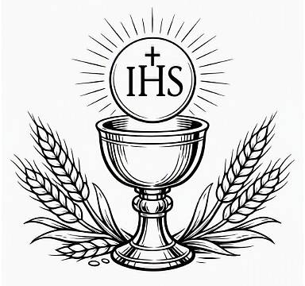
All are invited to make a acknowledgement to each other to mark the sign of the peace.

The Agnus Dei
All say or sing:
Lamb of God, you take away the sins of the world, have mercy on us.
Lamb of God, you take away the sins of the world, have mercy on us.
Lamb of God, you take away the sins of the world, grant us peace.

The Invitation to Communion
Behold the Lamb of God, behold him who takes away the sins of the world. Blessed are those called to the supper of the Lamb.
Lord, I am not worthy that you should enter under my roof,
but only say the word and my soul shall be healed.
All who are regular communicants in their own tradition are welcome to receive the sacrament if you are not a communicant you are welcome to come forward at this point in the service to receive a blessing To indicate that it is just a blessing you require, please take this service sheet up with you. We have returned to offering the chalice at the time of communion but please do not feel any pressure to receive from the common cup as the church teaches that the sacrament is received fully in one kind. We request that you do not intinct (dip) your host in the Chalice but either take a sip from the cup or return directly to your seat. This is for reasons of good hygiene.
The Communion Hymn

1. Lord Jesus Christ
You have come to us
You are one with us, Mary's Son.
Cleansing our souls from all their sin.
Pouring Your love and goodness in.
Jesus our love for you we sing,
Living Lord.
2. Lord Jesus Christ
Now and every day
Teach us how to pray, Son of God.
You have commanded us to do
This in remembrance Lord of you
Into our lives your power breaks through,
Living Lord.
3. Lord Jesus Christ
You have come to us
Born as one with us, Mary's Son.
Led out to die on Calvary,
Risen from death to set us free,
Living Lord Jesus help us see
You are Lord.
4. Lord Jesus Christ
I would come to you
Live my life for you, Son of God.
All your commands I know are true,
Your many gifts will make me new,
Into my life your power breaks through,
Living Lord.

We stand for The Prayer After Communion

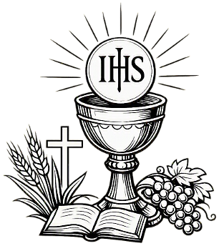
Let us pray. Renewed by this bread from the heavenly table, we beseech you, Lord, that, being the food of charity, it may confirm our hearts and stir us to serve you in our neighbour. Through Christ our Lord. Amen.

We remain standing for The Parish Mission Prayer
Lord Jesus, you call us to be your missionary disciples.
Guide and strengthen us to share your love with all we meet.
Give us courage to reach out to help others.
Give us wisdom to know how best to care,
And give us hope to believe we can make a difference.
Bless us all who bring your compassion and mercy to the poor and marginalised.
Together, may we make known your love on earth.
We make our prayer through Christ Our Lord. Amen.

The priest may give some brief notice
The Concluding Rites- Blessing and Dismissal
The Lord be with you. And with your spirit.
May almighty God bless you, the Father, and the Son, ✠ and the Holy Spirit.
Amen.
Go forth, the Mass is ended. Thanks be to God.

The Final Hymn
1. 'Take up your cross,' the Saviour said,
'if you would my disciple be;
deny yourself, forsake the world,
and humbly follow after me.'
2. Take up your cross — let not its weight
fill your weak soul with vain alarm;
his strength shall bear your spirit up,
and brace your heart, and nerve your arm.
3. Take up your cross, nor heed the shame,
nor let your foolish pride rebel;
the Lord for you the cross endured
to save your soul from death and hell.
4. Take up your cross, then, in his strength,
and calmly every danger brave;
he guides us to a better home,
and leads to conquest of the grave.
5. Take up your cross and follow Christ,
nor think till death to lay it down;
for only they who bear the cross
may hope to win the glorious crown.

The Angelus
The Angel of the Lord declared unto Mary. And she conceived of the Holy Spirit.

Hail Mary, full of grace, The Lord is with Thee; Blessed art thou among women,
And blessed is the fruit of thy womb, Jesus.
Holy Mary, Mother of God, Pray for us sinners,
Now and at the hour of our death.

Behold the handmaid of the Lord.
Be it done to me according to thy word. Hail Mary. . .

And the Word was made flesh.
And dwelt among us. Hail Mary…

Pray for us, O holy Mother of God.
That we may be made worthy of the promises of Christ.

Let us pray: Pour forth, we beseech Thee, O Lord, Thy grace into our hearts, that we to whom the Incarnation of Christ Thy Son was made known by the message of an angel, may by His Passion and Cross be brought to the glory of His Resurrection. Through the same Christ Our Lord. Amen.

…………………………………………………
The Notices:
Welcome to our team, Allison Kirby who will be our Parish Administrator she can be contacted on admin@stpeterplymouth.org
Walsingham Pilgrimage if you have any dietary needs can you please fill in the online form or see Fr David or Sue to fill in a hard copy
Providing a Welcoming Presence in our Cloisters are- every morning 8.30 till noon we provide a safe space for those who need it- including offering toast and hot drinks- would you be able to assist in providing a welcoming presence in this area- if so please speak to Fr David or Fr Ben
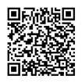
Lunch and Discussion- we are exploring starting a monthly lunch group which would also have a facilitated discussion to help us grow in faith- would you be interested in this? If so please speak to Fr David or Fr Ben
For online Donation to Support the Mission and Ministry of this Mission Community please scan the QR Code
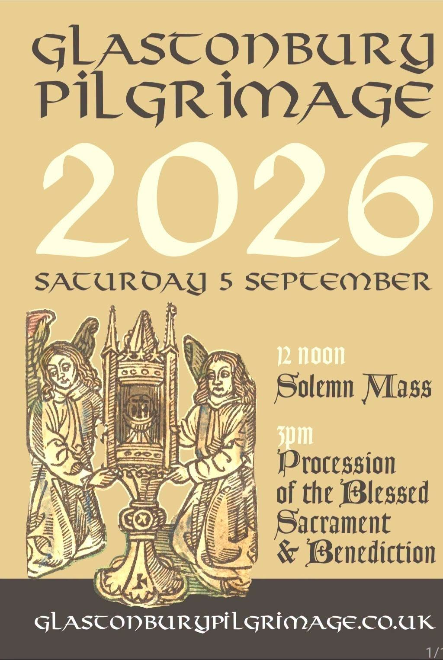For prayer
Those who have asked for our prayers…. Denise, Janice Allin, Leslie Porch,
Sheila Tucker, Tina Smart, Bobby Lilicrap, June Brock, Emma Addison, Georgie Maher, Brenda Alderson, Lois Tobin, Brenda Steed, Anne Lewis, Jackie Morrison, Anna, Gwen Lamb, Anna Lynch, Helen Lewis, Val Bradden, Pauleen Stewart, Amelia Coughlan, Roger Lewis, Shaun Carrie, Catherine Samuel, Julian Davies, Will Coughlan, Fr Philip Lamb, Fr Luke Demetri

Recently Departed- Heather Smith

Anniversaries of Death-

30th August
- Humphrey Barnicoat (priest)
- Marion Sloman
- George Mortimer

31st August
- Diana Princess of Wales
- Wesley John Lucas
- William Watts

1st September
- Harry Eades
- Blanche Harriet Marsden Jones
- Walter Ley Woolcombe
- Horace Debnam
- Clifford Allen
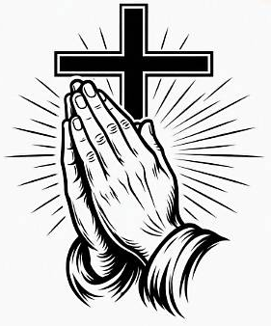
- Stanley Bond

2nd September
- Ethel Ellsmore
- Ambrose Wood

3rd September
- Henry Tubal Hole (Priest)

4th September
- Gladys Carlyon
- John William Ryder
- Maureen Crocker
- Hilda Brace

5th September
- John Ware
- Mary Backler
- Ada Mellor
- Betty Bradshaw
- Winifred Baker

The Mission Community of St Peter and the Holy Apostles
St Peter, Wyndham Square + St Thomas, Royal Navy Avenue + St James-the-Less, Ham Drive

A Church of England Parish in the care of the Bishop of Oswestry

Parish Priest Fr. David Way SSC: 01752 240119 fr.david@stpeterplymouth.org

Parish Deacon: Dcn Ben Otley 07939800544 benotley.mission.plym@gmail.com

Parish Administrator Allison Kirby admin@stpeterplymouth.org

Parish Website: plymouthstpeter.co.uk ~ FOR MUCH MORE INFORMATION ON EVENTS, ETC.

Sunday 30th August  The Twenty-Second Sunday  in Ordinary Time  (Year A/ Psalter Week ii) | 8.30am St Thomas Fr DCW  11.00am St Peter Fr DCW | Mass with Hymns  Sung Mass
Monday 31st- Weekday in OT/  St Aidan and the Saints of Lindisfarne | St Peter 10.00am Fr PL | Mass
Tuesday 1st September-  Weekday in OT | St Peter 10.00am Fr DCW | Mass
Wednesday 2nd- Weekday in OT | St Peter 10.00am Fr DCW | Mass
Thursday 3rd- St Gregory the Great | St Peter 10.00am Fr DCW | Mass
Friday 4th- Weekday in OT/  St Cuthbert | St Peter 10.00am Fr MB | Mass
Saturday 5th- Weekday in OT/  St Teresa of Calcuta | St Peter 10.00am Fr MB | Mass
Sunday 6th September  The Twenty-Third Sunday  in Ordinary Time  (Year A/ Psalter Week iii) | 8.30am St Thomas Fr DW  11.00am St Peter Fr MB | Mass with Hymns  Sung Mass

St Peters is open daily 8.30am- 12noon- Place of Welcome, Place of Prayer.
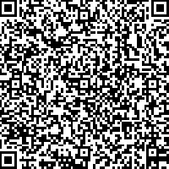

Safeguarding: If you have any concerns regarding the safety of children and others who are vulnerable, regardless of age, you must tell the Duty Priest or our parish Lay Safeguarding Representative- Jackie Morrison- email randj49@gmail.com Tel 07848859124. Or use the QR Code

