Psalm 124
Please stand, if able, and join in with the verses in bold italics

If it had not been the Lord who was on our side
—let Israel now say—
if it had not been the Lord who was on our side,
when our enemies attacked us,
then they would have swallowed us up alive,
when their anger was kindled against us;
then the flood would have swept us away,
the torrent would have gone over us;
then over us would have gone
the raging waters.

Blessed be the Lord,
who has not given us as prey to their teeth.
We have escaped like a bird from the snare of the fowlers;
the snare is broken, and we have escaped.

Our help is in the name of the Lord,
who made heaven and earth.

Glory be to the Father and to the Son and to the Holy Spirit,
as it was in the beginning, is now and ever shall be,
world without end. Amen

Summer Fayre – Thank You
Thank you to everyone who helped at our Summer Fayre, together we raised £780 towards the new building fund.
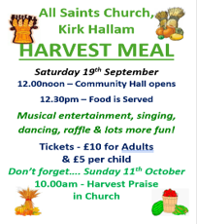

In our weekly prayers for our parish
This week we pray for God’s blessing on Godfrey Drive, Goodwood Crescent and Goole Avenue

All Saints Church
Distribution of Communion –currently the Priest will dip the communion wafer in the wine while we discern a safe way to bring the common cup back into worship, as we want everyone to feel included and safe. We also have gluten free wafers available.

Do you want this to carry on, or would you rather have the chalice? We will be asking everyone what they would like and take it to the PCC meeting in September.
Refreshments After the Morning Service
Please stay seated after the service and a hot drink will be brought to you in the pews. Do not get up and head to the back of church, it is becoming a hazard, and a risk as trays of hot drinks could be knocked over.
Church contact information
Contact: Rev’d Christine - revchristine@outlook.com
The Rectory, The Village, West Hallam, DE7 6GR
Landline 0115 646 1497
Rev’d Ailsa -revailsahunt@gmail.com
Tel - 07356064856

Churchwardens – Mrs Janet Wheeldon, -Tel: 0115 8771593
Mrs Linda Gregory – linda.gregory3@icloud.com
https://www.achurchnearyou.com/church/13402/
https://www.facebook.com/allsaintskirkhallam
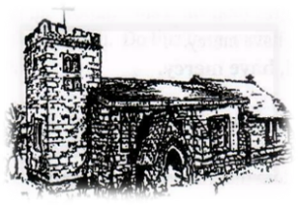
Kirk Hallam
Disabled Toilet in Friendship House.
Disabled Toilet in Friendship House.

Working with God to transform lives & communities.
Please can you ensure your mobile is on silence, or off during the service, it is affecting people with hearing aids and the loop system.

23rd August – Twelfth Sunday After Trinity
10.00am CW Communion Service with Archdeacon Emma
1.00pm Baptism of Polly Padget
6.00pm BCP Evening Prayer with Eileen

Forthcoming Events
Tues 25th 5.30pm Wedding Rehearsal in church
Tues 25th 6.30pm Home Group in Friendship House
Weds 26th 9.30am Morning Prayer at UCAS
Thurs 27th 11.00am Funeral for John Parker in church
Fri 28th 6.00pm Choir in Friendship House
Sat 29th 10.00am Prayer Meeting in Friendship House

30th August – Thirteenth Sunday After Trinity
10.00am Iona Communion Service with Rev’d Jan
6.00pm Iona Evening Prayer with Rev’d Christine

It’s Good to Talk! If you spot that someone is missing, please pop a news sheet through their door, & if you’ve time, call for a chat - just to check they’re OK & to let them know that they are not forgotten!
‘Trust in the Lord with all your heart and lean not on your own understanding’ Proverbs 3:5

