SUNDAY
Readings Romans 11^{1-2a, 29-32}, Matt. 15²¹⁻²⁸
8am HOLY COMMUNION [BCP] Archd Sue
11am HOLY COMMUNION [CW] Rev Marcus

Our Favourite Butterfly
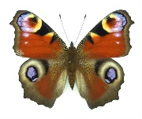
The colourful peacock butterfly is
is our favourite, according to a
to a recent poll.

The butterflies, with their striking colours and ‘eye-spots’ designed to fend off predators, beat 59 other British species in the vote run by Butterfly Conservation.
More than 20,000 votes were cast across the UK, with a rainbow of colourful species making up the top five.
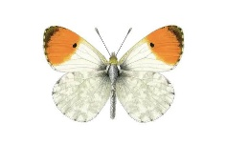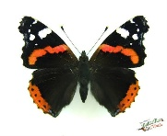
The orange-tip butterfly came a close second to the peacock, followed by red admirals in third, holly blues in fourth and the bright yellow brim- stone butterfly in fifth.
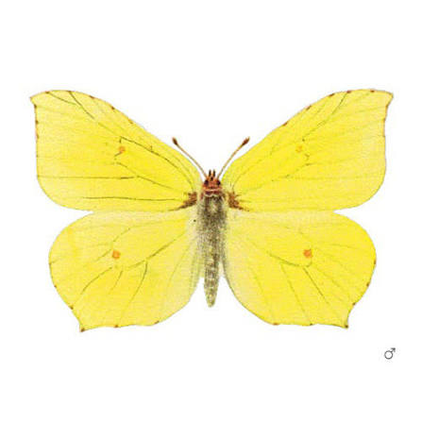

Butterfly Conservation, a wildlife charity, declared a “butterfly emergency” in 2024 as numbers recorded during the annual count fell to a record low.

WEDNESDAY (19th)

10:30am HOLY COMMUNION Rev Mark
Readings Ezekiel 34¹⁻¹¹, Matthew 20¹⁻¹⁶

Services next week
Sun 23rd 11:00am Holy Communion

Weds 26th 10:30am Holy Communion
NB there will be no service in St. James on
30th Aug – it will be a joint service at
St. Barnabas church at 10:30am

Don’t forget –
Kettle’s On! at St. Barnabas
from 10:30 every Tuesday .
Tea, coffee and a chat.

THANK YOU
to everyone who made our Music Day last Saturday such a success. The next Beat’n’Beans will be on 12th Sept. at 10:30am with the Yardarm Folk Orchestra as our guests.

PRAYER FOR THE WEEK

Thank You, Lord, for the gift of this new week and for the opportunities that lie before us. May our conversations this day be life-giving; may our decisions this day be life-enhancing; and may our thoughts this day be life-affirming. AMEN BRF

Please pray also for Derek Cotgrove, Guy Negus Derek & Pam Johnson, Carol Atkins, Sue Burton, Tessa Yates and Janice Millar.

