All Saints’ Church, Orton

Notice Sheet
Sunday 16th August: 11th Sunday after Trinity
10.30 a.m. Holy Communion with the Revd. Christopher Jenkin
Old Testament: Isaiah 56:1, 6-8 (Janet Capp)
New Testament: Romans 11:1-2a, 29-32 (Garth Blundell)
Gospel: Matthew 15:21-28
Prayers: Margaret Longworth Welcomer: Mary Jenkin
Organ voluntary: “Alla Marcia” by Thomas Adam (1857-1918).

Collect
O God, you declare your almighty power most chiefly in showing mercy and pity: mercifully grant to us such a measure of your grace, that we, running the way of your commandments, may receive your gracious promises, and be made partakers of your heavenly treasure; through Jesus Christ your Son our Lord, who is alive and reigns with you, in the unity of the Holy Spirit, one God, now and for ever. Amen.

THIS WEEK
Monday 17th: 10.30am – 12.30pm: Drop In at The Hub, St. James’, Tebay.
Wednesday 19th: 10.30 a.m. – 12 noon: Drop In at Orton Chapel Schoolroom. Free coffee, cakes and friendly conversation.
2.0 – 4.0 p.m. WI Concert at Tebay Chapel (see overleaf)
Thursday 20th: 7.30 p.m. Benefice Choir Practice at Kirkby Stephen Church.
Friday 21st: 7.30 p.m. Orton bell-ringing practice
Next Sunday, Sunday 23rd August, 10.30 a.m.
Three-Churches All-Age Communion Service with Holy Baptism
of Luca Ellis, child of Rebecca Kate Fisher and Robert Peter Wharton,
of Highfield, Tebay, with the Revd. Fran Parkinson
Reading: Matthew 28:16-20 (Mary Jenkin)
Prayers: Margaret Longworth Welcomers: Keith and Janet Capp
AHEAD:
Sunday 30th August, 10.30 a.m.: United Benefice Service at All Saints, with the Revd. Charles Cowling. Preacher: Archdeacon of Carlisle, the Venerable Ruth Newton. The Benefice Choir will sing.

Monday 7th September, 7.00 p.m. at Kirkby Stephen Parish Church
The Licensing of the Revd. Rebecca Gilbert as our new vicar
by the Bishop of Penrith, the Rt. Revd. Dr. Michael Leyden.
The Revd. Charles Cowling will be licensed as Associate Priest.

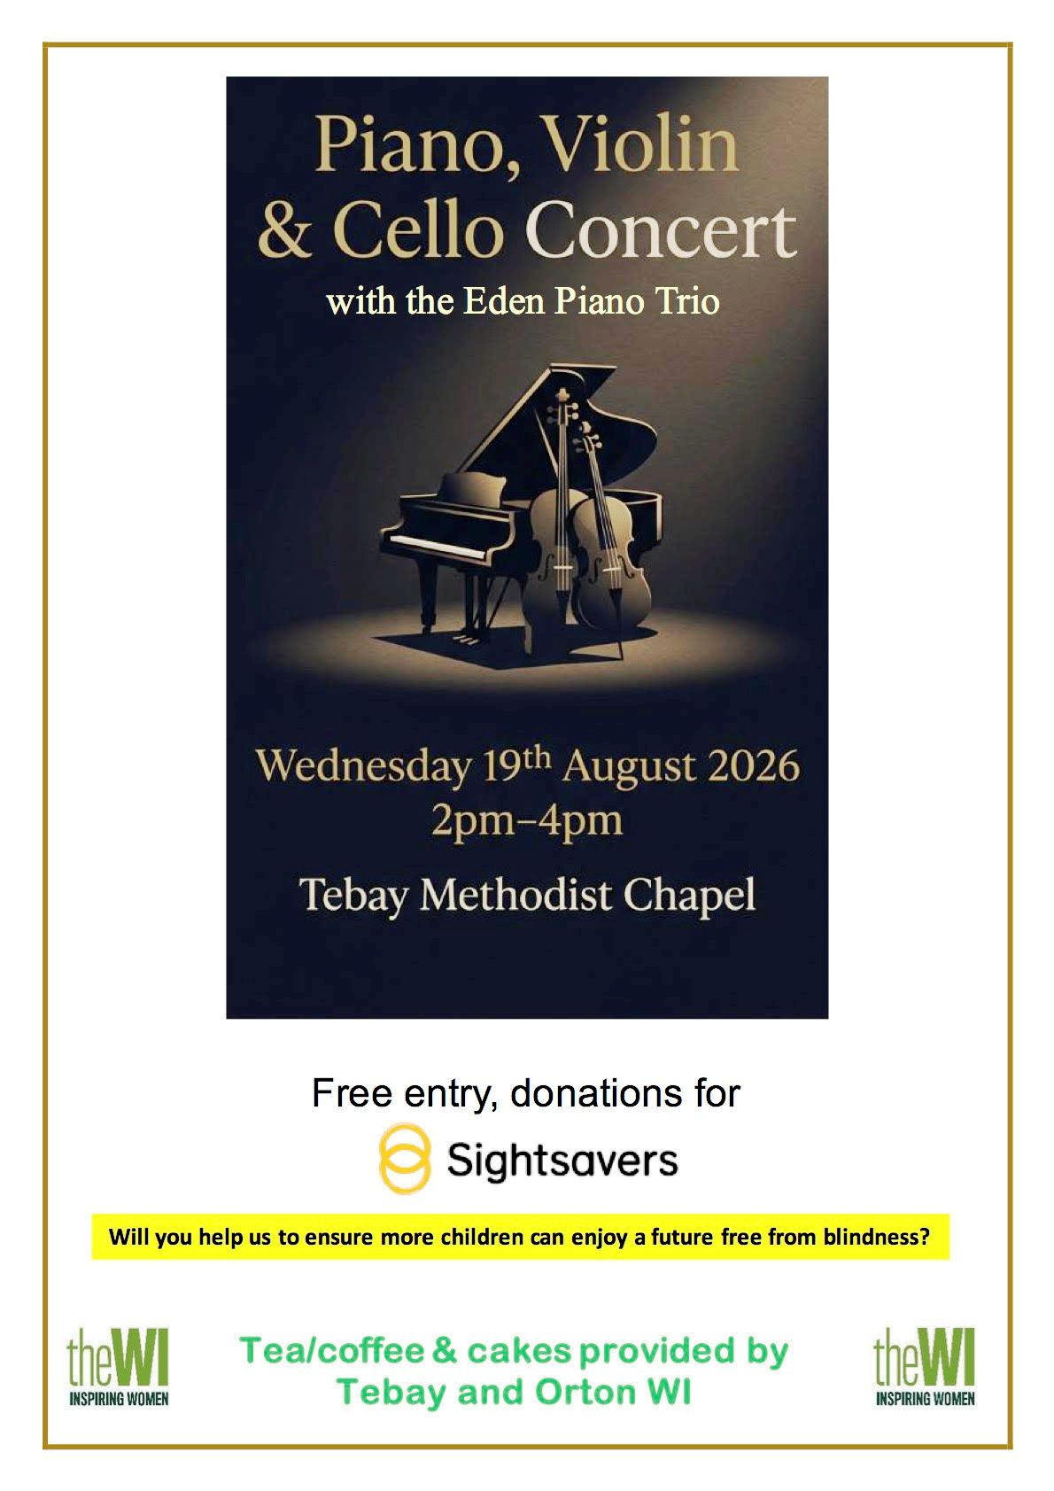

https://allsaintschurchorton.com/

