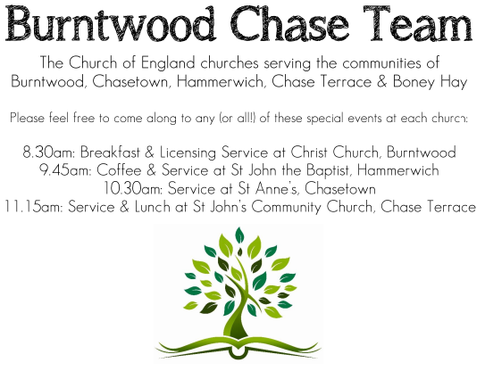
CHRIST CHURCH, BURNTWOOD
Registered Charity Nos: 1217129

SERVICE ON SUNDAY 16TH AUGUST 2026 AT 10AM

HOLY COMMUNION

The 11th Sunday after Trinity

First Bible Reading – Isaiah 56: 1, 6-8

Thus says the Lord:
Maintain justice, and do what is right, for soon my salvation will come and my deliverance be revealed.
⁶ And the foreigners who join themselves to the Lord, to minister to him, to love the name of the Lord, and to be his servants, all who keep the Sabbath and do not profane it and hold fast my covenant—
⁷ these I will bring to my holy mountain and make them joyful in my house of prayer; their burnt offerings and their sacrifices will be accepted on my altar, for my house shall be called a house of prayer for all peoples.
⁸ Thus says the Lord God, who gathers the outcasts of Israel:
I will gather others to them besides those already gathered.^{[a]}

Gospel Reading – Matthew 15: 10-28

¹⁰ Then he called the crowd to him and said to them, “Listen and understand: ¹¹ it is not what goes into the mouth that defiles a person, but it is what comes out of the mouth that defiles.” ¹² Then the disciples approached and said to him, “Do you know that the Pharisees took offense when they heard what you said?” ¹³ He answered, “Every plant that my heavenly Father has not planted will be uprooted. ¹⁴ Let them alone; they are blind guides of the blind.^{[e]} And if one blind person guides another, both will fall into a pit.” ¹⁵ But Peter said to him, “Explain this parable to us.” ¹⁶ Then he said, “Are you also still without understanding? ¹⁷ Do you not see that whatever goes into the mouth enters the stomach and goes out into the sewer? ¹⁸ But what comes out of the mouth proceeds from the heart, and this is what defiles. ¹⁹ For out of the heart come evil intentions, murder, adultery, sexual immorality, theft, false witness, slander. ²⁰ These are what defile a person, but to eat with unwashed hands does not defile.”
²¹ Jesus left that place and went away to the district of Tyre and Sidon. ²² Just then a Canaanite woman from that region came out and started shouting, “Have mercy on me, Lord, Son of David; my daughter is tormented by a demon.” ²³ But he did not answer her at all. And his disciples came and urged him, saying, “Send her away, for she keeps shouting after us.” ²⁴ He answered, “I was sent only to the lost sheep of the house of Israel.” ²⁵ But she came and knelt before him, saying, “Lord, help me.” ²⁶ He answered, “It is not fair to take the children’s food and throw it to the dogs.” ²⁷ She said, “Yes, Lord, yet even the dogs eat the crumbs that fall from their masters’^{[f]} table.” ²⁸ Then Jesus answered her, “Woman, great is your faith! Let it be done for you as you wish.” And her daughter was healed from that moment.

Collect for Today

O God, you declare your almighty power most chiefly in showing mercy and pity: mercifully grant to us such a measure of your grace, that we, running the way of your commandments, may receive your gracious promises, and be made partakers of your heavenly treasure; through Jesus Christ your Son our Lord, who is alive and reigns with you, in the unity of the Holy Spirit, one God, now and for ever.
Amen

Forthcoming Services in Church

Wednesday 19th August Morning Prayer 9.30am

Sunday 23rd August Morning Worship 10am

Wednesday 26th August Morning Prayer 9.30am

Sunday 30th August Holy Communion 10am

Future Event For Your Diary
Saturday 14th November Christmas Fayre 2-4pm

Food bank

We are continuing to support this important ministry for people in need in our local community, for which the following items are always needed: ‘Long Life Milk, Custard, Rice Pudding, Cereals. Many thanks for your support. The Food Bank is very grateful for whatever you may be able to donate.

Floodlighting
If you would like to commemorate a special occasion by floodlighting our Church, please contact Chris Brown on 01543 683862 for details.

Prayer Chain

Christ Church is blessed with a very active prayer chain. If you, or anyone you know, feel that they would like others to pray for them, please speak to Chris Brown on 01543 683862.

Home Visits and Communion

For anyone who is unable to attend church and would like a Home Visit and Communion, please contact the Vicar and he will be able to carry this out.

Vicar’s Contact Details

Rev’d Stephen Morgan - Telephone: 07305 852152

Church Wardens Contact Details

Judith Rogers - Telephone: 01543 324718
Mike Holmes - Telephone: 01543 672970

Church Office Telephone: 01543 642187 [Please leave a message and we will respond in due course]

Church Web Site:www.christchurchburntwood.org.uk
Church Email: christchurchburntwood15@gmail.com
Facebook: www.facebook.com/group/christchurchburntwood/

Next Sunday’s Service – The 12th Sunday after Trinity

Sunday 23rd August – Morning Worship at 10am
Bible Readings: Isaiah 51:1-6 and Matthew 16:13-20

