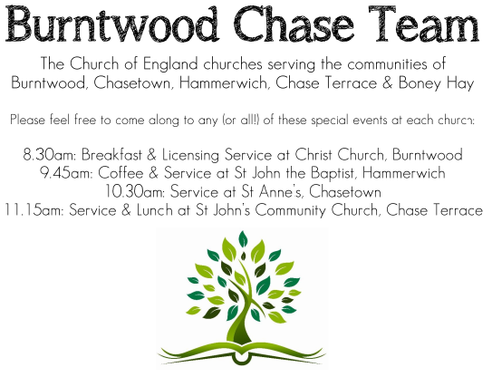
CHRIST CHURCH, BURNTWOOD
Registered Charity Nos: 1217129

SERVICE ON SUNDAY 30TH AUGUST 2026 AT 10AM

HOLY COMMUNION

The 13th Sunday after Trinity

First Bible Reading – Jeremiah 15: 15-21

O Lord, you know; remember me and visit me, and bring down retribution for me on my persecutors. In your forbearance do not take me away; know that on your account I suffer insult. ¹⁶ Your words were found, and I ate them, and your words became to me a joy and the delight of my heart, for I am called by your name, O Lord, God of hosts.
¹⁷ I did not sit in the company of merrymakers, nor did I rejoice; under the weight of your hand I sat alone, for you had filled me with indignation. ¹⁸ Why is my pain unceasing, my wound incurable, refusing to be healed? Truly, you are to me like a deceitful brook, like waters that fail. ¹⁹ Therefore thus says the Lord: If you turn back, I will take you back, and you shall stand before me. If you utter what is precious and not what is worthless, you shall serve as my mouth. It is they who will turn to you, not you who will turn to them. ²⁰ And I will make you to this people a fortified wall of bronze; they will fight against you, but they shall not prevail over you, for I am with you to save you and deliver you, says the Lord. ²¹ I will deliver you out of the hand of the wicked and redeem you from the grasp of the ruthless.

Gospel Reading – Matthew 16: 21-28

From that time on, Jesus began to show his disciples that he must go to Jerusalem and undergo great suffering at the hands of the elders and chief priests and scribes and be killed and on the third day be raised. ²² And Peter took him aside and began to rebuke him, saying, “God forbid it, Lord! This must never happen to you.” ²³ But he turned and said to Peter, “Get behind me, Satan! You are a hindrance to me, for you are setting your mind not on divine things but on human things.” ²⁴ Then Jesus told his disciples, “If any wish to come after me, let them deny themselves and take up their cross and follow me. ²⁵ For those who want to save their life will lose it, and those who lose their life for my sake will find it. ²⁶ For what will it profit them if they gain the whole world but forfeit their life? Or what will they give in return for their life? ²⁷ “For the Son of Man is to come with his angels in the glory of his Father, and then he will repay everyone for what has been done. ²⁸ Truly I tell you, there are some standing here who will not taste death before they see the Son of Man coming in his kingdom.”

Collect for Today

Almighty God, who called your Church to bear witness that you were in Christ reconciling the world to yourself: help us to proclaim the good news of your love, that all who hear it may be drawn to you; through him who was lifted up on the cross, and reigns with you in the unity of the Holy Spirit, one God, now and for ever.

Amen

Forthcoming Services in Church

Wednesday 2nd September Morning Prayer 9.30am

Sunday 6th September Holy Communion 10am

Wednesday 9th September Morning Prayer 9.30am

Sunday 13th September Morning Worship 10am

Future Events For Your Diary
Art Cafe Saturday 5th September 3.00 to 5.00pm
Cameo cafe Monday 7th September 1000am to 1200
MOB meeting Weds 9th September 7.00 for 7.30 at Burntwood Methodist Church

Thursday 24th September Burntwood W.I. Choir
Musical Evening.
(Free entry. Cold drinks and
biscuits will be available.) 7pm start

Saturday 14th November Christmas Fayre 2-4pm

Food bank

We are continuing to support this important ministry for people in need in our local community, for which the following items are always needed: ‘Long Life Milk, Custard, Rice Pudding, Cereals. Many thanks for your support. The Food Bank is very grateful for whatever you may be able to donate.

Floodlighting
If you would like to commemorate a special occasion by floodlighting our Church, please contact Chris Brown on 01543 683862 for details.

Prayer Chain

Christ Church is blessed with a very active prayer chain. If you, or anyone you know, feel that they would like others to pray for them, please speak to Chris Brown on 01543 683862.

Home Visits and Communion

For anyone who is unable to attend church and would like a Home Visit and Communion, please contact the Vicar and he will be able to carry this out.

Vicar’s Contact Details

Rev’d Stephen Morgan - Telephone: 07305 852152

Church Wardens Contact Details

Judith Rogers - Telephone: 01543 324718
Mike Holmes - Telephone: 01543 672970

Church Office Telephone: 01543 642187 [Please leave a message and we will respond in due course]

Church Web Site:www.christchurchburntwood.org.uk
Church Email: christchurchburntwood15@gmail.com
Facebook: www.facebook.com/group/christchurchburntwood/

Next Sunday’s Service – The 14th Sunday after Trinity

Sunday 6th September – Holy Communion at 10am
Bible Readings: Ezekiel 33: 7-11 and Matthew 18: 15-20

