Parish Magazine Article - September
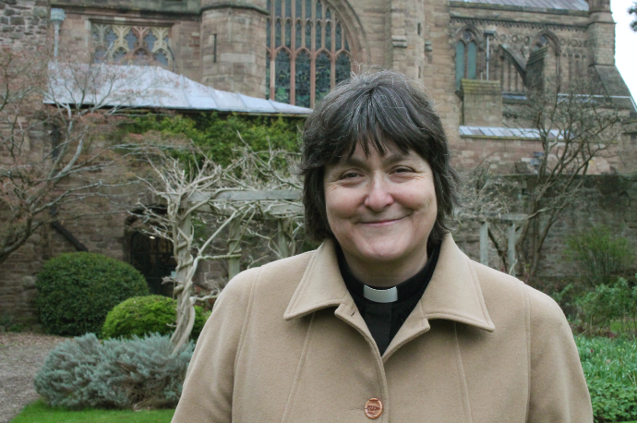
On being yourself
I remember my first day of school in September 1969. "Just be yourself!” exhorted my grandpa - which at the tender age of four made no sense whatsoever but which I have had good reason to think about many times since.
I have learned that ‘being yourself’ is an important part of living a full and faithful life. Each of us is unique yet we feel continual pressure to fit in with the expectations of others. As my grandpa tried to point out to the anxious four-year-old in the oversized blazer, happiness comes from embracing who God made us to be. When we are comfortable in our own skins, we are able to contribute authentically to our communities and build stronger relationships with others.
It is true of the church too. A church that is unsure of itself can easily drift into simply reflecting the preferences of society. A confident Church that knows who and whose it is can lovingly but clearly proclaim its beliefs even when they are unfashionable and teach the gospel in all seasons even (perhaps especially) at the hour of death.
Which brings me to the horror of what are euphemistically called “Pure Cremations”. One might also accurately call them Carcass Disposal. Increasingly, society is sold on direct cremation because it appears simple, efficient and cheap. It is also pastorally destructive leaving families with no space to grieve and acknowledge death. The Church should ask itself why it is handing the business of dealing with death over to the secular and profit-seeking funeral industry and whether something important is being lost on our watch. Christian funerals are not simply about disposing of a body. They are acts of worship in which we commend a loved one to God's mercy, support the grieving, give thanks for a life lived, and proclaim the resurrection of Jesus.
The Church of England is a custodian of the Christian understanding of death, burial, resurrection, and hope. For two millennia, Christians have cared deeply about the treatment of the body because the body matters to God.
When the Church conducts a funeral, whether culminating in burial or cremation, it is being itself. It is doing what Christians have done for centuries: gathering around the dead and the bereaved, speaking words of hope, praying together, and declaring that death does not have the last word. If the Church becomes hesitant about offering this witness, it risks forgetting part of its own identity.
To be confident in whose we are means being confident enough to say that people need more than efficiency at the end of life. They need prayer, community, ritual, remembrance and hope. The Church serves society best not by surrendering these things but by offering them generously and joyfully and unashamedly in the way that it knows. Let's be who we are.
The Very Revd Sarah Brown
Dean of Hereford

