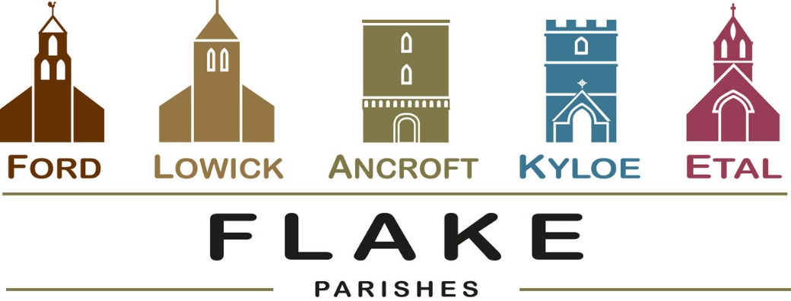
A very warm welcome to you, especially if you are visiting. Please take this sheet home with you and use it as a basis for prayer.

Sunday 30th August 2026: Flake Service
10am at Lowick with Revd Canon Dr Rob Kelsey
Whom we warmly welcome back to our parishes
Fairtrade Stall

Sunday 6th September 2026
Lowick 9.15 Holy Communion
No service at Ford due to Etal Show

Sunday 13th September 2026
Lowick 9.15 Holy Communion
Ford 11am Holy Communion
Lowick Vicarage Garden 4pm Pet Blessing and tea

Sunday 20th September 2026
Lowick 9.15 Holy Communion
Ford 11am Holy Communion

Sunday 27th September 2026
Lowick 9.15 Harvest Thanksgiving
Ford 11am Harvest Thanksgiving


SEPTEMBER
- Saturday 5th September 8.30am Lowick White Swan Men’s Breakfast book with Kevin 07530000941
- Sunday 6th September 5-7pm Lowick Village Hall
‘Let’s Talk About It’ Do encourage and bring a friend – leaflets available
- Monday 7th September
10.30am Lowick Church Start of Term School Service
- 12th September 12-1.30pm Soup Saturday LVH
Wedding at Ford of Jamie and Jessica
- Sunday 13th September Lowick Vicarage Garden
Pet Blessing 4pm with refreshments
Contact Alex for details 07935 732811
- Friday 18th September Lowick Church
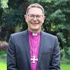
‘Looking through Lowick’s windows’
6pm -7.30pm Drinks, nibbles, donations
- Saturday 19th September 9am -1pm
Etal Village Hall Vision Morning 2 with
Rt Revd Mark Wroe, Bishop of Berwick Sign up sheet at back of church
- Sunday 20th September 6pm Evensong Berwick Parish Church for installation of New Area Dean –
see poster, to join the choir
- Tuesday 22nd September 1.30pm Ancroft PCC

- Friday 25th September LVH Macmillan Coffee Morning 10-12
- Saturday 26thSeptember
7pm Lowick Village Hall
Harvest Supper with live music. Free tickets from Lowick Shop

September and October Sundays at 5pm-7pm
Lowick Village Hall
Questions of Life and Faith

Starting on Sept 6th – finish Oct 25th
8 days/16 hours - revisit some of the questions we all ask at one time or another. Bring your friends – and let’s explore together. A short video, open conversation, light refreshments. No pressure, no judgement. Come along and say what you think and hear what others think. Is there more to life?
Why did Jesus die? How can I have faith?

A Songs of Praise Special Event
Join Aled Jones and some very special guests at the iconic Gateshead Glasshouse for a spectacular Christmas concert. Bring your singing voice and Christmas jumper for an evening of classic carols and traditional hymns.
WHEN: Tuesday 6th October 2026 –
start at 19:00. Doors open at 18:00

In our prayers
All who suffer in body, mind or spirit, especially Heather Piper, George Hall, Gail Calder, Don and Sam Quilty, Sue Pattinson. We pray for those who mourn, especially the family and friends of Jane Pannell and for all who mark anniversaries of death at this time of year.

Flake Parishes Contacts
Revd Charlotte Osborn (Vicar) 01289 388591 ceosborn@mail.com 07957 367457
Revd Alex Firman (Assistant Curate) 07935 732811 alex_firman@hotmail.co.uk

Our other licensed clergy
Revd Margaret Sentamu 077871 204745
Canon Nick Sagovsky
Revd Marion Penfold 01289 305664

Church Contacts
Ancroft Leigh Yorke 07716 116739
Etal Andrew Joicey 01890 820540
Ford Kathleen Holmes 07951 099668
Lowick John Dickson 07967 343211

Parish Administrator
Sheena Atkinson
admin@flakeparishes.org
Safeguarding Officer
Philip Greene
safeguarding@flakeparishes.org
07555 412284

