Church service pattern for this month:
St. John’s:
2nd August, 11:00 – Holy Communion with Sunday School
9th August, 11:00 - Service of the Word with Sunday School
16^{h} & 23rdAugust, 11:00 – Holy Communion with Sunday School
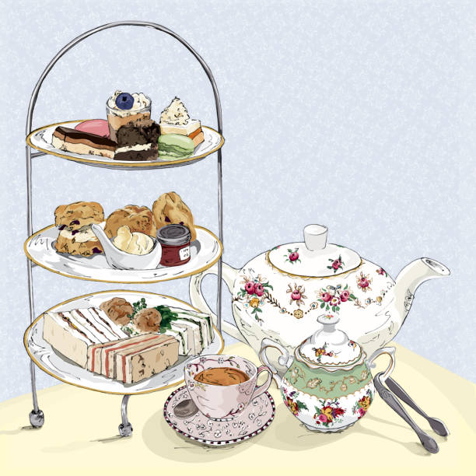
30th August, 10:30 – Joint Service at St James’.
St. James’:
2nd ,9th, 16th& 23rd August, 09:30- Holy Communion with Sunday School.
30th August, 10:30 – Joint Service at St James’.

Our New Vicar
Revd Emma Cooksey will be inducted into the Parish of St James’ & St John on Sunday October 18th at 2.30 in the afternoon. Please come along and encourage any members of the communities to come with you.

100 Club
A new 100 club is being launched next month The cost for a year is £20 and a draw will be made each month. A form to register for the draw is attached to this newsletter. You can complete it and return it to Helen or Ruth with £20 or hand it in at Church and pay by card.
Helpers for work with Children and Young People
As we look forward to the beginning a new school year in September we look forward to restarting Jellytots and Youth Groups and continuing Sunday School, but these groups only work because of the wonderful volunteers who run them.
If you think you could help with Jellytots on Weds morning, 9.30-11.45, Youth Groups on Friday evenings, 5.45-8.15 or Sunday School on Sunday morning, please do let someone know. Just once a month could make all the difference
Olive Branch
This time of the year is the “Lean” season of the Olive Branch as people go on holiday and schools are shut. They would be grateful for any donations but this is their suggested shopping list:
- Tinned meat meals, Luncheon meat, fish & Soup
- Tinned Veg & Fruit, especially tomatoes
- Cereal
- Pasta Sauce jars & Pasta
- Biscuits & Crisps, Coffee & Tea
- Tinned/Long-life puddings

.Afternoon Teas

You are warmly invited to join us for afternoon tea on Sunday 30th August 2026 at 1.30pm or 3.30pm in Shireshead St James Upper Room.
Tickets - £15 per person

To book your place call Joy (07702009421), Ruth (07928103368/01524792306), or Helen (07973203233) or emailing rross500@aol.com
St John’s Graveyard Working Party.

Have you relatives in St. John’s Graveyard? Do you walk through it regularly?
We are holding a Working Party in the Graveyard on Weds 26th August to tidy it up before the autumn. It is a big space for 3 people to manage! We need all the help we can get!
Please do try to come along between 2pm & 8pm for even a short time. Refreshments will be provided, during and afterwards.

Dates for your diary
20th August, 10.15-12.00 Coffee and Chat, St John’s Church
30th August,1.30 & 3.30 - Afternoon Teas, St James’ Shireshead.
9th September 10.00 – Jellytots resumes.
11th September, 18.00 – Youth Group resumes
20th September, 16.00-17.30 – Messy Church
18th October, 14.30 – Induction of Revd Emma Cooksey.

Contact Information
During the interregnum, please contact the Church wardens in the first place and they will find the right person to deal with your request.
St. John’s: Peter Harrison - 07947 385534
Steph Carter - 07952 712489
St James’: Alex Peill - 07914 382332
Anthony Chick – 07966 898427

