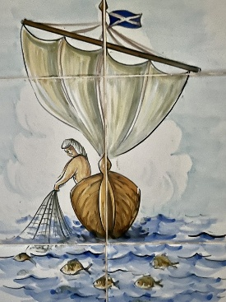
Rota St. Andrew’s Church Puerto Pollensa
September 2026
6th September | 13th September  40 years of Anglican Worship Celebration | 20th September | 27th September
Fourteenth Sunday after Trinity  (Green)  Ezekiel 12:1-14  Romans 13:8-end  Matthew 18:15-20 | Fifteenth Sunday after Trinity  (Green)  Genesis 50:15-21  Romans 14:1-12  Matthew 18:21-35 | Sixteenth Sunday after Trinity  (Green)  Jonah 3:10-end of 4  Philippians 1:21-end  Matthew 20:1-16 | Seventeenth Sunday after Trinity  (Green)  Ezekiel 18:1-4, 25-end  Philippians 2:1-13  Matthew 21:23-32
Holy Communion 11am  Followed by  Grub and Gospel | Holy Communion 11am  Archdeacon David Preaching | Holy Communion  11am | Morning Prayer or Holy Communion 11am
40 Years of the Anglican Church in Puerto Pollensa!
This year we will be celebrating our 40th Anniversary of Anglican Worship here in Puerto Pollensa.
Why not join us for an ‘Afternoon Tea’ on Saturday 13th September 2-4pm?
Talk at 2.30pm with the emphasis on sharing memories.
The tea is free; we will have our craft stall with all money going to St. Andrew’s Church.

