St Thomas’ Church and Community Project
“A Place for You”
August Newsletter
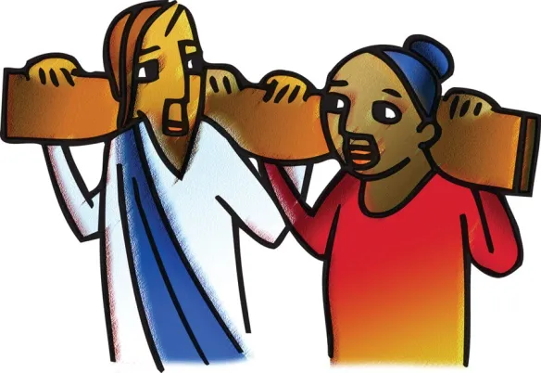
I have been thinking a lot about the need for rest recently. Not because I am especially tired, but because I see people around me who are. Not just needing rest for the body but also for the mind. Most especially for the mind.
I’m not talking here about the need for a Sabbath, given to us by God as a blessing. God took a Sabbath after he created the universe:
Thus, the heavens and the earth were completed in all their vast array. By the seventh day God had finished the work he had been doing; so on the seventh day he rested from all his work. Then God blessed the seventh day and made it holy, because on it he rested from all the work of creating that he had done. (Genesis 2 vv1-3)
I’m not thinking even of the need for expensive holidays, I’m thinking more about the need to take a break, to think about other things, to rest our bodies and our minds. To stop for a while.
Our Parish Environmental Champion reminds us about the 6Rs of sustainability: Refuse, Rethink, Reuse, Reduce, Repair, Recycle. As humans we are part of creation and need to consider our own self-sustainability.
Repairing the physical is easy enough – we have the NHS and each other, our friends and our families to provide care and practical support. And that which can’t be repaired because we are not as young or able as we used to be, we learn to live with. It’s not easy but we do it.
But the spiritual takes more work.
How much time and energy to we spend worried about things that aren’t really for us to worry about. How anxious do we get worrying about things that might or might not ever happen.

Matthew 11 vv 28-30:
“Come to me, all you who are weary and burdened, and I will give you rest. Take my yoke upon you and learn from me, for I am gentle and humble in heart, and you will find rest for your souls. For my yoke is easy and my burden is light.”
Jesus was ministering, praying and teaching in a land occupied by the Roman army which at the time occupied most of the surrounding area as far across as Rome itself and beyond.
Those living in the occupied territory were poor, frightened, hungry, often held in bondage and used as slaves. They were not treated well. They would have been so scared and worried for themselves and their families that their prayers would have been last in their thinking. How hard is it for us to pray when life is tough and gives us lemons. They would have tried because the Jews lived in fear and awe of God and feared the consequences of not praying, but they must have felt helpless and abandoned.
They were working harder than ever to avoid being held captive and doing what they could to earn a living.
Then along comes Jesus and says:
For my yoke is easy and my burden is light.”
Jesus was offering an alternative way and saying quite clearly that his yoke is not one of bondage.
Jesus was, and still is, offering people a choice to make of their own free will. To yoke ourselves to Him and to live as he intended sharing our cares and worries, and joys and blessings with Him who will always stand by us.
Rest isn't something we have to earn... it's a gift from God. It is necessary. It looks different for different people, for some it might be working on the allotment, for others its going for a long walk, for others it is a change of scenery, a holiday, for me it’s a good murder! Not committing one let the reader understand but reading one or watching one on TV. My spirit is most restored by the sea. For me the air is lighter there and my God even more accessible.
In the quiet moments, He restores weary hearts, renews our strength, and reminds us that His presence is enough. Sometimes the most faithful step we can take is simply to be still with Him. What a privilege.
Rev Sue Round

August church services
If you want to discover more, come and join us any Sunday morning or at any of our community activities throughout the week.
Sunday 2nd August 10am service morning prayer and Eco-Church theme.
Sunday 9th August 10am with Holy Communion (change from our normal rhythm)
Sunday 16th August 10am service with Holy Communion
Sunday 23rd 10am – service morning prayer with a Baptism for baby Zander at 1pm
Sunday 30th August 10am – morning prayer with Dan’s baptism in the service.

Children are always welcome and there is usually the opportunity for them to leave the main service for their own age-appropriate activities in Connect Group. And don’t worry if you arrive a bit late or need to leave before the end.

If you are on the rota to read during August please assume that you will be reading the gospel. These may be subject to change. The readings are listed here in case you want to practice:

Sunday 2nd | Matthew 14 vv 13-21
Sunday 9th | Matthew 14 vv 22-23
Sunday 16th | Matthew 15 vv 10-28
Sunday 23rd | Matthew 16 vv 13-20
Sunday 30th | Matthew 16 vv 21-end

MIDWEEK WORSHIP
Now that Citizens’ Advice have moved on the monthly Midweek service will revert to the 3rd Thursday in the month.
The next service will be Thursday 20th August 1pm.

Christian Outreach

Worship, prayer, teaching and Christian fellowship doesn’t just happen in church on Sunday mornings, the church is active out in the community throughout the week. However during August, we rest and our lovely volunteers will take their rest.

- Stay and Play group for babies and toddlers on Monday (resumes 13th September)

- Children’s club with fun and games, crafts, cooking, activities, challenges and bible stories on Mondays from 4.00 till 5.30 and youth club 5.45 till 7.15 – resumes 13th September

- Young Adults discipleship group – Monday evenings from 7.30 till 8.30 – resumes 13th September

- A church service Heartlands Care home happens twice monthly

- Pastoral visits at West Hall Court every other Thursday morning and at Heartlands Care Home on Friday afternoons.

- Godly Play at Oasis Blakenhale Juniors on alternate Tuesdays – Christian teaching with classes from years 3 and 4. Resumes when school opens in September.

- The Open the Book team make monthly visits to the school assembly at Oasis Blakenhale Infants School. Resumes when school opens in September

- Activities for those over 50 on Thursday and Friday – continues throughout the summer.

Foodbank Update
The foodbank is open on Wednesday mornings from 10.00 till 11.00 p.m. and we have a wonderful team of volunteers from the church and community. We are very busy serving on average 25 people a week with food to feed around 60 people. With high demand all donations are very welcome; if you can provide occasional tins of beans, spaghetti, soup, vegetables etc please leave them in the collection tray at the back of the church or in the hall entrance. We now also provide fresh fruit and vegetables and there are usually some left after our Foodbank session so please help yourselves rather than letting them go waste. A small donation is welcome.
Thank you to everyone.
If you have any spare shopping bags, or bags-for-life, we will be very grateful for them and we are happy to re-use plastic carrier bags you may have. Please leave them in the donation boxes or pass to Jan or Jo.

Website update
Our website reflects everything that happens in church on Sundays, including other acts of worship and study groups, as well as what happens during the week, all in the name of St Thomas. Please have a look if you are able. If you have any comments, observations of additional thoughts, please contact Rev Sue. In future all our newsletters will also be available on the website so don’t worry if you lose it. If you would like your own copy emailed to you, again, please contact Rev Sue.

Our web address is www.st-toms.com

If you use Facebook please like and follow us on St Thomas Church & Community Project.


The afternoon buffet organised by Carol Malone raised £1030 for Breast Cancer research which is an awesome achievement. Thank you so much Carol, and to you all your amazing helpers on the day!

Prayer Requests and Prayer Pointers

Prayer means putting ourselves into a communicating relationship with the divine God. Prayer is often used to build a relationship with God, offering thanksgiving, asking for help, and seeking forgiveness. It is described as a means to express gratitude and find comfort and strength. It is a gift for our own sense of identity as children of God, and for our own sense of purpose. It is often helpful to end or begin our prayer time with the prayer Jesus taught us:
Our Father in heaven,
hallowed be your name,
your kingdom come,
your will be done,
on earth as in heaven.
Give us today our daily bread.
Forgive us our sins
as we forgive those who sin against us.
Lead us not into temptation
but deliver us from evil.
For the kingdom, the power, and the glory are yours
now and for ever.
Amen.

In your prayers this month please consider including these pointers:
- Pray for all those who are currently unwell, receiving treatment, recovering from illness or surgery and those in residential care.
- Please remember Rev Susan Larkin. Pray for all those who will surround her with skill, care and compassion and ask the Holy Spirit to send rapid and effective healing.
- For those who work in nursing and caring roles in hospitals, residential homes and at home. For social workers and those who work in prisons.
- For those with families affected by the troubles in the Middle East.
- For world leaders striving to negotiate peace.
- For the UK Government and our new Prime Minister.
- For our congregation to continue to grow in faith and numbers.
- For our work in local care homes and at Oasis Blakenhale School.
- For those preparing to be confirmed in September, especially those from our own fellowship.
- For Zander and Dan shortly to be baptised.
- For yourself, and your own family and friends.

A prayer sourced by Pat Stansbie:
When pain comes at night and sleep disappears,
when nothing feels right and you’re riddled with fears
remember God loves you

When sickness is on you and health takes a blow
when joys all desert you and energy is low
Remember God loves you

When life feels all empty weighed down with its care
When tears come in plenty with no one to share
Remember God loves you

FAYE’S WORK EXPERIENCE REPORT
On the last week of June I did my work experience at St Thomas's working alongside Susan and others doing various activities which they engage with throughout the week such as on Monday morning I went to little angels and help set up the equipment they were using and also signed people in and engaged with things such as singing nursery rhymes to the children and at the end tidying up with help of the parents which showed me how everyone works together and its like a community. Then on Tuesday morning I went to Blakenhale with Susan to see how she deliver faith into to the community and how the children at school also engage with it and how they show interest to deepen their faith and understanding, later on in the afternoon I went to the Church for a 1 on 1 session with Sue to discuss how the church uses social media to gain insight from the community and to show events that go on, this really showed me what range of events go on at the church and gave me information that I didn't know before. On Wednesday, I went to the food bank and shadowed some people who volunteer there and helped put food parcels together and looked at how the registration works and this showed me how the food bank operates but also how the people that go just go to have somewhere to socialise as well as get support. Then later on I went to Heartlands Care Home for a service with Jan, Susan and Carol and had a chance to speak with the workers there and also the residents as well about things that they enjoyed and remembered. Then on Thursday I went to 50+ yoga in the morning where Brian and Sam spoke to me about the benefits 50+ has to the people in the community and how it is a great impact on them also and how they can come to socialise, then a little bit later I went with Jan and Linda to do 1 to 1 visits with them at West Hall Court and this showed me how people live and how they still also spiritually engage with people who live there, then I went back to church for the afternoon session of 50+ where I spoke to some of the members about why they go to 50+ and just having a conversation with them. Finally on Friday I went to 50+ morning session and spoke to some of the members while also learning a new skill of felting and then in the afternoon I went to St Richards and helped sort clothes for when they go over to Malawi to give to the people in need. This week has really showed me what the church do for the community and how giving they are and if i could I would do this week again as it has really showed me the positivity they bring to people.

SHANNON IS PAYING US A VISIT!!
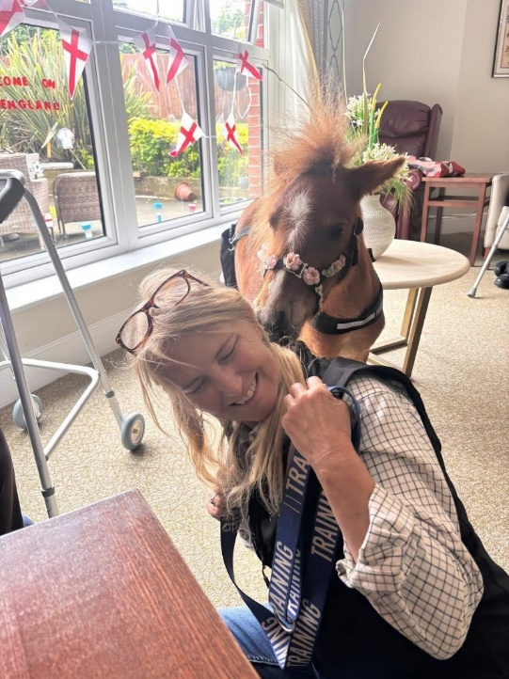
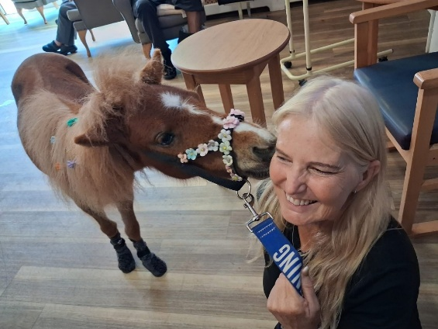
Shannon is a gorgeous miniature pony looked after by Janice who drives her where she needs to go. Her hooves don’t reach the pedals! Shannon likes to visit care homes, and other places where people meet. She loves social interaction and fun. Shannon is skilled in bringing joy, relieving stress, and boosting wellbeing. She also has very pretty face. So why not come along to Thursday Club on 6th August at 1pm for a cuddle, create a memory and have your photo taken with her. This is a new date as Shannon’s human mummy had a fall and couldn’t come.

She’s also clearly an England fan! Hopefully she wasn’t too disappointed. Bet she cheered herself horse? (hoarse)..

Volunteers to follow behind with a mop and bucket??


Last month, as I wrote the newsletter the current heatwave had peaked at 37.7ºC. Today, we are experiencing the fourth heatwave of the year so far, which is unprecedented, the UK has received little or no rain for a month and the Met Office predicts temperatures will remain firmly above normal into early August, meaning further hot spells are highly likely. While most of us can cope with the very hot weather, it’s estimated that there have been 2000 or more ‘excess deaths’ so far this year – mainly of older people and vulnerable people with heart or lung conditions, caused by the very hot weather.
This was the backdrop to the showing of the People’s Emergency Briefing film I mentioned in the last newsletter, which took place on the 8th of July. We had 29 people there altogether, including the councillor for Garretts Green, Mr. Saddak Miah. The film didn’t pull any punches about the impact that climate change will have on peoples’ lives in the UK if action isn’t taken, and there was a stunned silence in the room at the end, as people absorbed the implications. Afterwards, we served refreshments and Revd Sue had put a couple of questions on each table, so there was plenty of conversations around the tables. If you would like to see the film for yourself, speak to me or Revd Sue.
All of the toilets in the church and the community centre are now dual-flush (the hall toilets have been dual-flush since they were installed) to enable us to save water. Look out for signs showing you how to operate them.
On the subject of saving water, Severn Trent have not imposed a hosepipe ban, but they are asking us all to do what we can to save water. We haven’t used the hosepipe at home at all this year, but we’ve got very little water left in our water butt now. When we run the hot tap for washing up we have to run some cold water off and we save this into a bucket for watering the runner beans and bedding plants. If you like your tap water cold, instead of running the tepid water off each time, you could fill a large bottle with tap water and chill it down in the fridge. If you use a dishwasher or washing machine, try to make sure you have a full load in there when you run it.
Linda Nugent (Parish Environment Champion)

Our little courtyard garden is starting to look quite summery and flourishing well thanks to the help from our willing volunteers under the guidance of Sam Ellgood our 50+ leader and a generous donation of bedding plants. Come and have a look and enjoy a cuppa out there.


Established in 1998, AbilityNet is a pioneering UK charity transforming the lives of older and disabled people and working with organisations of all types and sizes to build a digital world that is accessible to all. They are visiting us on 27thAugust, 3rd September and 10th September offering 2 hour workshops talking about digital skills, staying safe online, spotting scams online and over the telephone. Each session is 12.30-2.30pm and will be very useful sessions.

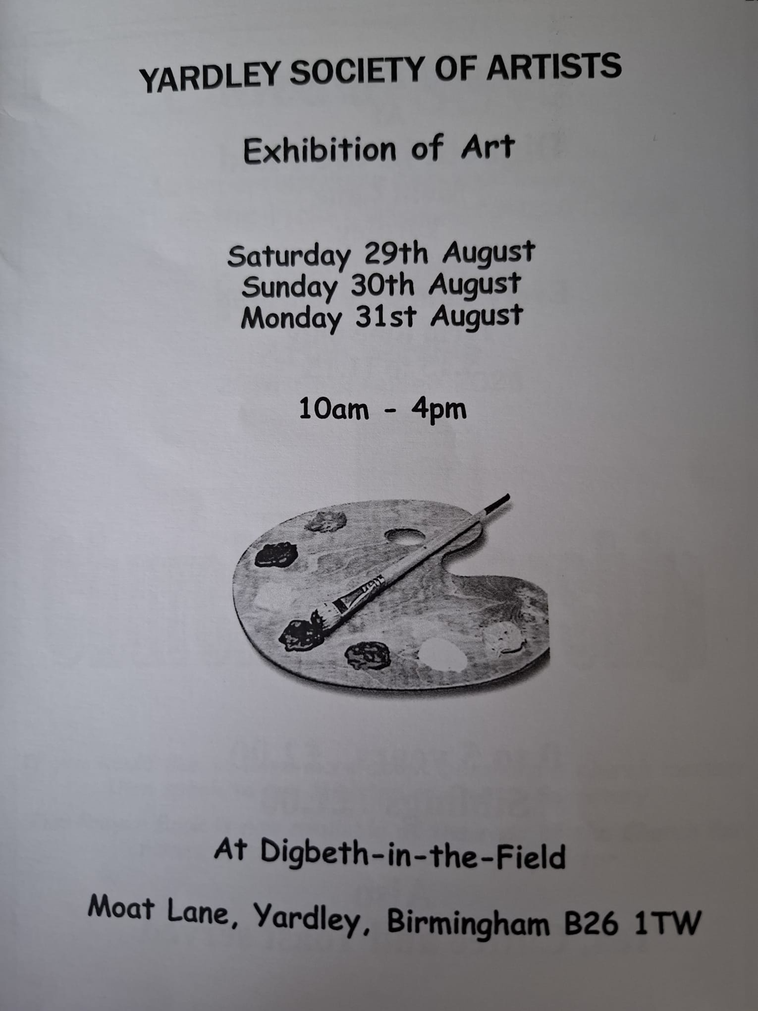


- Fish and chips wrapped in newspaper
- Glass bottles with a refundable deposit
- 78rpm records
- Party telephone lines
- Milk delivered in glass bottles
- Television in black and white only
- Beat bobbies both day and night
- The coal man delivering
- Shilling-in-the-slot utility meters
- Your GP making house calls
- Television rental services
- Scouts and guides bob-a-job week
- Two films shown per sitting
- Conductors on the buses
- Usherettes at the cinemas

Busy doing nothing – an update from Rev Susan
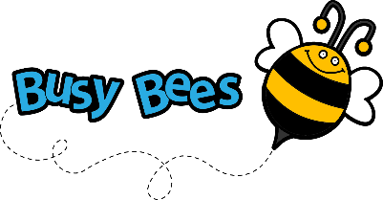
Who remembers Arthur Askey? A comedian from the 1950s who had used to sing and dance to …..
I’m busy doing nothin'
Working the whole day through
Trying to find lots of things not to do
We're busy going nowhere
Isn't it just a crime
I’d like to be unhappy, but
I never do have the time!
Well, that’s me, except I’m not doing the little busy bee dance!
I am usually a very busy bee, as are many of you and I often think to myself “I’d love to be able to just sit in the garden with a magazine, or watch TV, complete a knitting project or try some new hobbies.” Well right now I have the time and I’ve done absolutely nothing … except maybe an inch or so of knitting, most of what’s on TV is rubbish and it’s too hot in the garden … but I have read a couple of books at night when I couldn’t sleep.
This is because I recently had knee replacement surgery, which was successful. I’m recovering very well and I can get around fairly easily on two crutches but the problem is I can’t carry anything and can’t get comfortable but it’s mainly because I feel my brain is still asleep. It’s early days yet and in our September newsletter I’ll hopefully report on what I have achieved.
I am blessed with so many fabulous friends, good neighbours and of course family. Adam stayed overnight for the first few days I was home, cooked meals and put up grab rails and got other aids to help me. My very aged cat Lucy knew which side her bread was buttered as he fussed her and fed her.
I really want to thank you all for your prayers, positive messages, practical support and encouragement; I really think all your help and care is contributing to my recovery and I hope to see you over the coming weeks. Meanwhile anyone want to foster an elderly, noisy and very impatient cat whose given up on me because I don’t jump to immediately meet her every need? 
I will restore your health and heal your wounds says the Lord.
Jeremiah 30 v 17
For a quiet moment
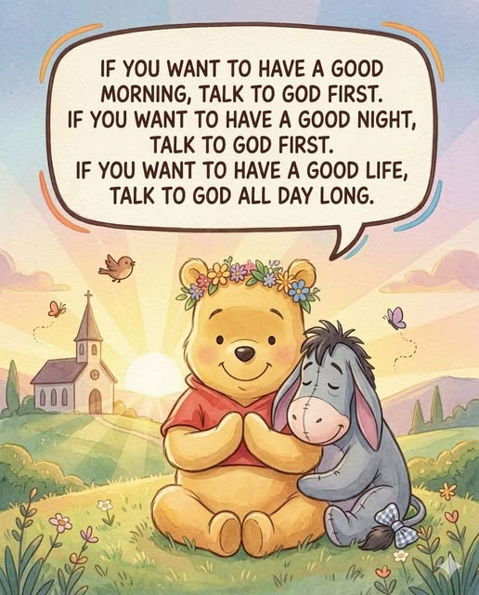
The older I get, the more I realize that talking to God isn’t something reserved only for difficult days.
It’s not just for emergencies.
Not just for heartbreak.
Not just for the nights when life feels too heavy to carry alone.
Sometimes the most beautiful prayers are the quiet little conversations that happen throughout ordinary days.
A whispered:
“Thank You.”
“Help me today.”
“Please give me peace.”
“Protect the people I love.”
Because life moves fast.
Every day pulls us in a hundred different directions.
Responsibilities pile up. We worry about things we need not. Stress grows quietly.
And sometimes we don’t even realize how tired our hearts have become. That’s why moments with God matter so much.
Not because He needs constant reminders that we exist…
but because we need constant reminders that we are not alone.
There’s peace in starting the morning with prayer before the noise of the world gets too loud.
Before the bad news.
Before the pressure.
Before the worries try to take over your thoughts.
And there’s comfort in ending the night the same way.
Laying your burdens down. Releasing the fear you carried all day.
Trusting that while you sleep, God is still working on things you cannot yet see.
Some of the strongest people you know are the ones who quietly keep praying even when life doesn’t make sense. Even when answers are delayed. Even when the waiting hurts.
Even when they feel tired emotionally, mentally, and spiritually.
Because faith isn’t pretending life is easy.
Faith is believing God is still good even during the hard seasons.
And maybe that’s what prayer really does.
It softens the heart.
It calms the mind.
It reminds us that peace doesn’t come from controlling everything…
..it comes from trusting the One who already sees tomorrow.
The older I get, the more I understand why people who stay close to God often carry a different kind of peace.
Not a perfect life.
Just a peaceful spirit.
They still face struggles. They still cry sometimes. They still have unanswered questions.
But deep down, they know they don’t walk through any season alone.
So yes…
If you want a peaceful morning, talk to God first.
If you want rest at night, talk to God first.
And if you want a life filled with strength, grace, wisdom, and peace…
keep talking to Him through every ordinary moment in between.

Bible One-Liners
Q: Why was the musician locked out of his house?
A: He left his keys on the piano.
Q: Why did the scarecrow get promoted?
A: Because he was outstanding in his field.

Items and articles for this newsletter are always welcome.

For the September Newsletter please send your articles and items of interest to
Revd Sue Round
Sue.Round@st-toms.com
Contact details: Rev Paul Bracher 0121-783 2319 paul.bracher@saintrichards.org.uk
Rev Susan Larkin – not available during the summer.
Rev Sue Round 0777 343 1028 sue.round@st-toms.com

