The Blessed Vigin Mary, Nettlecombe.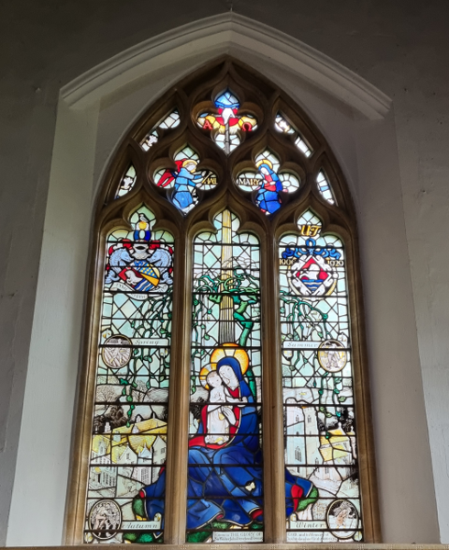
Patronal Evensong on Sunday 13th September at 6pm.
In Ecclesia will be leading the music which will include pieces by Herbert Sumsion and Benjamin Britten.
The Right Reverend Nigel Stock will officiate.
There will be refreshments following the service.
It would be helpful if you could indicate if you will be attending by contacting Jane Wynne on 01984 640743 or jwchurch22@gmail.com

The church is found next to Nettlecombe Field Studies Centre TA4 4HT.
Parking is available.

