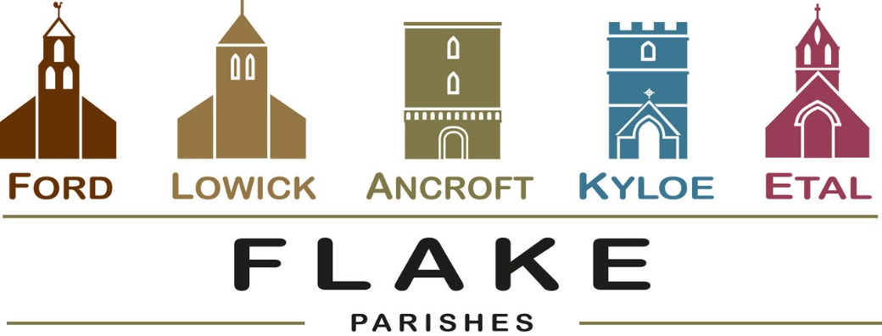

A very warm welcome to you, especially if you are visiting.
Please take this sheet home with you and use it as a basis for prayer.

Sunday 12th July 2026
Lowick 9.15 Holy Communion
Ford 11am Holy Communion

Sunday 19th July 2026
Lowick 9.15 Holy Communion
Ford 11am Holy Communion

Sunday 26th July 2026
Lowick 9.15 Holy Communion
Ford 11am Holy Communion
Ancroft Patronal Festival 1-4pm
Pilgrimage walk from Lowick to Ancroft, 2pm
Ancroft 5pm Hymns and Pimms

Sunday 2nd August 2026
Lowick 9.15 Holy Communion
Ford 11am Holy Communion
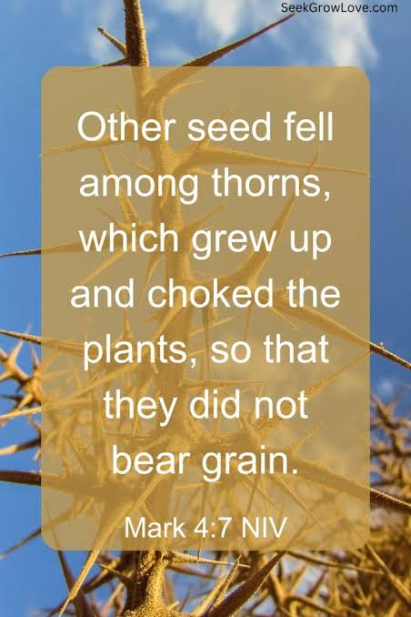
Today is the Sixth Sunday after Trinity and the lectionary Gospel reading is one most of us will have heard many, many times before, so let us ask God to open our ears, eyes and hearts afresh to the new thing we are each to learn, understand or be challenged by….

- Thursday 16th July, 7.30pm Lowick PCC meeting at the Vicarage
- Friday 17th July 1.30pm Ford School end of Term Service in Church.

- Saturday 18th July 9am
Churchwardens’ Meeting at
Fordhill

- 12.30 pm Wedding of Ian
and Yvonne in Ford Church

- 3pm Thanksgiving Service in
Ford Church for the life of Doug Reavley

- Thursday 23rd July 5.30pm Ford PCC meeting at Fordhill
- Saturday 25th July, 2.30pm Funeral of Ruth Turner at
St Anne’s, Ancroft

- Sunday 26th July: St Anne’s, Ancroft Patronal Festival
1-4pm in church with teas, tower tours, music, heritage crafts

- Sunday 26th July 2pm from Lowick Church – pilgrim walk to Ancroft to join the 5pm service of Hymns and Pimms
– see Alex for details,
For our prayers

Ian and Yvonne who will marry on 18th July at Ford.

All who suffer in body, mind or spirit, especially Heather Piper, George Hall, Gail Calder, Don and Sam Quilty, Alison Murray. Carol Kerr.

All who have recently died, especially Doug Reavley.

We pray for those who mourn, and for all who mark anniversaries of death at this time of year.

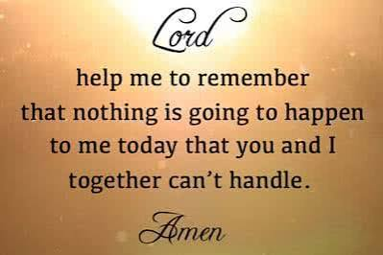

Flake Parishes Contacts

Revd Charlotte Osborn (Vicar) 01289 388591 ceosborn@mail.com 07957 367457

Revd Alex Firman (Assistant Curate) 07935 732811
alex_firman@hotmail.co.uk

Our other licensed clergy

Revd Margaret Sentamu 077871 204745, Canon Nick Sagovsky,
Revd Marion Penfold 01289 305664

Church Contacts

Ancroft Leigh Yorke 07716 116739
Etal Andrew Joicey 01890 820540
Ford Kathleen Holmes 07951 099668
Lowick John Dickson 07967 343211

Parish Administrator
Sheena Atkinson
admin@flakeparishes.org

Safeguarding Officer
Philip Greene
safeguarding@flakeparishes.org
07555 412284

